Computer Networks and Internets
By: Douglas E. Comer

http://www.eg.bucknell.edu/~cs363/lecture_notes/lecture_notes.html

CHAPTER | TITLE | PAGE
Chapter 1 | Introduction | 2
Chapter 2 | Motivation and Tools | 5
PART I | Data Transmission
Chapter 3 | Transmission Media | 10
Chapter 4 | Local Asynchronous Communication (RS-232) | 16
Chapter 5 | Long-Distance Communication (Carriers And Modems) | 24
PART II | Packet Transmission
Chapter 6 | Packets, Frames, And Error Detection | 35
Chapter 7 | LAN Technologies And Network Topology | 45
Chapter 8 | Hardware Addressing And Frame Type Identification | 61
Chapter 9 | LAN Wiring, Physical Topology, And Interface Hardware | 70
Chapter 10 | Extending LANs: Fiber Modems, Repeaters, Bridges, and Switches | 83
Chapter 11 | Long-Distance Digital Connection Technologies | 94
Chapter 12 | WAN Technologies And Routing | 103
Chapter 13 | Network Ownership, Service Paradigm, And Performance
Chapter 14 | Protocols And Layering | 115
PART III | Internetworking
Chapter 15 | Internetworking: Concepts, Architecture, and Protocols | 128
Chapter 16 | IP: Internet Protocol Addresses | 134
Chapter 17 | Binding Protocol Addresses (ARP) | 141
Chapter 18 | IP Datagrams And Datagram Forwarding | 150
Chapter 19 | IP Encapsulation, Fragmentation, And Reassembly | 156
Chapter 20 | The Future IP (IPv6) | 162
Chapter 21 | An Error Reporting Mechanism (ICMP) | 167
Chapter 22 | TCP: Reliable Transport Service | 171
PART IV | Network Applications
Chapter 23 | Client-Server Interaction | 183
Chapter 24 | The Socket Interface | 189
Chapter 25 | Example Of A Client And A Server | 196
Chapter 26 | Naming With The Domain Name System | 201
Chapter 27 | Electronic Mail Representation And Transfer | 211
Chapter 28 | File Transfer And Remote File Access | 221
Chapter 29 | World Wide Web Pages And Browsing | 227
Chapter 30 | CGI Technology For Dynamic Web Documents | 233
Chapter 31 | Java Technology For Active Web Documents | 239
Chapter 32 | RPC and Middleware | 247
Chapter 33 | Network Management (SNMP) | 252
Chapter 34 | Network Security | 258
Chapter 35 | Initialization (Configuration) | 262
Bibliography
 | Prof. M. Anvari, OS and Networking

Chapter 1 - Introduction

Section | Title
1 | How do Computer Networks and Internets Operate?
2 | Explosive growth
3 | Internet
4 | Economic impact
5 | Complexity
6 | Abstractions and concepts
7 | On-line resources

How do Computer Networks and Internets Operate?

Network: system for connecting computer using a single transmission technology
Internet: set of networks connected by routers that are configured to pass traffic among any computers attached to networks in the set
- Data transmission - media, data encoding
- Packet transmission - data exchange over a network
- Internetworking - universal service over a collection of networks
- Network applications - programs that use an internet
Explosive growth
- New phenomenon - now, networks are an important part of everyday activities
  - Business
  - Home
  - Government
  - Education
- Global Internet growing exponentially
  - Initially a research project with a few dozen sites
  - Today, millions of computers and thousands of networks world-wide
Internet

- Roots in military network called Arpanet
  - Fundamental changes from centralized to distributed computing
  - Incorporated features for reliability and robustness
    - Multiple links
    - Distributed routing
- Ethernet made local networking feasible
- TCP/IP protocol made internetworking possible
  - Developed after Arpanet
  - Switchover occurred in 1983
- Exponential growth - doubling every 18 months
Economic impact

- Large industry has grown around:
  - Networking hardware
  - Computers
  - Software
- Companies must integrate planning, implementation, management and upgrade
Complexity

- Computer networking is complex
  - Many different hardware technologies
  - Many different software technologies
  - All can be interconnected in an internet
- No underlying theory
- Terminology can be confusing
  - TLAs
  - Industry redefines or changes terminology from academia
  - New terms invented all the time
Abstractions and concepts

- Will concentrate on abstractions and concepts to unravel complexity
- Examples:
  - Types of LAN wiring, rather than details of LAN data transmission
  - Definition and concept of congestion, rather than specific congestion control mechanisms
Chapter 2 - Motivation and Tools

Section | Title
1 | Introduction
2 | Historic motivation
3 | ARPA
4 | Packet switching
5 | Internetworking
6 | History and growth
7 | Growth since 1981
8 | Growth (logarithmic axis)
9 | Probing the Internet
10 | ping
11 | ping  (Example)
12 | ping  (Example)
13 | traceroute
14 | traceroute  (Example)
15 | traceroute  (Example)
16 | Web access to tools

Introduction

- Motivation
- Service
- Tools for exploration

Historic motivation

- Early computers were expensive
  - Large footprint
  - Centralized
- Programs took a long time to run
- Couldn't afford to put computers everywhere
ARPA

- Advanced Research Projects Agency initiated project to connect researchers with computers
- Adopted new technology:
  - Packet switching
  - Internetworking
- Resulted in system for remote access to expensive resources
Packet switching

- Data transmitted in small, independent pieces
  - Source divides outgoing messages into packets
  - Destination recovers original data
- Each packet travels independently
  - Includes enough information for delivery
  - May follow different paths
  - Can be retransmitted if lost
Internetworking

- Many (mutually incompatible) network technologies
- No one technology appropriate for every situation
- Internetworking glues together networks of dissimilar technologies with routers
- Result is virtual network whose details are invisible
History and growth

- ARPAnet began in late 1960s (not using TCP/IP)
- TCP/IP developed in late 1970s
- ARPAnet switched to TCP/IP in early 80s
- Start of Internet
  - Few hundred computers
  - Few tens of networks
Growth since 1981

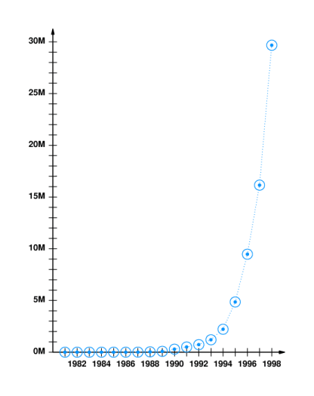
Probing the Internet

- Two tools:
  - ping - sends message that is echoed by remote computer
  - traceroute - reports path to remote computer
ping

- Sends packet to remote computer
- Remote computer replies with echo packet
- Local computer reports receipt of reply
- % ping merlin.cs.purdue.edu
- merlin.cs.purdue.edu is alive

ping (Example)

- Can arrange to send multiple packets
- Reports round trip time
- % ping -s www.bucknell.edu 100 5
- PING web.bucknell.edu: 100 data bytes
- 108 bytes from web.bucknell.edu (134.82.6.6): icmp_seq=0. time=8. ms
- 108 bytes from web.bucknell.edu (134.82.6.6): icmp_seq=1. time=5. ms
- 108 bytes from web.bucknell.edu (134.82.6.6): icmp_seq=2. time=3. ms
- 108 bytes from web.bucknell.edu (134.82.6.6): icmp_seq=3. time=2. ms
- 108 bytes from web.bucknell.edu (134.82.6.6): icmp_seq=4. time=2. ms

- ----web.bucknell.edu PING Statistics----
- 5 packets transmitted, 5 packets received, 0% packet loss
- round-trip (ms) min/avg/max = 2/4/8

ping (Example)

% PING merlin.cs.purdue.edu: 100 data bytes
108 bytes from merlin.cs.purdue.edu (128.10.2.3): icmp_seq=0. time=64. ms
108 bytes from merlin.cs.purdue.edu (128.10.2.3): icmp_seq=1. time=58. ms
108 bytes from merlin.cs.purdue.edu (128.10.2.3): icmp_seq=2. time=55. ms
108 bytes from merlin.cs.purdue.edu (128.10.2.3): icmp_seq=3. time=63. ms
108 bytes from merlin.cs.purdue.edu (128.10.2.3): icmp_seq=4. time=54. ms

----merlin.cs.purdue.edu PING Statistics----
5 packets transmitted, 5 packets received, 0% packet loss
round-trip (ms) min/avg/max = 54/58/64

traceroute

- Sends series of packets along path to destination
  - Each successive packet identifies next router along path
  - Uses expanding ring search
- Reports list of packets
Traceroute (Example)

% traceroute www.bucknell.edu
traceroute to web.bucknell.edu (134.82.6.6), 30 hops max, 40 byte packets
1 DanaRout-p13-s56.eg.bucknell.edu (134.82.56.254) 8 ms 5 ms 5 ms
2 CCSServB-p1p17-s254.bucknell.edu (134.82.254.3) 4 ms 7 ms 4 ms
3 web.bucknell.edu (134.82.6.6) 3 ms 3 ms 3 ms

traceroute (Example)

traceroute merlin.cs.purdue.edu
traceroute to merlin.cs.purdue.edu (128.10.2.3), 30 hops max, 40 byte packets
1 CCSServC (134.82.7.254) 2 ms 1 ms 1 ms
2 134.82.254.253 (134.82.254.253) 2 ms 2 ms 3 ms
3 12.127.210.89 (12.127.210.89) 22 ms 20 ms 20 ms
4 gr1-a3100s5.wswdc.ip.att.net (192.205.34.9) 20 ms 20 ms 20 ms
5 Hssi2-1-0.GW1.DCA1.ALTER.NET (157.130.32.21) 20 ms 20 ms 20 ms
6 104.ATM2-0.XR2.DCA1.ALTER.NET (146.188.161.30) 21 ms 39 ms 20 ms
7 194.ATM2-0.TR2.DCA1.ALTER.NET (146.188.161.146) 20 ms 20 ms 20 ms
8 101.ATM6-0.TR2.CHI4.ALTER.NET (146.188.136.109) 40 ms 41 ms 56 ms
9 198.ATM7-0.XR2.CHI4.ALTER.NET (146.188.208.229) 41 ms 41 ms 41 ms
10 194.ATM8-0-0.GW1.IND1.ALTER.NET (146.188.208.165) 63 ms 66 ms 51 ms
11 purdue-gw.customer.alter.net (157.130.101.106) 56 ms 54 ms 54 ms
12 cisco-cs-atm.gw.purdue.edu (128.210.252.21) 66 ms 65 ms 63 ms
13 merlin.cs.purdue.edu (128.10.2.3) 68 ms 84 ms 63 ms

Web access to tools

ping/traceroute

http://www.net.cmu.edu/cgi-bin/netops.cgi

Ping/Traceroute Gateway
Ping/Traceroute Gateway
This application allows you to ping or traceroute to hosts on other networks. Carnegie Mellon has redundant internet connections described here. We also have a connection to the VBNS.
Top of Form
Host (IP or hostname):
Operation: traceroute ping

Chapter 3 - Transmission Media

Section | Title
1 | Basic Idea
2 | Transmission media
3 | Copper wires
4 | Glass fibers
5 | Radio
6 | Wireless Example
7 | Wireless Exmaple
8 | Microwave
9 | Infrared
10 | Laser
11 | Choosing a medium
12 | Media in use at Bucknell

Basic Idea

- Encode data as energy and transmit energy
- Decode energy at destination back into data
- Energy can be electrical, light, radio, sound, ...
- Each form of energy has different properties and requirements for transmission
Transmission media

- Transmitted energy is carried through some sort of medium
- Transmitter encodes data as energy and transmits energy through medium
  - Requires special hardware for data encoding
  - Requires hardware connection to transmission medium

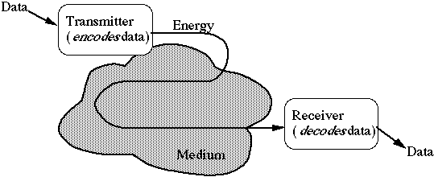

- Media can be copper, glass, air, ...
Copper wires

- Twisted pair uses two wires
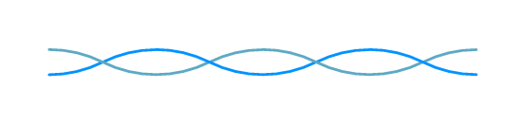

- Coaxial cable includes shield for improved performance
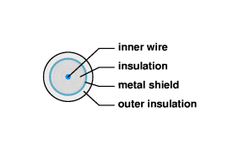
Glass fibers

- Thin glass fiber carries light with encoded data
- Plastic jacket allows fiber to bend (some!) without breaking
- Fiber is very clear and designed to reflect light internally for efficient transmission
- Light emitting diode (LED) or laser injects light into fiber
- Light sensitive receiver at other end translates light back into data

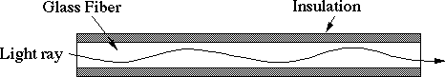

Radio

- Data transmitted using radio waves
- Energy travels through the air rather than copper or glass
- Conceptually similar to radio, TV, cellular phones
- Can travel through walls and through an entire building
- Can be long distance or short distance
  - Long distance with satellite relay
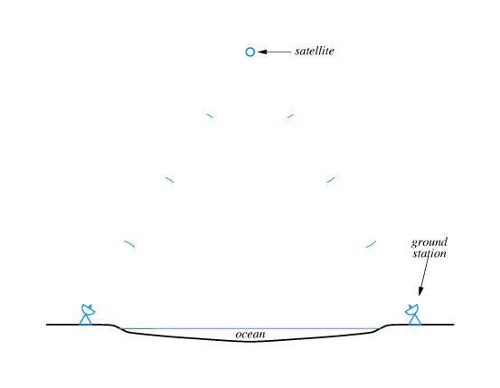
  - Short distance - wireless computer network
Wireless Example

- Wireless bridge and antenna
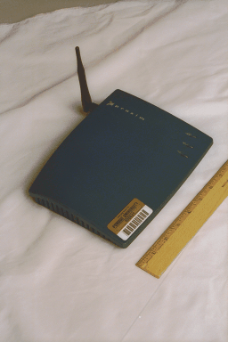

Wireless Example

- Remote station (laptop) interface

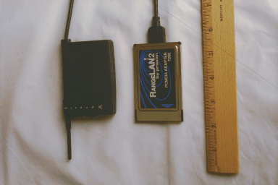

Microwave

- High frequency radio waves
- Unidirectional, for point-to-point communication
- Antennas mounted on towers relay transmitted data
Infrared

- Infrared light transmits data through the air
- Similar to technology used in TV remote control
- Can propagate throughout a room (bouncing off surfaces), but will not penetrate walls
- Becoming common in personal digital assistants
Laser

- Unidirectional, like microwave
- Higher speed than microwave
- Uses laser transmitter and photo-sensitive receiver at each end
- Point-to-point, typically between buildings
- Can be adversely affected by weather
Choosing a medium

- Copper wire is mature technology, rugged and inexpensive; maximum transmission speed is limited
- Glass fiber:
  - Higher speed
  - More resistant to electro-magnetic interference
  - Spans longer distances
  - Requires only single fiber
  - More expensive; less rugged
- Radio and microwave don't require physical connection
- Radio and infrared can be used for mobile connections
- Laser also does not need physical connection and supports higher speeds
Media in use at Bucknell
- Copper/fiber for long-distance connection to Internet
- Fiber between buildings
- Copper within buildings

Chapter 4 - Local Asynchronous Communication

Last modified: Mon Jan 18 08:51:15 2000
Section | Title
1 | Bit-wise data transmission
2 | Asynchronous communication
3 | Using electric current to send bits
4 | Sending bits - example
5 | Transmission timing
6 | RS-232
7 | Details of RS-232
8 | RS-232 wiring and connectors
9 | Identifying asynchronous characters
10 | Timing
11 | Measures of transmission rates
12 | Framing
13 | Full-duplex communication
14 | RS-232 connection standards
15 | 2-3 swap
16 | RS-232 cable breakout-box
17 | Limitations of real hardware
18 | Hardware bandwidth
19 | Bandwidth and data transmission
20 | Summary

Bit-wise data transmission

- Data transmission requires:
  - Encoding bits as energy
  - Transmitting energy through medium
  - Decoding energy back into bits
- Energy can be electric current, radio, infrared, light
- Transmitter and receiver must agree on encoding scheme and transmission timing
Asynchronous communication

- One definition of asynchronous: transmitter and receiver do not explicitly coordinate each data transmission
  - Transmitter can wait arbitrarily long between transmissions
  - Used, for example, when transmitter such as a keyboard may not always have data ready to send
- Asynchronous may also mean no explicit information about where data bits begin and end
Using electric current to send bits

- Simple idea - use varying voltages to represent 1s and 0s
- One common encoding use negative voltage for 1 and positive voltage for 0
- In following figure, transmitter puts positive voltage on line for 0 and negative voltage on line for 1
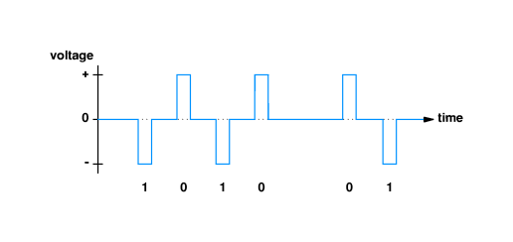
Transmission timing

- Encoding scheme leaves several questions unanswered:
  - How long will voltage last for each bit?
  - How soon will next bit start?
  - How will the transmitter and receiver agree on timing?
- Standards specify operation of communication systems
  - Devices from different vendors that adhere to the standard can interoperate
  - Example organizations:
    - International Telecommunications Union (ITU)
    - Electronic Industries Association (EIA)
    - Institute for Electrical and Electronics Engineers (IEEE)
RS-232

- Standard for transfer of characters across copper wire
- Produced by EIA
- Full name is RS-232-C
- RS-232 defines serial, asynchronous communication
  - Serial - bits are encoded and transmitted one at a time (as opposed to parallel transmission)
  - Asynchronous - characters can be sent at any time and bits are not individually synchronized
Details of RS-232

- Components of standard:
  - Connection must be less than 50 feet
  - Data represented by voltages between +15v and -15v
  - 25-pin connector, with specific signals such as data, ground and control assigned to designated pins
  - Specifies transmission of characters between, e.g., a terminal and a modem
- Transmitter never leaves wire at 0v; when idle, transmitter puts negative voltage (a 1) on the wire
RS-232 wiring and connectors

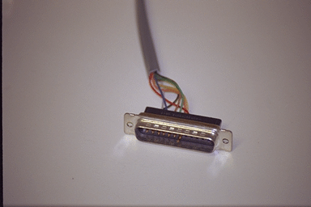

Identifying asynchronous characters

- Transmitter indiciates start of next character by transmitting a zero
  - Receiver can detect transition as start of character
  - Extra zero called the start bit
- Transmitter must leave wire idle so receiver can detect transition marking beginning of next character
  - Transmitter sends a one after each character
  - Extra one call the stop bit
- Thus, character represented by 7 data bits requires transmission of 9 bits across the wire
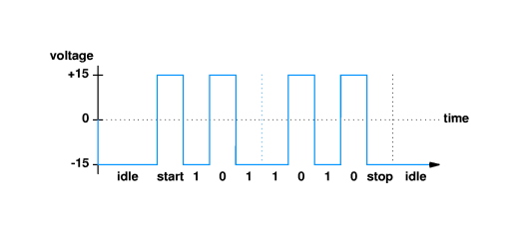

- RS-232 terminology:
  - MARK is a negative voltage (== 1)
SPACE is a positive voltage (== 0)
Timing

- Transmitter and receiver must agree on timing of each bit
- Agreement accomplished by choosing transmission rate
  - Measured in bits per second
  - Detection of start bit indicates to receiver when subsequent bits will arrive
- Hardware can usually be configured to select matching bit rates
  - Switch settings
  - Software
  - Auto detection
Measures of transmission rates

- Baud rate measures number of signal changes per second
- Bits per second measures number of bits transmitted per second
- In RS-232, each signal change represents one bit, so baud rate and bits per second are equal
- If each signal change represents more than one bit, bits per second may be greater than baud rate
Framing

- Start and stop bits represent framing of each character
- If transmitter and reciver are using different speeds, stop bit will not be received at the expected time
- Problem is called a framing error
- RS-232 devices may send an intentional framing error called a BREAK
Full-duplex communication

- Two endpoints may send data simultaneously - full-duplex communication
- Requires an electrical path in each direction

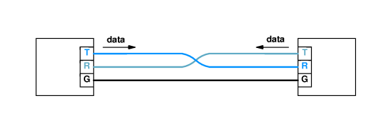

RS-232 connection standards

- RS-232 specifies use of 25 pin connector (DB-25)
- Pins are assigned for use as data, ground and control:
  - Pin 2 - Receive (RxD)
  - Pin 3 - Transmit (TxD)
  - Pin 4 - Ready to send (RTS)
  - Pin 5 - Clear to send (CTS)
  - Pin 7 - Ground
2-3 swap

- Cable must cross-over wires to connect pins 2 and 3 on receiver and transmitter

- To avoid 2-3 swap, RS-232 specifies that modems transmit on pin 2 and receive on pin 3, while computers transmit on pin 3 and receive on pin 2
- However, RS-232 cables between two computers must have 2-3 swap
RS-232 cable breakout-box

- May need to test RS-232 connections
- Breakout-box gives access to signals

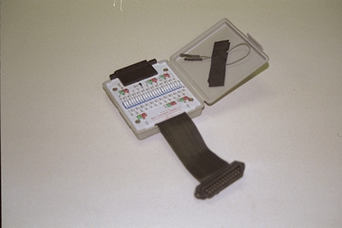

Limitations of real hardware

- Effects of wire mean waveforms look like:
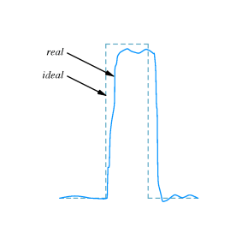
- Longer wire, external interference may make signal look even worse
- RS-232 standard specifies how precise a waveform the transmitter must generate, and how tolerant the receiver must be of imprecise waveform
Hardware bandwidth

- Limitations on time to change voltages imposes upper limit on number of changes per second
- Theoretical upper limit is called the bandwidth
- Measured in cycles per second or Hertz
Bandwidth and data transmission

- Nyquist sampling theorem expresses relationship between bandwidth and maximum data transmission speed
- For RS-232, using two voltages, maximum speed over medium with bandwidth B is 2B
- In general, for system using K different states, maximum is 2Blog₂K
- In practice, noise limits maximum data transmission rate to less than maximum allowed by Nyquist sampling theorem; Claude Shannon
Summary

- Asynchronous communication - data can start at any time; individual bits not delineated
- RS-232 - EIA standard for asynchronous character transmission
- Characters per second and baud rate
- Bandwidth limits maximum data transmission rate
Chapter 5 - Long-Distance Communication

Last modified: Wed Jan 20 07:28:26 2000
Section | Title
1 | Long-distance communication
2 | Sending signals long distances
3 | Oscillating signals
4 | Encoding data with a carrier
5 | Types of modulation
6 | Examples of modulation techniques
7 | Encoding data with phase shift modulation
8 | Hardware for data transmission
9 | Full duplex communication
10 | Modems
11 | Other types of modems
12 | Leased serial data circuits
13 | Optical, radio and dialup modems
14 | Dialup modems
15 | Operation of dialup modems
16 | Carrier frequencies and multiplexing
17 | Multiplexing
18 | Spread spectrum multiplexing
19 | Time division multiplexing
20 | Summary

Long-distance communication

- Encoding used by RS-232 cannot work in all situations
  - Over long distances
  - Using existing systems like telephone
- Different encoding strategies needed
Sending signals long distances

- Electric current becomes weaker as it travels on wire
- Resulting signal loss may prevent accurate decoding of data
- Signal loss prevents use of RS-232 over long distances
Oscillating signals

- Continuous, oscillating signal will propagate farther than electric current
- Long distance communication uses such a signal, called a carrier
- Waveform for carrier looks like:

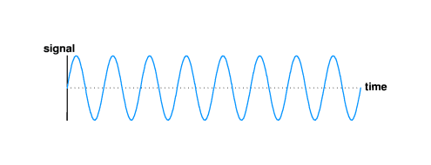

- Carrier can be detected over much longer distances than RS-232 signal
Encoding data with a carrier

- Modifications to basic carrier encode data for transmission
- Technique called modulation
- Same idea as in radio, television transmission
- Carrier modulation used with all types of media - copper, fiber, radio, infrared, laser
Types of modulation

- Amplitude modulation - strength, or amplitude of carrier is modulated to encode data
- Frequency modulation - frequency of carrier is modulated to encode data
- Phase shift modulation - changes in timing, or phase shifts encode data
Examples of modulation techniques

- Amplitude modulation:
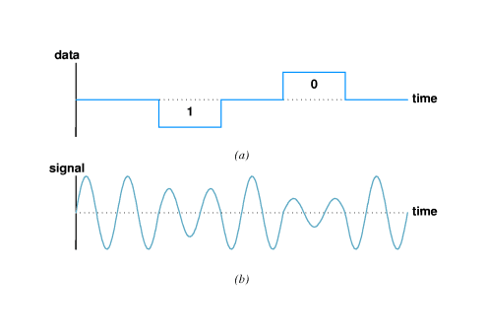

- Phase shift modulation:

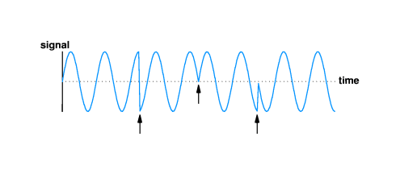
Encoding data with phase shift modulation

- Amount of phase shift can be precisely measured
  - Measures how much of sine wave is "skipped"
  - Example shows 1/2 and 3/4 cycle

- Each phase shift can be used to carry more than one bit; in example, four possible phase shifts encode 2 bits:
  - 00 - no shift
  - 01 - 1/4 phase
  - 10 - 1/2 phase
  - 11 - 3/4 phase
- Thus, each phase shift carries 2 bits
- Data rate is twice the baud rate
Hardware for data transmission

- Modulator encodes data bits as modulated carrier
- Demodulator decodes bits from carrier
- Data transmission requires modulator at source and demodulator at destination
Full duplex communication

- Most systems provide for simultaneous bidirectional, or full duplex, transmission
- Requires modulator and demodulator at both endpoints:

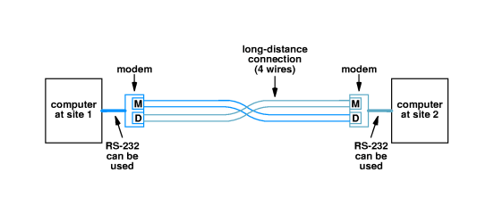
- Long-distance connection is called 4-wire circuit
- Modulator and demodulator typically in single device called a modem (modulator/demodulator)
Modems

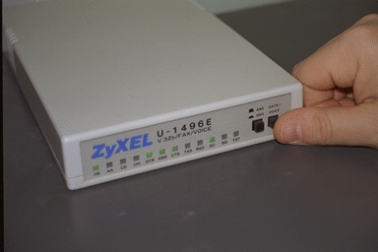

- If external to computer, RS-232 can be used between modem and computer

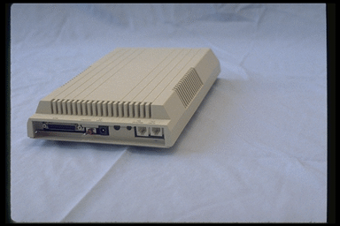

- If internal, direct bus connection used
- Can also be rack-mounted

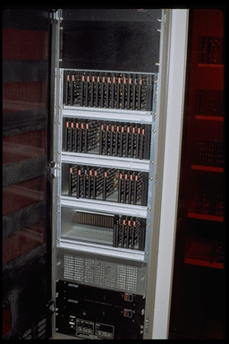
Other types of modems

- ISDN modem
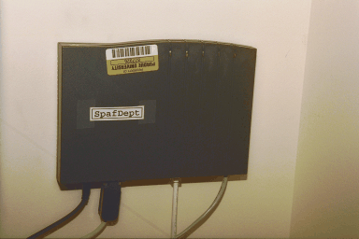

- Cable modem (front)

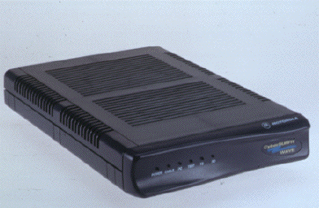

- Cable modem (rear) with coax connector for cable and 10Base-T connector

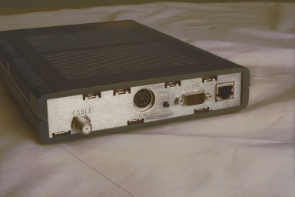

Leased serial data circuits

- Organizations often include 4-wire circuits in network
- Within a site - on a campus - organization can install its own 4-wire circuits
- Telephone company supplies off-campus wires
  - Telephone cables have extra wires (circuits) for expansion
  - Telephone company lease right to use wires to organization
  - Organization uses modems for data transfer
- Called serial data circuit or serial line
- Operates in parallel with (but not connected to) telephone circuits
Optical, radio and dialup modems

- Modems used with other media in addition to dedicated data circuits
- Special form of encoding/decoding transducers that use modulation for data encoding
  - Glass - data encoded as modulated light beam
  - Radio - data encoded as modulated radio signal
  - Dialup - data encoded as modulated sound
- Dialup modem connects to ordinary phone line 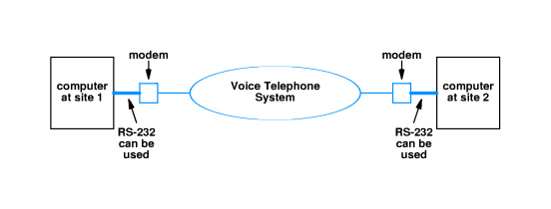
Dialup modems

- Circuitry for sending data
- Circuitry to mimic telephone operation
  - Lifting handset
  - Dialing
  - Replacing handset (hanging up)
  - Detect dial tone
- Full duplex on one voice channel
  - Different carrier frequencies for each direction
  - Filters eliminate interference
Operation of dialup modems

- Receiving modem waits for call in answer mode
- Other modem, in call mode:
  - Simulates lifting handset
  - Listens for dial tone
  - Sends tones (or pulses) to dial number
- Answering modem:
  - Detects ringing
  - Simulates lifting handset
  - Sends carrier
- Calling modem:
  - Sends carrier
- Data exchanged
Carrier frequencies and multiplexing

- Multiple signals with data can be carried on same medium without interference
  - Allows multiple simultaneous data streams
  - Dialup modems can carry full-duplex data on one voice channel
- Example - multiple TV stations in air medium
- Each separate signal is called a channel
Multiplexing

- Carrying multiple signals on one medium is called multiplexing
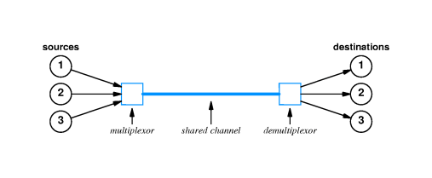

- Frequency division multiplexing (FDM) achieves multiplexing by using different carrier frequencies
- Receiver can "tune" to specific frequency and extract modulation for that one channel
  - Frequencies must be separated to avoid interference
  - Only useful in media that can carry multiple signals with different frequencies - high-bandwidth required
Spread spectrum multiplexing

- Spread spectrum uses multiple carriers
- Single data stream divided up and sent across different carriers
- Can be used to bypass interference or avoid wiretapping
Time division multiplexing

- Time division multiplexing uses a single carrier and sends data streams sequentially
- Transmitter/receiver pairs share single channel
- Basis for most computer networks used shared media - will give details in later chapters
Summary

- Long-distance communications use carrier and modulation for reliable communication
- Modulator encodes data and demodulator decodes data
- Can use amplitude, frequency or phase shift modulation
- Multiple transmitter/receiver pairs can use multiplexing to share a single medium

Chapter 6 - Packets, Frames and Error Detection

Section | Title
1 | Shared communication media
2 | Packets
3 | Motivation
4 | Dedicated network access
5 | Packet switching access
6 | Time-division multiplexing
7 | Time-division multiplexing - example
8 | Packets and frames
9 | Frame formats
10 | Defining the framing standard
11 | Frame format
12 | Packet framing
13 | Framing in practice
14 | Transmitting arbitrary data
15 | Data stuffing
16 | Byte stuffing
17 | Byte stuffing example
18 | Transmission errors
19 | Error detection and correction
20 | Parity checking
21 | Parity and error detection
22 | Limitations to parity checking
23 | Alternative error detection schemes
24 | Checksums
25 | Implementing checksum computation
26 | Limitations to checksums
27 | Cyclic redundancy checks
28 | Hardware components
29 | CRC hardware
30 | Error detection and frames
31 | Summary
Shared communication media

- Most network use shared media which interconnect all computers
- However - only one source can transmit data at a time

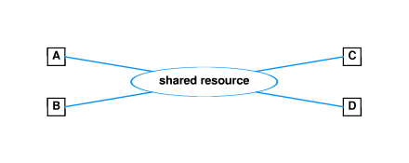
Packets

- Most networks divide into small blocks called packets for transmission
- Each packet sent individually
- Such networks are called packet networks or packet switching networks
Motivation

- Coordination - helps transmitter and receiver determine which data have been received correctly and which have not
- Resource sharing - allows multiple computers to share network infrastructure
- Networks enforce fair use - each computer can only send one packet at a time
Dedicated network access

- 5MB file transferred across network with 56Kbps capacity will require 12 minutes:
5x10⁶ bytes * 8 bits/byte  60 secs/minute * 56x10³ bits/second | = 11.9 minutes
- All other computers will be forced to wait 12 minutes before initiating other transfers
Packet switching access

- If file is broken into packets, other computers must only wait until packet (not entire file) has been sent
- From previous example, suppose file is broken into 1000 byte packets
- Each packet takes less than .2 seconds to transmit:
1000 bytes * 8 bits/byte  56x10³ bits/second | = .143 seconds
- Other computer must only wait .143 seconds before beginning to transmit
- Note:
  - If both files are both 5MB long, each now takes 24 minutes to transmit
  - BUT if second file is only 10KB long, it will be transmitted in only 2.8 seconds, while 5MB file still takes roughly 12 minutes
Time-division multiplexing

- Dividing data into small packets allows time-division multiplexing
- Each packet leaves the source and is switched onto the shared communication channel through a multiplexor
- At the destination, the packet is switched through a demultiplexor to the destination

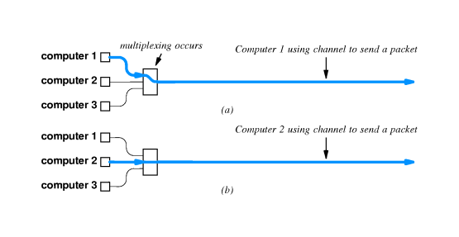
Time-division multiplexing - example

http://www.eg.bucknell.edu/~cs363/lecture_notes/chap06/chap06_7.html
Shockwave

Packets and frames

- Packet is ``generic'' term that refers to a small block of data
- Each hardware technology uses different packet format
- Frame or hardware frame denotes a packet of a specific format on a specific hardware technology
Frame formats

- Need to define a standard format for data to indicate the beginning and end of the frame
- Header and trailer used to ``frame'' the data
Defining the framing standard

- Can choose two unused data values for framing
- E.g., if data is limited to printable ASCII, can use
  - ``Start of header'' (soh)
  - ``end of text'' (eot)
- Sending computer sends soh first, then data, finally eot
- Receiving computer interprets and discards soh, stores data in buffer and interprets and discards eot
Frame format

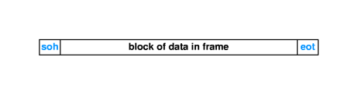
Packet framing

http://www.eg.bucknell.edu/~cs363/lecture_notes/chap06/chap06_12.html
Shockwave

Framing in practice

- Incurs extra overhead - soh and eot take time to transmit, but carry no data
- Accommodates transmission problems:
  - Missing eot indicates sending computer crashed
  - Missing soh indicates receiving computer missed beginning of message
  - Bad frame is discarded
Transmitting arbitrary data

- Suppose system can't afford to reserve two special characters for framing
- E.g., transmitting arbitrary 8-bit binary data
- soh and eot as part of data will be misinterpreted as framing data
- Sender and receiver must agree to encode special characters for unambiguous transmission
Data stuffing

- Bit stuffing and byte stuffing are two techniques for inserting extra data to encode reserved bytes
- Byte stuffing translates each reserved byte into two unreserved bytes
- For example, can use esc as prefix, followed by x for soh, y for eot and z for esc:
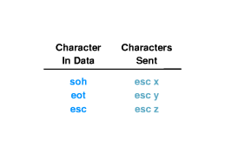
Byte stuffing

- Sender translates each reserved byte into the appropriate encoding pair of bytes
- Receiver interprets pairs of bytes and stores encoded byte in buffer
- Data still framed by soh and eot
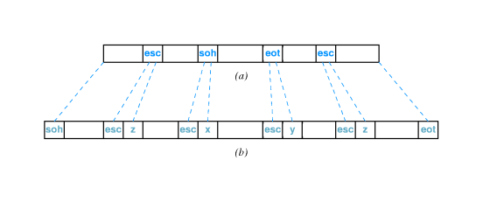
Byte stuffing example

http://www.eg.bucknell.edu/~cs363/lecture_notes/chap06/chap06_17.html
Shockwave
Transmission errors

- External electromagnetic signals can cause incorrect delivery of data
  - Data can be received incorrectly
  - Data can be lost
  - Unwanted data can be generated
- Any of these problems are called transmission errors
Error detection and correction

- Error detection - send additional information so incorrect data can be detected and rejected
- Error correction - send additional information so incorrect data can be corrected and accepted
Parity checking

- Parity refers to the number of bits set to 1 in the data item
  - Even parity - an even number of bits are 1
  - Odd parity - an odd number of bits are 1
- A parity bit is an extra bit transmitted with a data item, chose to give the resulting bits even or odd parity
  - Even parity - data: 10010001, parity bit 1
  - Odd parity - data: 10010111, parity bit 0
Parity and error detection

- If noise or other interference introduces an error, one of the bits in the data will be changed from a 1 to a 0 or from a 0 to a 1
- Parity of resulting bits will be wrong
  - Original data and parity: 10010001+1 (even parity)
  - Incorrect data: 10110001+1 (odd parity)
- Transmitter and receiver agree on which parity to use
- Receiver detects error in data with incorrect parity
Limitations to parity checking

- Parity can only detect errors that change an odd number of bits
  - Original data and parity: 10010001+1 (even parity)
  - Incorrect data: 10110011+1 (even parity!)
- Parity usually used to catch one-bit errors
Alternative error detection schemes

- Many alternative schemes exist
  - Detect multi-bit errors
  - Correct errors through redundant information
- Checksum and CRC are two widely used techniques
Checksums

- Sum of data in message treated as array of integers
- Can be 8-, 16- or 32-bit integers
- Typically use 1s-complement arithmetic
- Example - 16-bit checksum with 1s complement arithmetic
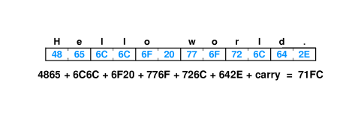
Implementing checksum computation

- Easy to do - uses only addition
- Fastest implementations of 16-bit checksum use 32-bit arithmetic and add carries in at end
- Can also speed computation by unrolling loop and similar optimizations
Limitations to checksums

- May not catch all errors 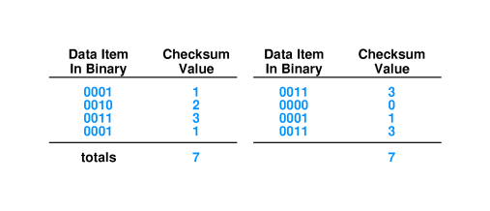
Cyclic redundancy checks

- Consider data in message as coefficients of a polynomial
- Divide that coefficient set by a known polynomial
- Transmit remainder as CRC
  - Good error detection properties
  - Easy to implement in hardware
Hardware components

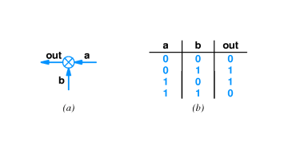

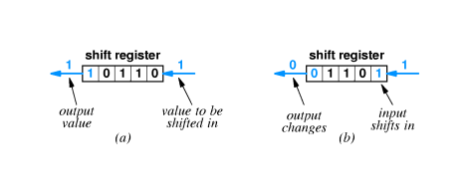
CRC hardware

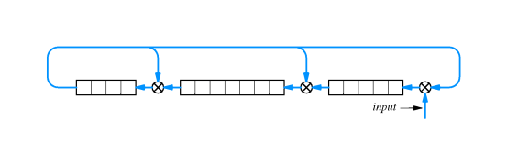
Error detection and frames

- Error detection typically done for each frame
- Error in frame typically causes receiver to discard frame
- Example - CRC sent after end of frame computed on data in frame
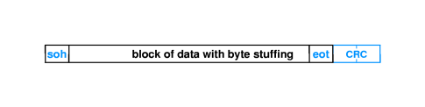
Summary

- Computer networks divide data into packets
  - Resource sharing
  - Fair allocation
- Hardware frames are specific to a particular hardware network technology
- Each frame has a specific format that identifies the beginning and end of the frame
- Error detection and correction is used to identify and isolate transmission errors

Chapter 7 - LAN Technologies and Network Topology

Section | Title
1 | Introduction
2 | Direct point-to-point communication
3 | Connections in a point-to-point network
4 | Connections in a point-to-point network
5 | Reducing the number of communication channels
6 | Growth of LAN technologies
7 | Locality of reference
8 | LAN topologies
9 | Star topology
10 | Star topology in practice
11 | Ring topology
12 | Bus topology
13 | Why multiple topologies?
14 | Ethernet
15 | Ethernet speeds
16 | Ethernet operation
17 | Ethernet example
18 | CSMA
19 | CSMA example
20 | Collision detection - CD
21 | Collision example
22 | Ethernet CD
23 | Recovery from collision
24 | Exponential backoff
25 | Wireless LAN
26 | Limited connectivity with wireless
27 | CSMA/CA
28 | Collisions
29 | LocalTalk
30 | Token ring
31 | Transmission around a token ring
32 | Using the token
33 | Token and synchronization
34 | IBM token ring
35 | FDDI
36 | FDDI and reliability
37 | ATM - Star network
38 | ATM details
39 | ATM switches
40 | Summary

Introduction

- Sending packets across shared networks
- Network wiring topologies
- Details of Local Area Network (LAN) technologies
Direct point-to-point communication

- Computers connected by communication channels that each connect exactly two computers
- Forms mesh or point-to-point network
- Allows flexibility in communication hardware, packet formats, etc.
- Provides security and privacy because communication channel is not shared
Connections in a point-to-point network

- Number of wires grows as square of number of computers
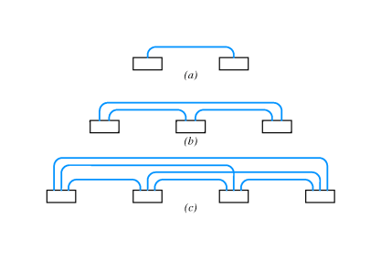
- For N computers:
Connections = | (n² - n)  2

Connections in a point-to-point network

- Connections between buildings can be prohibitive:
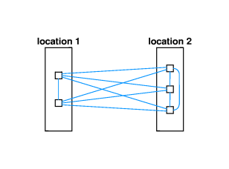
- Adding a new computer requires N - 1 new connections
Reducing the number of communication channels

- LANs developed in late 1960s and early 1970s
- Key idea - reduce number of connections by sharing connections among many computers
  - Computers take turns - TDM
  - Must include techniques for synchronizing use
Growth of LAN technologies

- LAN technologies reduce cost by reducing number of connections
- But ... attached computers compete for use of shared connection
- Local communication almost exclusively LAN
- Long distance almost exclusively point-to-point
  - SMDS
  - ATM
Locality of reference

- Principle of locality of reference helps predict computer communication patterns:
  - Spatial (or physical) locality of reference - computers likely to communicate with other computers that are located nearby
  - Temporal locality of reference - computers are likely to communicate with the same computers repeatedly
- Thus - LANs are effective because of spatial locality of reference, and temporal locality of reference may give insight into which computers should be on a LAN
LAN topologies

- Networks may be classified by shape
- Three most popular:
  - Star
  - Ring
  - Bus
Star topology

- All computers attach to a central point:
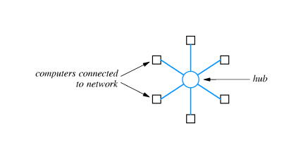
- Center of star is sometimes called a hub
Star topology in practice

- Previous diagram is idealized; usually, connecting cables run in parallel to computers:

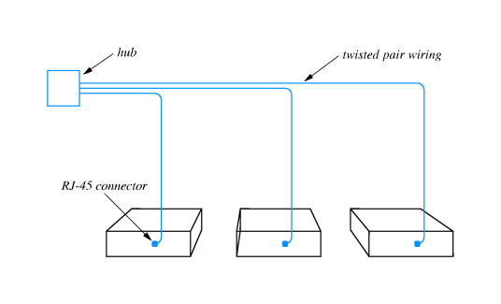

- Result is:

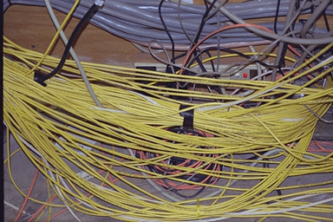

Ring topology

- Computers connected in a closed loop
- First passes data to second, second passes data to third, and so on
- In practice, there is a short connector cable from the computer to the ring
- Ring connections may run past offices with connector cable to socket in the office:
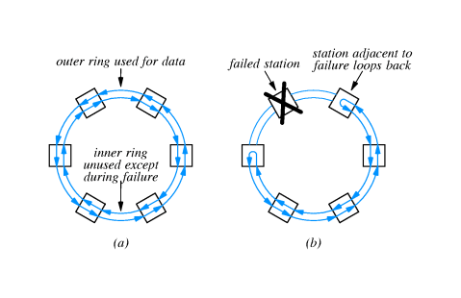

Bus topology

- Single cable connects all computers
- Each computer has connector to shared cable
- Computers must synchronize and allow only one computer to transmit at a time
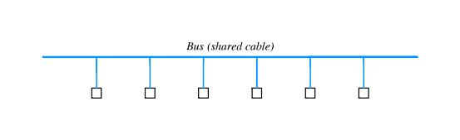
Why multiple topologies?

- Each has advantages and disadvantages:
  - Ring ease synchronization; may be disabled if any cable is cut
  - Star easier to manage and more robust; requires more cables
  - Bus requires fewer cables; may be disable if cable is cut
- Bucknell has used all three; now almost entirely star topology
- Industry is settling on star topology as most widely used
Ethernet

- Widely used LAN technology
  - Invented at Xerox PARC (Palo Alto Research Center) in 1970s
  - Defined in a standard by Xerox, Intel and Digital - DIX standard
  - Standard now managed by IEEE - defines formats, voltages, cable lengths, ...
- Uses bus topology
  - Single coax cable - the ether
  - Multiple computers connect
- One Ethernet cable is sometimes called a segment
  - Limited to 500 meters in length
  - Minimum separation between connections is 3 meters
Ethernet speeds

- Originally 3Mbps
- Current standard is 10Mbps
- Fast Ethernet operates at 100Mbps
Ethernet operation

- One computer transmits at a time
- Signal is a modulated carrier which propagates from transmitter in both directions along length of segment
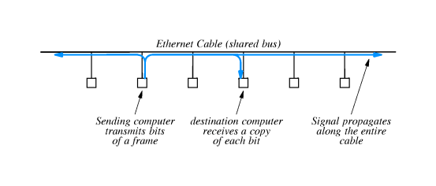
Ethernet example

http://www.eg.bucknell.edu/~cs363/lecture_notes/chap07/chap07_17.html

Shockwave

CSMA

- No central control managing when computers transmit on ether
- Ethernet employs CSMA to coordinate transmission among multiple attached computers
- Carrier Sense with Multiple Access
  - Multiple access - multiple computers are attached and any can be transmitter
  - Carrier sense - computer wanting to transmit tests ether for carrier before transmitting

CSMA example

http://www.eg.bucknell.edu/~cs363/lecture_notes/chap07/chap07_19.html

Shockwave

Collision detection - CD

- Even with CSMA, two computers may transmit simultaneously
  - Both check ether at same time, find it idle, and begin transmitting
  - Window for transmission depends on speed of propagation in ether
- Signals from two computers will interfere with each other
- Overlapping frames is called a collision
  - No harm to hardware
  - Data from both frames is garbled

Collision example

http://www.eg.bucknell.edu/~cs363/lecture_notes/chap07/chap07_21.html

Shockwave

Ethernet CD

- Ethernet interfaces include hardware to detect transmission
  - Monitor outgoing signal
  - Garbled signal is interpreted as a collision
- After collision is detected, computer stops transmitting
- So, Ethernet uses CSMA/CD to coordinate transmissions
Recovery from collision

- Computer that detects a collision sends special signal to force all other interfaces to detect collision
- Computer then waits for ether to be idle before transmitting
  - If both computers wait same length of time, frames will collide again
  - Standard specifies maximum delay, and both computers choose random delay less than maximum
- After waiting, computers use carrier sense to avoid subsequent collision
  - Computer with shorter delay will go first
  - Other computers may transmit first
Exponential back-off

- Even with random delays, collisions may occur
- Especially likely with busy segments
- Computers double delay with each subsequent collision
- Reduces likelihood of sequence of collisions
Wireless LAN

- Use radio signals at 900MHz
- Data rate of 2Mbps
- Shared medium - radio instead of coax
Limited connectivity with wireless

- In contrast with wired LAN, not all participants may be able to reach each other
  - Low signal strength
  - Propagation blocked by walls, etc.
- Can't depend on CD; not all participants may hear
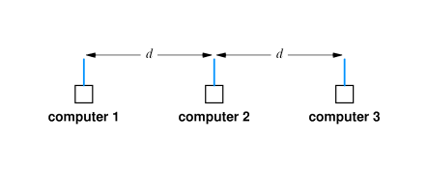
CSMA/CA

- Wireless uses collision avoidance rather than collision detection
  - Transmitting computer sends very short message to receiver
  - Receiver responds with short message reserving slot for transmitter
- Response from receiver is broadcast so all potential transmitters receive reservation
Collisions

- Receiver may receive simultaneous requests
  - Results in collision at receiver
  - Both requests are lost
  - Neither transmitter receives reservation; both use back-off and retry
- Receiver may receive closely spaced requests
  - Selects one
  - Selected transmitter sends message
  - Transmitter not selected uses back-off and retries
LocalTalk

- LAN technology that uses bus topology
- Interface included with all Macintosh computers
- Relatively low speed - 230.4Kbps
- Low cost (``free'' with a Macintosh); easy to install and connect
- Uses CSMA/CD
Token ring

- Many LAN technologies that use ring topology use token passing for synchronized access to the ring
- Ring itself is treated as a single, shared communication medium
- Bits pass from transmitter, past other computers and are copied by destination
- Hardware must be designed to pass token even if attached computer is powered down

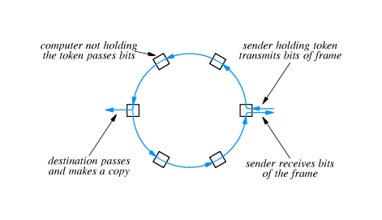

Transmission around a token ring

http://www.eg.bucknell.edu/~cs363/lecture_notes/chap07/chap07_31.html

Shockwave

Using the token

- When a computer wants to transmit, it waits for the token
- After transmission, computer transmits token on ring
- Next computer ready to transmit receives token and then transmits
http://www.eg.bucknell.edu/~cs363/lecture_notes/chap07/chap07_32.html

Shockwave

Token and synchronization

- Because there is only one token, only one computer will transmit at a time
  - Token is short, reserved frame that cannot appear in data
  - Hardware must regenerate token if lost
- Token gives computer permission to send one frame
  - If all ready to transmit, enforces ``round-robin'' access
  - If none ready to transmit, token circulates around ring
IBM token ring

- Very widely used
- Originally 4mbps, now 16Mbps
- Uses special connector cable between computer and ring interface
FDDI

- Fiber Distributed Data Interconnect (FDDI) is another ring technology
  - Uses fiber optics between stations
  - Transmits data at 100Mbps
- Uses pairs of fibers to form two concentric rings
FDDI and reliability

- FDDI uses counter-rotating rings in which data flows in opposite directions
- In case of fiber or station failure, remaining stations loop back and reroute data through spare ring
- All stations automatically configure loop back by monitoring data ring
ATM - Star network

- Asynchronous Transfer Mode technology consists of electronic packet switches to which computers can connect
- ATM switches form hub into which computers connect in a star topology
- Computers get point-to-point connections - data from transmitter is routed directly through hub switches to destination
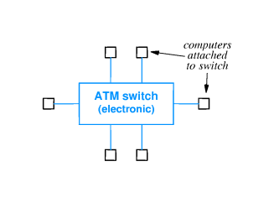
ATM details

- Transmits data at over 100Mbps
- Uses fiber optics to connect computer to switch
- Each connection includes two fibers
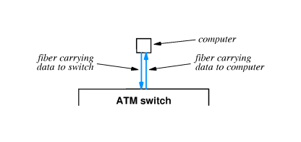

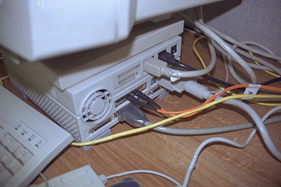

ATM switches

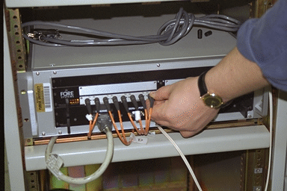

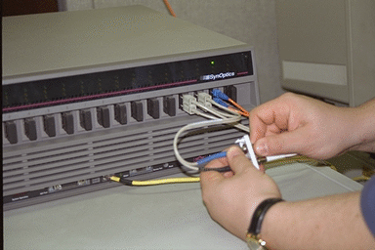

Summary

- LAN technologies use shared communication media to interconnect multiple computers over short distances
- Transmitting computer has exclusive use of communication medium; computers must synchronize transmission and share available capacity
- LAN topologies:
  - Star
  - Ring
  - Bus
- LAN technologies
  - Ethernet
  - Wireless
  - LocalTalk
  - IBM Token Ring
  - FDDI
  - ATM
Chapter 8 - Hardware Addressing and Frame Type Identification

Section | Title
1 | Introduction
2 | Specifying a destination
3 | Hardware addressing
4 | LAN hardware and packet filtering
5 | LAN hardware and packet filtering
6 | Format of hardware addresses
7 | Assigning hardware addresses
8 | Broadcasting
9 | Identifying packet contents
10 | Headers and frame formats
11 | Example frame format
12 | Ethernet fields
13 | Frames without type fields
14 | Encoding the data type
15 | IEEE 802.2 LLC
16 | Unknown types
17 | Network analyzers
18 | Operation of a network analyzer
19 | Filtering incoming frames
20 | Summary

Introduction

- Previous chapter on LAN technology described techniques for providing connectivity between computers
- Need to devise technique for delivering message through LAN medium to single, specific destination computer
- Sending computer uses a hardware address to identify the intended destination of a frame
- Sending computer also identifies type of data carried in the frame
Specifying a destination

- Data sent across a shared network reaches all attached stations - for all LAN topologies
- Interface hardware detects delivery of frame and extracts frame from medium
- But ... most applications want data to be delivered to one specific application on another computer - not all computers
Hardware addressing

- Most network technologies have a hardware addressing scheme that identifies stations on the network
- Each station is assigned a numeric hardware address or physical address
- Sender includes hardware address in each transmitted frame
- Only station identified in frame receives copy of frame
- Most LAN technologies include sender's hardware address in frame, too
LAN hardware and packet filtering

- A little detail about organization of LAN hardware and computer:

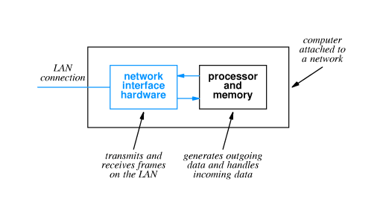
LAN hardware and packet filtering

- LAN interface handles all details of frame transmission and reception
  - Adds hardware addresses, error detection codes, etc. to outgoing frames
  - May use DMA to copy frame data directly from main memory
  - Obeys access rules (e.g., CSMA/CD) when transmitting
  - Checks error detection codes on incoming frames
  - May use DMA to copy data directly into main memory
  - Checks destination address on incoming frames
- If destination address on incoming frame matches the local station's address, a copy of the frame is passed to the attached computer
- Frames not addressed to the local computer are ignored and don't affect the local computer in any way
Format of hardware addresses

- Numeric value
- Size selected for specific network technology
- Length is one to six bytes
Assigning hardware addresses

- Hardware addresses must be unique on a LAN
- How can those addresses be assigned and who is responsible for uniqueness?
Static: | Hardware manufacturer assigns permanent address to each interface | Manufacturer must ensure every interface has a unique address
Dynamic: | Address can be set by end user, either through switches or jumpers on the interface or through software | System administrators must coordinate to avoid conflict
Automatic: | Interface automatically assigns hardware address each time it is powered up | Automatic scheme must be reliable to prevent conflicts
Broadcasting

- Some applications want to broadcast messages to all stations on the LAN
- Shared communication channel can make broadcast efficient - message is delivered to all stations
- Special broadcast address used to identify broadcast messages, which are captured by all stations
Identifying packet contents

- Destination must get some clue about how to interpret frame data
- Can use:
  - Explicit frame type - identifying value included with frame describes type of included data
  - Implicit frame type - receiver must infer type from frame data
Headers and frame formats

- LAN technology standards define frame format for each technology
- All contemporary standards use the following general format:

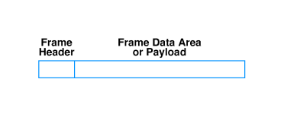

- Frame header has address and other identifying information
- Information typically in fields with fixed size and location
- Data area may vary in size
Example frame format

- Ethernet frame format:
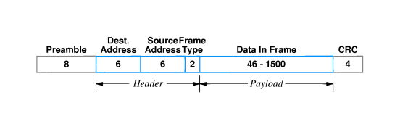
- Details:
Field | Purpose
Preamble | Receiver synchronization
Dest. addr. | Identifies intended receiver
Source addr. | Hardware address of sender
Frame type | Type of data carried in frame
Data | Frame payload
CRC | 32-bit CRC code
Ethernet fields

- Preamble and CRC often not shown
- Destination address of all 1s is the broadcast address
- Special values are reserved for frame type field:

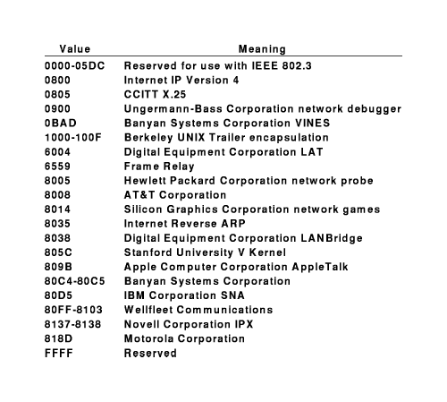
Frames without type fields

- Some LAN technologies do not include a type field
- Sender and receiver can agree on interpretation:
  - Agree on a single data format and use only that format
    - Limits LAN to one type of data
    - All computers on LAN must use one format
  - Agree to encode the data format in the first few bytes of the data field
Encoding the data type

- Illustration of using data area to encode data type:

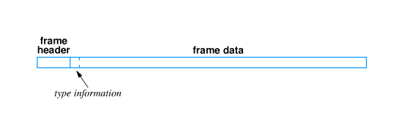
- To ensure interoperability, format of encoding area must be universally agreed upon
- Format typically set by standards body
IEEE 802.2 LLC

- IEEE 802.2 standard includes Logical Link Control (LLC) SubNetwork Attachment Point (SNAP) header
- SNAP/LLC format widely used; e.g., by Ethernet

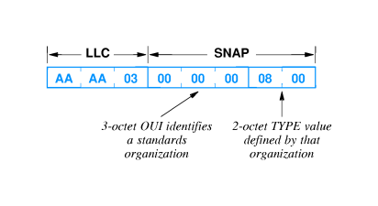

- LLC portion indicates SNAP field to follow
- OUI (Organizationally Unique Identifier) identifies Ethernet specification organization
- TYPE field interpreted as in Ethernet (in this case, IP)
Unknown types

- For either encoding format, some computers may not be prepared to accept frames of some types
  - Protocol type not installed
  - Newly defined type
- Receiving computer examines type field and discards any frames with unknown type
Network analyzers

- A network analyzer or network monitor or ``network sniffer'' is used to examine the performance of or debug a network
- Can report statistics such as capacity utilization, distribution of frame size, collision rate or token circulation time
- Can record and display specific frames, to understand and debug packet transmissions and exchanges
Operation of a network analyzer

- Basic idea is a computer with a network interface that receives all frames
- Sometimes called promiscuous mode
- Many desktop computers have interface that can be configured for promiscuous mode
  - Combined with software, computer can examine any frame on LAN
  - Communication across a LAN is not guaranteed to be private!
- Computer receives and displays (but does not respond to) frames on the LAN
Filtering incoming frames

- Analyzer can be configured to filter and process frames
  - Count frames of a specific type or size
  - Display only frames from or to specific computers
  - In general, can be configured to match value of any field and capture only those frames meeting the filter specification
- Analyzer can display real-time performance by computing running totals over specific time periods
Summary

- LAN technologies use hardware addresses to identify destination for frames sent across shared communication channel
- Each LAN technology defines its own hardware format
- Addresses may be statically assigned, configurable or automatically assigned
- Each station must have a unique address on the LAN segment
- Frames include a header with fields for destination, source and other information such as frame type
- Frame type defines how to interpret frame data
- Network analyzer can receive all frames and display statistics or aid in debugging problems
Chapter 9 - LAN Wiring, Physical Topology and Interface Hardware

Section | Title
1 | Introduction
2 | Speeds of LANs and computers
3 | Network interface hardware
4 | I/O interfaces
5 | Network connector
6 | NICs and network hardware
7 | NIC and CPU processing
8 | Connection between NIC and physical network
9 | Thick Ethernet wiring
10 | Thick Ethernet example
11 | Connection multiplexing
12 | Thin Ethernet wiring
13 | Thin Ethernet wiring (continued)
14 | Thin Ethernet wiring (continued)
15 | 10Base-T
16 | Hubs
17 | Protocol software and Ethernet wiring
18 | Comparison of wiring schemes
19 | Comparison of wiring schemes (continued)
20 | Topologies and network technologies
21 | Other technologies
22 | Technology translation
23 | Summary

Introduction

- Interface cards
  - Why a separate card
  - How to connect the interface to the computer
  - What is a ``transceiver''?
- LAN wiring schemes
- Logical and physical topology
Speeds of LANs and computers

- LAN data transmission speeds are typically ``fast'' relative to CPU speeds
- 100MHz CPU could execute only one instruction for each bit on a 100Mhz Ethernet
- LAN speeds are defined independent of any specific processor speeds
  - Allows for mix of attached systems
  - New computers can be attached without affecting LAN speeds
Network interface hardware

- CPU can't process data at network speeds
- Computer systems use special purpose hardware for network connection
  - Typically a separate card in the backplane
  - Network adapter card or network interface card (NIC)
- Connector at back of computer then accepts cable to physical network
I/O interfaces

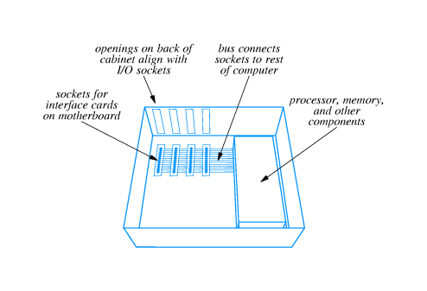
Network connector

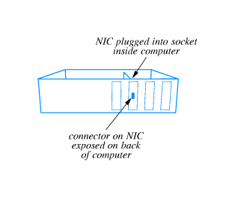
NICs and network hardware

- NIC is built for one kind of physical network
  - Ethernet interface can't be used with token ring
  - ATM interface can't be used with FDDI
- Some NICs can be used with different, similar hardware
  - Thick, thin and 10Base-T Ethernet
  - 10Mbps and 100Mbps Ethernet
NIC and CPU processing

- NIC contains sufficient hardware to process data independent of system CPU
  - Some NICs contain separate microprocessor
  - Includes analog circuitry, interface to system bus, buffering and processing
- Looks like any other I/O device to system CPU
  - System CPU forms message request
  - Sends instructions to NIC to transmit data
  - Receives interrupt on arrival of incoming data
Connection between NIC and physical network

- Two alternatives:
  - NIC contains all circuitry and connects directly to network medium
  - Cable from NIC connects to additional circuitry that then attaches to the network medium
- Thin Ethernet vs. 10Base-T
- Both are Ethernet; network technology not limited to one style of connection
Thick Ethernet wiring

- Uses thick coax cable
- AUI cable (or transceiver or drop cable connects from NIC to transceiver
- AUI cable carries digital signal from NIC to transceiver
- Transceiver generates analog signal on coax
- Wires in AUI cable carry digital signals, power and other control signals
Thick Ethernet example

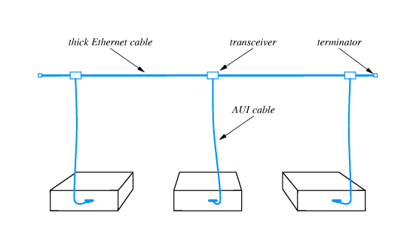

- Thick Ethernet also requires termination to avoid signal reflectance
Connection multiplexing

- In some circumstances, transceivers may be inconvenient; e.g., workstations in a lab
- Connection multiplexor connects multiple computers to a single transceiver
  - Each computer's AUI cable connects to connection multiplexor
  - One AUI from multiplexor to Ethernet coax
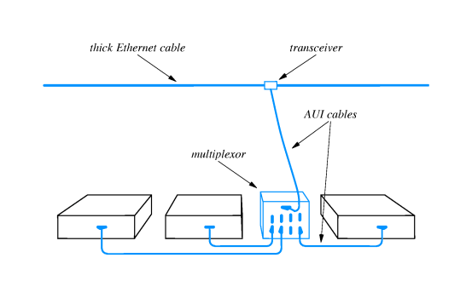

- Connection multiplexor completely invisible to attached computers
Thin Ethernet wiring

- Uses thin coax that is cheaper and easier to install than thick Ethernet coax
- Transceiver electronics built into NIC; NIC connects directly to network medium
- Coax cable uses BNC connector
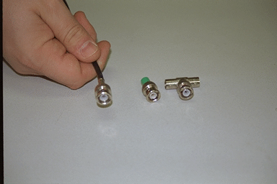
Thin Ethernet wiring (continued)

- Coax runs directly to back of each connected computer
- T connector attaches directly to NIC
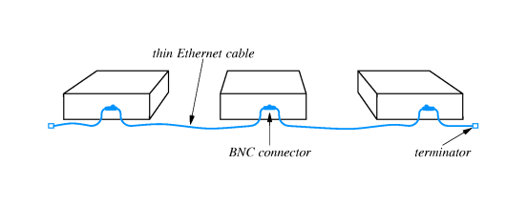

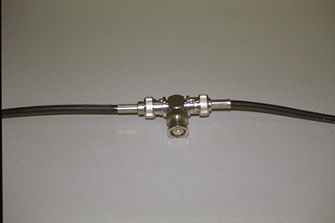

Thin Ethernet wiring (continued)

- Useful when many computers are located close to each other
- May be unreliable - any disconnection disrupts entire net
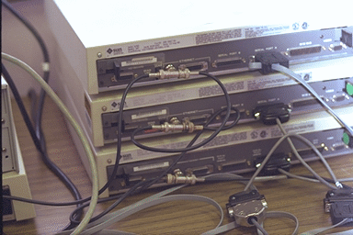

10Base-T

- Variously called 10Base-T, twisted pair or TP Ethernet
- Replaces AUI cable with twisted pair cable
- Replaces thick coax with hub

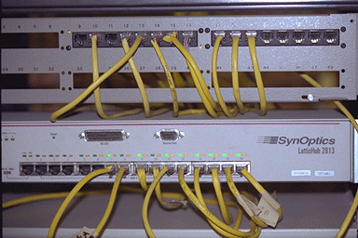

Hubs

- Extension of connection multiplexing concept
- Sometimes called ``Ethernet-in-a-box''
- Effectively a very short Ethernet with very long AUI cables
- Can be connected into larger Ethernets

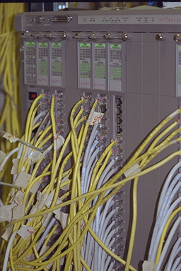

Protocol software and Ethernet wiring

- All wiring technologies use identical Ethernet specification
  - Same frame format
  - Same CSMA/CD algorithms
- Can mix different technologies in one Ethernet
- NICs can provide all three connection technologies
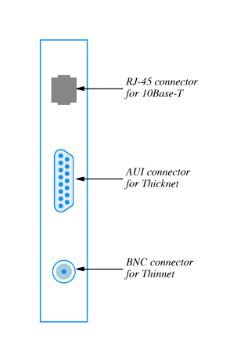
- Protocol software can't differentiate among wiring technologies
Comparison of wiring schemes

- Separate transceiver allows computer to be powered off or disconnected from network without disrupting other communication
- Transceiver may be located in an inconvenient place
- Finding malfunctioning transceiver can be hard
- Thin coax takes minimum of cable
- Disconnecting one computer (or one loose connection) can disrupt entire network
- Hub wiring centralizes electronics and connections, making management easier
- Bottom line - 10Base-T most popular because of cost
Comparison of wiring schemes (continued)

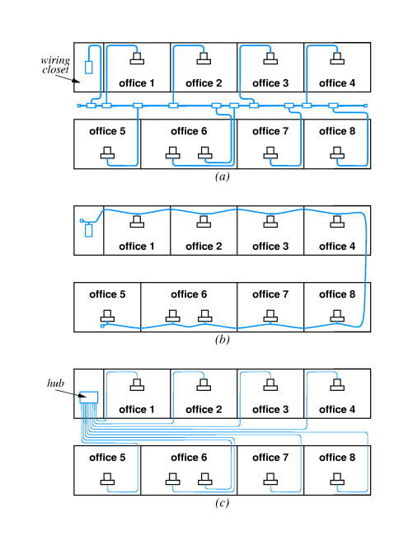
Topologies and network technologies

- 10Base-T network topology is a bus; wiring topology is a star
- Token ring network topology is a ring; wiring topology is a star
- Remember to distinguish between logical and physical topologies
Other technologies

- AppleTalk uses bus wiring with coax cable between transceivers
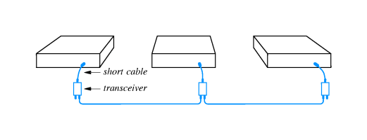
- AppleTalk can also use hub technology or spare wires in 4-wire phone cable
Technology translation

- Adapters can translate between some network technologies
  - Ethernet AUI-to-thinnet
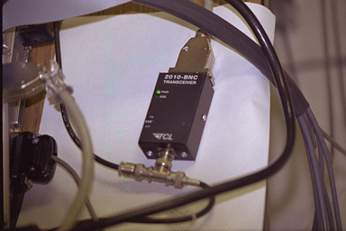
  - Ethernet AUI-to-10Base-T adapters

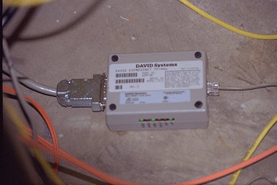

- AppleTalk to phone wire
Summary

- Network interface card (NIC) connects computer system to network
  - NIC operates independently; is fast enough to keep up with network
  - Typically uses interrupts to interact with CPU
- Many physical wiring schemes are available for logical network topology
- 10Base-T is a logical bus and a physical star
Chapter 10 Extending LANs: Fiber Modems, Repeaters, Bridges and Switches

Section | Title
1 | Introduction
2 | LAN design for distance
3 | LAN extensions
4 | Fiber optic extensions
5 | Repeaters
6 | Ethernet repeaters
7 | Limits on repeaters
8 | Repeater architecture
9 | Characteristics of repeaters
10 | Bridges
11 | Bridged LAN segments
12 | Characteristics of bridges
13 | Filtering bridges
14 | Frame filtering
15 | How does bridge set up table?
16 | Filtering example
17 | Startup behavior of filtering bridges
18 | Designing with filtering bridges
19 | Bridging between buildings
20 | Bridging across longer distances
21 | Bridges and cycles
22 | Cycles of bridges
23 | Eliminating broadcast cycles
24 | Switching
25 | Switches and hubs
26 | Summary

Introduction

- LAN technologies are designed with constraints of speed, distance and costs
- Typical LAN technology can span, at most, a few hundred meters
- How can a network be extended to cover longer distances; e.g., the Bucknell campus?
LAN design for distance

- Many LANs use shared medium - Ethernet, token ring
- Length of medium affects fair, shared access to medium
  - CSMA/CD - delay between frames, minimum frame length
  - Token passing - circulation time for token
- Length of medium affects strength of electrical signals and noise immunity
LAN extensions

- Several techniques extend diameter of LAN medium
- Most techniques use additional hardware
- LAN signals relayed between LAN segments
- Resulting mixed technology stays within original engineering constraints while spanning greater distance
Fiber optic extensions

- Can extend connection to a computer using fiber optic cable
- Insert fiber modems and fiber optic cable into AUI cable
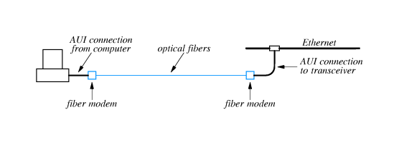
- Fiber modems:
  - Convert AUI signals to digital signal
  - Transmit digital signals via fiber optic cable to other modem
- Most often used to connect two LANs - typically through a bridge - different buildings
Repeaters

- May want to extend LAN medium
  - Ethernet - timing constraints allow longer medium
  - Signal strength constraints limit length
- Repeater - bidirectional, analog amplifier that retransmits analog signals
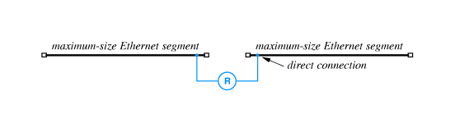
- One repeater can effectively double the length of an LAN segment
Ethernet repeaters

- Simply copy signals between segments
  - Do not understand frame formats
  - Do not have hardware addresses
- Any Ethernet segment is limited to 500 meters
- Repeater can double to 1,000 meters
Limits on repeaters

- Can't extend Ethernet with repeaters indefinitely
- CSMA/CD requires low delay; if medium is too long, CSMA/CD won't work
- Ethernet standard includes limit of 4 repeaters between any two Ethernet stations

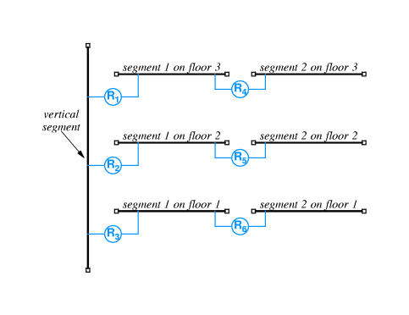
Repeater architecture

- With four repeaters, can extend Ethernet through a building
http://www.eg.bucknell.edu/~cs363/lecture_notes/chap10/chap10_8.html

Shockwave

- FOIRL - Fiber Optic Intra-Repeater Link - can be used to connect bridges
Characteristics of repeaters

- Very easy to use - just plug in
- Repeaters simply re-transmit analog signals
  - Collisions affect entire network
  - Transient problems - noise - propagates throughout network
Bridges

- Also connect two LAN segments
- Retransmits frames from one segment on other segment(s)
- Handles complete frame
  - Uses NIC like any other station
  - Performs some processing on frame
- Invisible to other attached computers
Bridged LAN segments

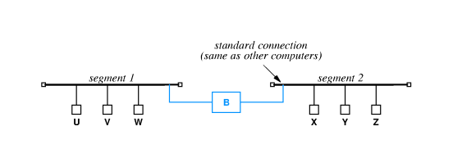
Characteristics of bridges

- Relatively easy to use - just plug in
- Isolate collisions, noise
http://www.eg.bucknell.edu/~cs363/lecture_notes/chap10/chap10_12.html

Shockwave
Filtering bridges

- Bridges can do additional processing
  - Don't forward collisions, noise
  - Only forward frames where necessary
- Bridge performs frame filtering and forwards frames along LAN segments to destination
  - Learns location of stations by watching frames
  - Forwards all broadcast and multicast packets
Frame filtering

- Bridge checks destination of each incoming frame
- Looks up destination in list of known stations
  - Forwards frame to next interface on path to destination
  - Doesn't forward frame if destination on LAN segment from which frame was received
How does bridge set up table?

- Bridge examines source address in each frame
- Adds entry to list for LAN segment from which frame was received
- Must forward any frame whose destination is not in the list on every interface
Filtering example

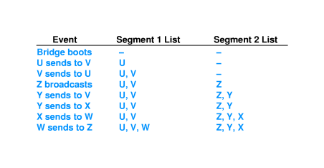
Startup behavior of filtering bridges

- Initially, the forwarding tables in all bridges are empty
- First frame from each station on LAN is forwarded to all LAN segments
- After all stations have been identified, frames are only forwarded as needed
- May result in burst of traffic after, e.g., power failure
Designing with filtering bridges

- Filtering bridge allows concurrent use of different LAN segments if traffic is local
- U and V can exchange frames at the same time X and Y exchange frames
- Designers identify patterns of local communication and isolate groups of communicating computers with bridges
Bridging between buildings

- Similar to extending AUI with fiber modems
- Can put bridge in one building with long connection to LAN segment in different building
- Avoids extended AUI connection for each computer in remote building
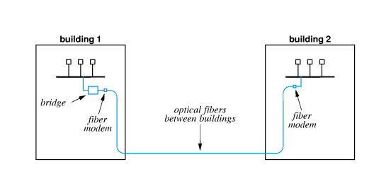

Bridging across longer distances

- Can use leased line, microwave, laser or satellite to connect two bridges and LAN segments

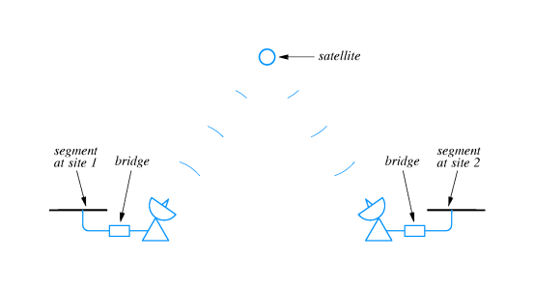
- Using two bridges instead of one:
  - Filters at both ends, reducing traffic across slow link
  - Provides buffering at both ends, matching dissimilar transmission speeds
Bridges and cycles

- Can use multiple bridges to interconnect many LAN segments
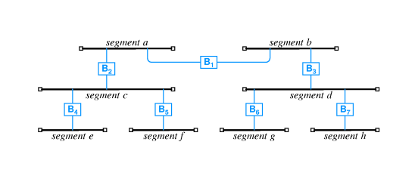
- Station of segment c sends frames to station on segment g through B₂, B₁, B₃ and B₆
- Broadcasts are forwarded through all bridges
- Suppose another bridge connects g and f?
Cycles of bridges

- A circular path through bridged networks is called a cycle
- Adding B₄ creates a cycle
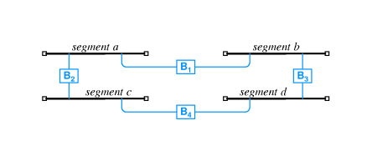
Eliminating broadcast cycles

- Bridges must cooperate to broadcast frames exactly once on each segment
- Solution from graph theory - spanning tree - used to determine which bridges will forward broadcasts
- As each bridge joins the network, it communicates with other bridges on special hardware (typically multicast) address
  - Learns network topology
  - Performs spanning tree computation
  - Determines if bridge will form a cycle
Switching

- Effectively a separate LAN segment for each port
- Similar to hub - hub shares single segment among all ports
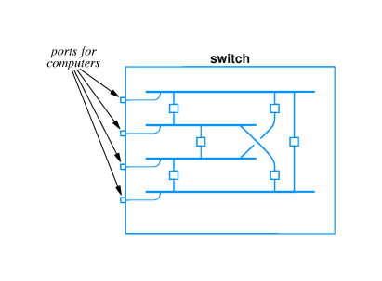

- With switching, multiple stations can transmit simultaneously
- Provides much higher aggregate bandwidth
Switches and hubs

- Switches are more expensive per port
- May make more sense economically to use hubs for some stations and switches for others
Summary

- Optical fiber and modems can be used to extend AUI for single station
- Repeater acts as amplifier and retransmits analog signals
- Bridge accepts entire incoming frame and retransmits
  - Doesn't forward collisions
  - Avoids collisions on destination segments
- Filtering bridge forwards frames only as needed
  - Allows simultaneous use of LAN segments for local transmission
  - Forwards all broadcast and multicast packets
- Switches provide full LAN speed to each port by simulating separate LAN segments
Chapter 11 Long-Distance Digital Connection Technologies

Section | Title
1 | Introduction
2 | Digital telephony
3 | Digitizing voice
4 | Example
5 | Sampling parameters
6 | Synchronous communication
7 | Using digital telephony for data delivery
8 | Conversion for digital circuits
9 | Using DSU/CSU
10 | Telephone standards
11 | Intermediate capacity
12 | Higher capacity circuits
13 | About the terminology
14 | SONET
15 | Getting to your home
16 | ISDN
17 | DSL
18 | ADSL technology
19 | Adaptive transmission
20 | Other DSL technologies
21 | Cable modem technologies
22 | Features of cable modems
23 | Upstream communication
24 | Alternatives
25 | Summary

Introduction

- Previous technologies cover "short" distances
- Can extend over short distances
- Need to cover longer distances - e.g., Bucknell to New York
- Will call this technology WAN - Wide Area Network
- Two categories:
  - Long distance between networks
  - "Local loop"
Digital telephony

- Telephone system spans long distances
- Digital telephony improved long distance service:
  - Better quality
  - More connections in wire
Digitizing voice

- Problem: encode analog audio signal as digital data
- Solution:
  - Sample audio signal at periodic intervals
  - Convert to digital using A-to-D converter
  - Send data over wire
  - Reconvert to audio using D-to-A converter
Example

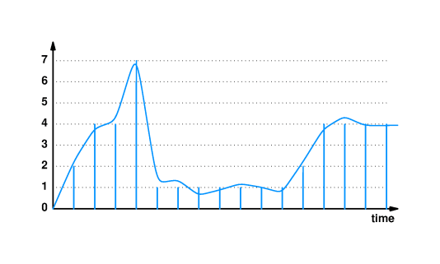
Sampling parameters

- Want to carry signals up to 4000Hz
- Select sample rate of 8000Hz
- Each sample is in range 0-255 (8 bits)
- Standard called Pulse Code Modulation (PCS
Synchronous communication

- Converting back to audio requires data be available "on time"
- Digital telephony systems use clocking for synchronous data delivery
- Samples not delayed as traffic increases
Using digital telephony for data delivery

- So, digital telephony can handle synchronous data delivery
- Can we use that for data delivery?
- Ethernet frame != 8-bit PCM synchronous
- Need to convert formats...
Conversion for digital circuits

- To use digital telephony for data delivery:
  - Lease point-to-point digital circuit between sites
  - Convert between local and PCM formats at each end
- Use a Data Service Unit/Channel Service Unit (DSU/CSU) at each end
  - CSU - manages control functions
  - DSU - converts data
Using DSU/CSU

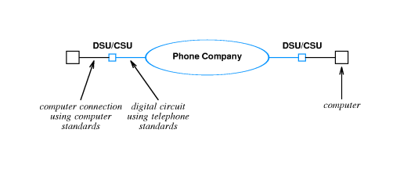
Telephone standards

- Several standards exist for data transmission rates
- Called T-series standards
Name | Bit Rate | Voice Circuits
- | 0.064 Mbps | 1
T1 | 1.544 Mbps | 24
T2 | 6.312 Mbps | 96
T3 | 44.736 Mbps | 672

Intermediate capacity

- Price does not go up linearly with speed
- $$ for T3 < $$ for 28 * T1
...however, if all you need is 9 Mbps, $$ for T3 > $$ for 6 * T1
- Solution: combine multiple T1 lines with inverse multiplexor
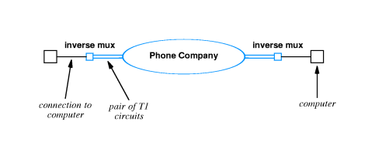
Higher capacity circuits

Standard name | Optical name | Bit rate | Voice circuits
STS-1 | OC-1 | 51.840 Mbps | 810
STS-3 | OC-3 | 155.520 Mbps | 2,430
STS-12 | OC-12 | 622.080 Mbps | 9,720
STS-24 | OC-24 | 1,244.160 Mbps | 19,440
STS-48 | OC-48 | 2,488.320 Mbps | 38,880

About the terminology

- T-standards define underlying bit rate, Digital Signal Level standards (DS standards) define:
  - how to multiplex calls
  - effective bit rates
  - T1 line transmit data at DS-1 rate
- Synchronous Transport Signal (STS) standards define high speed connections over copper, Optical Carrier (OC) standard are for fiber
- C suffix indicates concatenated:
  - OC-3 == three OC-1 circuits at 51.84 Mbps
  - OC-3C == one 155.52 Mbps circuit
SONET

- Synchronous Optical Network (SONET) defines how to use high-speed connections
  - Framing: STS-1 uses 810 bytes per frame
  - Encoding: Each sample travels as one octet in payload

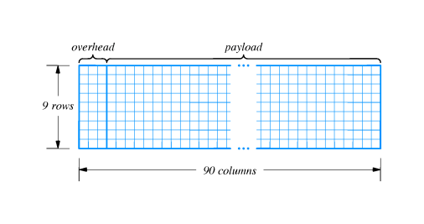
Getting to your home

- Local loop describes connection from telephone office to your home
- Sometimes called POTS (Plain Old Telephone Service)
- Legacy infrastructure is copper
- Other available connections include cable TV, wireless, electric power
ISDN

- Provides digital service (like T-series) on existing local loop copper
- Three separate circuits, or channels
  - Two B channels, 64 Kbps each; == 2 voice circuits
  - One D channel, 16 Kbps; control
- Often written as 2B+D; called Basic Rate Interface (BRI)
- Slow to catch on
  - Expensive
  - Charged by time used
  - (Almost) equaled by analog modems
DSL

- DSL (Digital Subscriber Line) is a family of technologies
  - Sometimes called xDSL
  - Provides high-speed digital service over existing local loop
- One common form is ADSL (Asymmetric DSL)
  - Higher speed into home than out of home
  - More bits flow in ("downstream") than out ("upstream")
- ADSL maximum speeds:
  - 6.144 Mbps downstream
  - 640 Kbps upstream
ADSL technology

- Uses existing local loop copper
- Takes advantage of higher frequencies on most local loops
- Can be used simultaneously for POTS

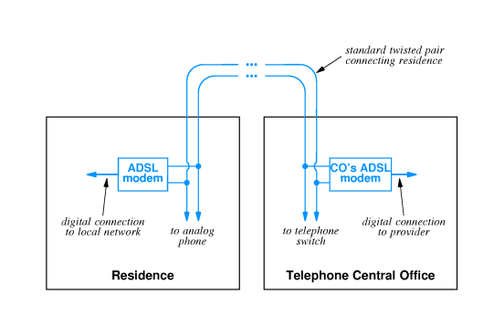
Adaptive transmission

- Individual local loops have different transmission characteristics
  - Different maximum frequencies
  - Different interference frequencies
- ADSL uses FDM
  - 286 frequencies
    - 255 downstream
    - 31 upstream
    - 2 control
- Each frequency carries data independently
  - All frequencies out of audio range
  - Bit rate adapts to quality in each frequency
Other DSL technologies

- SDSL (Symmetric DSL) provides divides frequencies evenly
- HDSL (High-rate DSL) provides DS1 bit rate both directions
  - Short distances
  - Four wires
- VDSL(Very high bit rate DSL) provides up to 52 Mbps
  - Very short distance
  - Requires Optical Network Unit (ONU) as a relay
Cable modem technologies

- Cable TV already brings high bandwidth coax into your house
- Cable modems encode and decode data from cable TV coax
  - One in cable TV center connects to network
  - One in home connects to computer
Features of cable modems

- Bandwidth multiplexed among all users
- Multiple access medium; your neighbor can see your data!
- Not all cable TV coax plants are bi-directional
Upstream communication

- Cable TV is one direction
  - Signal broadcast at central location
  - Amplifiers boost signal through network
- Amplifiers are unidirectional!
- Solutions:
  - Retrofit bi-directional amplifiers
  - Alternate upstream path - e.g., dialup
Alternatives

- Satellite
- "Fiber to the curb'
Summary

- WAN links between sites use digital telephony
  - Based on digitized voice service
  - Several standard rates
  - Requires conversion vis DSU/CSU
- Local loop technologies
  - ISDN
  - xDSL
  - Cable modem
  - Satellite
  - Fiber to the curb

Chapter 12 - WAN Technologies and Routing

Section | Title
1 | Introduction
2 | Characterizations of networks
3 | Differences between LAN and WAN
4 | Packet switches
5 | Connections to packet switches
6 | Packet switches as building blocks
7 | Store and forward
8 | Store and forward example
9 | Physical addressing in a WAN
10 | Next-hop forwarding
11 | Choosing next hop
12 | Source independence
13 | Hierarchical address and routing
14 | WAN architecture and capacity
15 | Routing in a WAN
16 | Modeling a WAN
17 | Route computation with a graph
18 | Redundant routing information
19 | Default routes
20 | Building routing tables
21 | Computation of shortest path in a graph
22 | Weighted graph
23 | Synopsis of Djikstra's algorithm
24 | Distance metrics
25 | Dynamic route computation
26 | Distributed route computation
27 | Vector-distance algorithm
28 | Vector-distance algorithm (continued)
29 | Link-state routing
30 | Comparison
31 | Examples of WAN technology
32 | Summary
Introduction

- LANs can be extended using techniques in previous chapter
- Can not be extended arbitrarily far or to handle arbitrarily many computers
  - Distance limitations even with extensions
  - Broadcast a problem
- Need other technologies for larger networks
Characterizations of networks

- Local Area Network (WAN) - single building
- Metropolitan Area Network (MAN) - single city
- Wide Area network (WAN) - country, continent, planet
Differences between LAN and WAN

- Satellite bridge can extend LAN across large distances
- Still cannot accommodate arbitrarily many computers
- WAN must be scalable to long distances and many computers
Packet switches

- To span long distances or many computers, network must replace shared medium with packet switches
  - Each switch moves an entire packet from one connection to another
  - A small computer with network interfaces, memory and program dedicated to packet switching function
Connections to packet switches

- Packets switches may connect to computers and to other packet switches
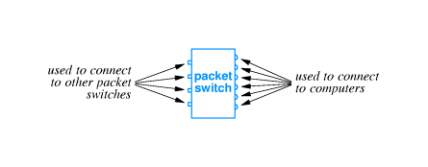
- Typically high speed connections to other packets switches, lower speed to computers
- Technology details depend on desired speed
Packet switches as building blocks

- Packet switches can be linked together to form WANs
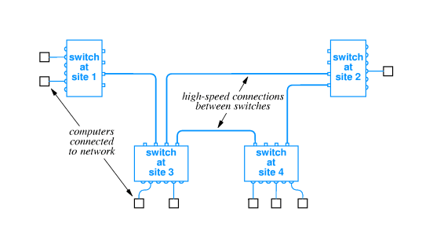
- WANs need not be symmetric or have regular connections
- Each switch may connect to one or more other switches and one or more computers
Store and forward

- Data delivery from one computer to another is accomplished through store-and-forward technology
  - Packet switch stores incoming packet
  - ... and forwards the packet to another switch or computer
- Packet switch has internal memory
  - Can hold packet if outgoing connection is busy
  - Packets for each connection held on queue
Store and forward example

http://www.eg.bucknell.edu/~cs363/lecture_notes/chap12/chap12_8.html
Shockwave
Physical addressing in a WAN

- Similar to LAN
  - Data transmitted in packets (equivalent to frames)
  - Each packet has format with header
  - Packet header includes destination and source addresses
- Many WANs use hierarchical addressing for efficiency
  - One part of address identifies destination switch
  - Other part of address identifies port on switch
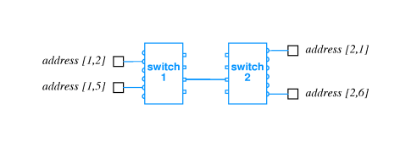
Next-hop forwarding

- Packet switch must choose outgoing connection for forwarding
  - If destination is local computer, packet switch delivers computer port
  - If destination is attached another switch, this packet switch forwards to next hop through connection to another switch
- Choice based on destination address in packet
Choosing next hop

- Packet switch doesn't keep complete information about all possible destination
- Just keeps next hop
- So, for each packet, packet switch looks up destination in table and forwards through connection to next hop
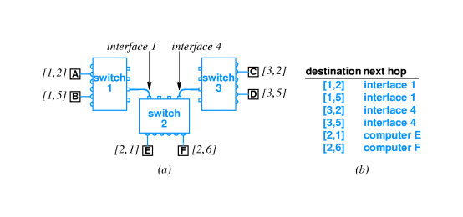
Source independence

- Next hop to destination does not depend on source of packet
- Called source independence
- Allows fast, efficient routing
- Packet switch need not have complete information, just next hop
  - Reduces total information
  - Increases dynamic robustness - network can continue to function even if topology changes without notifying entire network
Hierarchical address and routing

- Process of forwarding is called routing
- Information is kept in routing table
- Note that many entries have same next hop

- In particular, all destinations on same switch have same next hop
- Thus, routing table can be collapsed:

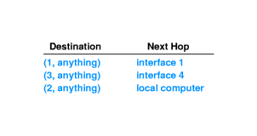
WAN architecture and capacity

- More computers == more traffic
- Can add capacity to WAN by adding more links and packet switches
- Packet switches need not have computers attached
- Interior switch - no attached computers
- Exterior switch - attached computers
Routing in a WAN

- Both interior and exterior switches:
  - Forward packets
  - Need routing tables
- Must have:
  - Universal routing - next hop for each possible destination
  - Optimal routes - next hop in table must be on shortest path to destination
Modeling a WAN

- Use a graph:
  - Nodes model switches
  - Edges model direct connections between switches
- Captures essence of network, ignoring attached computers
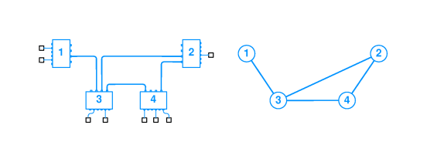
Route computation with a graph

- Can represent routing table with edges:
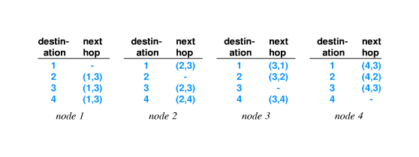

- Graph algorithms can be applied to find routes
Redundant routing information

- Notice duplication of information in routing table for node 1:

- Switch 1 has only one outgoing connection; all traffic must traverse that connection
- Extrapolate to Bucknell and Internet
Default routes

- Can collapse routing table entries with a default route
- If destination does not have an explicit routing table entry, use use the default route:
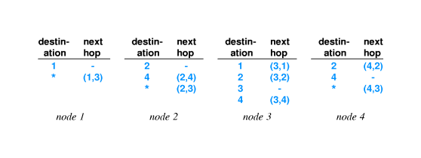

- Use of default route is optional (see node 3)
- Extrapolate to Bucknell
Building routing tables

- How to enter information into routing tables:
  - Manual entry - initialization file
  - Dynamically - through runtime interface
- How to compute routing table information:
  - Static routing - at boot time
  - Dynamic routing - allow automatic updates by a program
- Static is simpler; doesn't accommodate changes to network topology
- Dynamic requires additional protocol(s); can work around network failures
Computation of shortest path in a graph

- Assume graph representation of network at each node
- Use Djikstra's algorithm to compute shortest path from each node to every other node
- Extract next-hop information from resulting path information
- Insert next-hop information into routing tables
Weighted graph

- Djikstra's algorithm can accommodate weights on edges in graph
- Shortest path is then the path with lowest total weight (sum of weights of all edges)
- Shortest path not necessarily fewest edges (or hops)
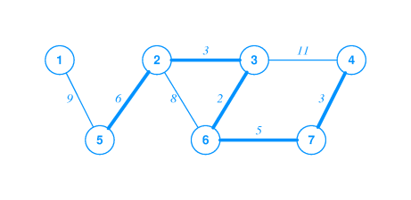
Synopsis of Djikstra's algorithm

- Keep data structure with list of nodes and weights of paths to those nodes
- Use infinity to represent a node in the set S of nodes for which a path has not yet been computed
- At each iteration, find a node in S, compute the path to that node, and delete the node from S
Synopsis of Djikstra's algorithm

- Keep data structure with list of nodes and weights of paths to those nodes
- Use infinity to represent a node in the set S of nodes for which a path has not yet been computed
- At each iteration, find a node in S, compute the path to that node, and delete the node from S
Distance metrics

- Weights on graph edges reflect "cost" of traversing edge
  - Time
  - Dollars
  - Hop count (weight == 1)
- Resulting shortest path may not have fewest hops

Dynamic route computation

- Network topology may change dynamically
  - Switches may be added
  - Connections may fail
  - Costs for connections may change
- Switches must update routing tables based on topology changes
Distributed route computation

- Pass information about network topology between nodes
- Update information periodically
- Each node recomputes shortest paths and next hops
- Inject changes into routing tables
Vector-distance algorithm

- Local information is next-hop routing table and distance from each switch
- Switches periodically broadcast topology information
- Other switches update routing table based on received information
Vector-distance algorithm (continued)

- In more detail:
- Wait for next update message
- Iterate through entries in message
- If entry has shorter path to destination:

- Insert source as next hop to destination
- Record distance as distance from next hop to destination PLUS
- Distance from this switch to next hop

Link-state routing

- Separates network topology from route computation
- Switches send link-state information about local connections
- Each switch builds own routing tables
  - Uses link-state information to update global topology
  - Runs Djikstra's algorithm
Comparison

- Vector-distance algorithm
  - Very simple to implement
  - May have convergence problems
  - Used in RIP
- Link-state algorithm
  - Much more complex
  - Switches perform independent computations
  - Used in OSPF
Examples of WAN technology

- ARPANET
  - Began in 1960s
  - Funded by Advanced Research Projects Agency, an organization of the US Defense Department
  - Incubator for many of current ideas, algorithms and internet technologies
  - See Where Wizards Stay Up Late
- X.25
  - Early standard for connection-oriented networking
  - From ITU, which was originally CCITT
  - Predates computer connections, used for terminal/timesharing connection
- Frame Relay
  - Telco service for delivering blocks of data
  - Connection-based service; must contract with telco for circuit between two endpoints
  - Typically 56Kbps or 1.5Mbps; can run to 100Mbps
- SMDS - Switched Multi-megabit Data Service
  - Also a Telco service
  - Connectionless service; any SMDS station can send a frame to any other station on the same SMDS "cloud"
  - Typically 1.5-100Mbps
- ATM - Asynchronous Transfer Mode
  - Designed as single technology for voice, video, data, ...
  - Low jitter (variance in delivery time) and high capacity
  - Uses fixed size, small cells - 48 octets data, 5 octets header
  - Can connect multiple ATM switches into a network
Summary

- WAN can span arbitrary distances and interconnect arbitrarily many computers
- Uses packet switches and point-to-point connections
- Packets switches use store-and-forward and routing tables to deliver packets to destination
- WANs use hierarchical addressing
- Graph algorithms can be used to compute routing tables
- Many LAN technologies exist
Chapter 14 - Protocols and Layering

Section | Title
1 | Introduction
2 | Why network software?
3 | Why protocols?
4 | One or many protocols?
5 | Protocol suites
6 | Layered protocol design
7 | The ISO 7-layer reference model
8 | The layers in the ISO model
9 | Layered software implementation
10 | Layered software and stacks
11 | Layering principle
12 | Messages and protocol stacks
13 | Commercial stacks
14 | Protocol headers
15 | Control packets
16 | Techniques for reliable network communication
17 | Out-of-order delivery
18 | Duplicate delivery
19 | Lost packets
20 | Retransmission
21 | Replay
22 | Flow control
23 | Stop-and-go flow control
24 | Sliding window
25 | Example of sliding window
26 | Comparison of stop-and-go and sliding window
27 | Transmission times
28 | Network congestion
29 | Aoviding and recovering from network congestion
30 | Art, engineering and protocol design
31 | Summary

Introduction

- LAN/WAN hardware can't solve all computer communication problems
- Software for LAN and WAN systems is large and complicated
- Layering is a structuring technique to organize networking software design and implementation
Why network software?

- Sending data through raw hardware is awkward and inconvenient - doesn't match programming paradigms well
- Equivalent to accessing files by making calls to disk controller to position read/write head and accessing individual sectors
- May not be able to send data to every destination of interest without other assistance
- Network software provides high-level interface to applications
Why protocols?

- Name is derived from the Greek protokollen, the index to a scroll
- Diplomats use rules, called protocols, as guides to formal interactions
- A network protocol or computer communication protocol is a set of rules that specify the format and meaning of messages exchanged between computers across a network
  - Format is sometimes called syntax
  - Meaning is sometimes called semantics
- Protocols are implemented by protocol software
One or many protocols?

- Computer communication across a network is a very hard problem
- Complexity requires multiple protocols, each of which manages a part of the problem
- May be simple or complex; must all work together
Protocol suites

- A set of related protocols that are designed for compatibility is called a protocol suite
- Protocol suite designers:
  - Analyze communication problem
  - Divide problems into subproblems
  - Design a protocol for each subproblem
- A well-designed protocol suite
  - Is efficient and effective - solves the problem without redundancy and makes best use of network capacity
  - Allows replacement of individual protocols without changes to other protocols
Layered protocol design

- Layering model is a solution to the problem of complexity in network protocols
- Model suggests dividing the network protocol into layers, each of which solves part of the network communication problem
- These layers have several constraints, which ease the design problem
- Network protocol designed to have a protocol or protocols for each layer
The ISO 7-layer reference model

- International Organization for Standards (ISO) defined a 7-layer reference model as a guide to the design of a network protocol suite

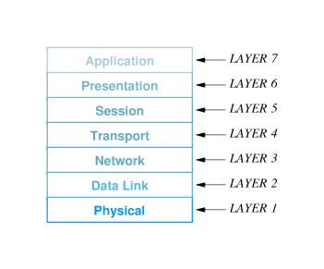

- Layers are named and numbered; reference to ``layer n'' often means the n^{th} layer of the ISO 7-layer reference model
The layers in the ISO model

- Caveat - many modern protocols do not exactly fit the ISO model, and the ISO protocol suite is mostly of historic interest
- Concepts are still largely useful and terminology persists
Layer 7: Application
Application-specific protocols such as FTP and SMTP (electronic mail)
Layer 6: Presentation
Common formats for representation of data
Layer 5: Session
Management of sessions such as login to a remote computer
Layer 4: Transport
Reliable delivery of data between computers
Layer 3: Network
Address assignment and data delivery across a physical network
Layer 2: Data Link
Format of data in frames and delivery of frames through network interface
Layer 1: Physical
Basic network hardware - such as RS-232 or Ethernet
Layered software implementation

- Software implemented from layered design has layered organization
- Software modules can be viewed as:

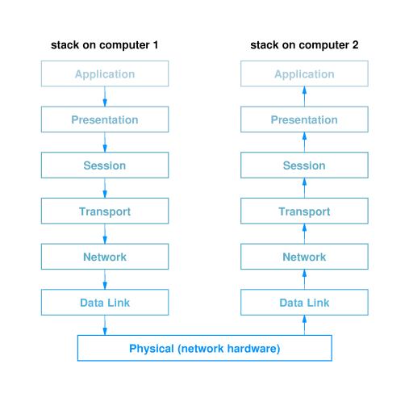
Layered software and stacks

- Related modules from previous figure are called a protocol stack or simply a stack
- Two constraints:
  - The software for each layer depends only on the services of the software provided by lower layers
  - The software at layer n at the destination receives exactly the same protocol message sent by layer n at the sender
- These constraints mean that protocols can be tested independently and can be replaced within a protocol stack
Layering principle

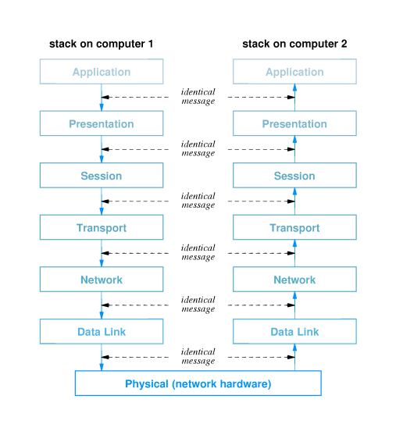
Messages and protocol stacks

- On the sender, each layer:
  - Accepts an outgoing message from the layer above
  - Adds a header and other processing
  - Passes resulting message to next lower layer
- On the receiver, each layer:
  - Receives an incoming message from the layer below
  - Removes the header for that layer and performs other processing
  - Passes the resulting message to the next higher layer
Commercial stacks

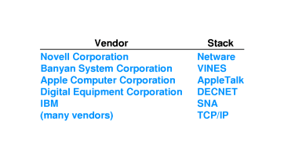
Protocol headers

- The software at each layer communicates with the corresponding layer through information stored in headers
- Each layer adds its header to the front of the message from the next higher layer
- Headers are nested at the front of the message as the message traverses the network

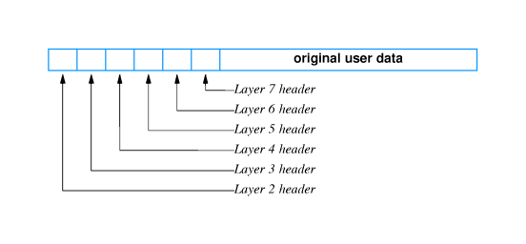
Control packets

- Protocol layers often need to communicate directly without exchanging data
  - Acknowledge incoming data
  - Request next data packet
- Layers use control packets
  - Generated by layer n on sender
  - Interpreted by layer n on receiver
  - Transmitted like any other packet by layers n-1 and below
Techniques for reliable network communication

- Model - reliable delivery of a block of data from one computer to another
  - Data values unchanged
  - Data in order
  - No missing data
  - No duplicated data
- Example - parity bit, checksum and CRC used to ensure data is unchanged
Out-of-order delivery

- Packets may be delivered out of order - especially in systems that include multiple networks
- Out of order delivery can be detected and corrected through sequencing
  - Sender attaches sequence number to each outgoing packet
  - Received uses sequence numbers to put packets in order and detect missing packets
Duplicate delivery

- Packets may be duplicated during transmission
- Sequencing can be used to...
  - Detect duplicate packets with duplicated sequence numbers
  - Discard those duplicate packets
Lost packets

- Perhaps the most widespread problem is lost packets
- Any error - bit error, incorrect length - causes receiver to discard packet
- Tough problem to solve - how does the receiver decide when a packet has been lost?
Retransmission

- Protocols use positive acknowledgment with retransmission to detect and correct lost packets
  - Receiver sends short message acknowledging receipt of packets
  - Sender infers lost packets from missing acknowledgments
  - Sender retransmits lost packets
- Sender sets timer for each outgoing packet
  - Saves copy of packet
  - If timer expires before acknowledgment is received, sender can retransmit saved copy
- Protocols define upper bound on retransmission to detect unrecoverable network failure
Replay

- Sufficiently delayed packets may be inserted into later sessions
- Suppose two computers exchange data with packets numbered 1 to 5
- Packet 4 encounters an extraordinary delay; computers use retransmission to deliver valid copy of packet 4
- Two computers exchange data later on with packets numbered 1 to 10
- Initial `packet 4' can arrive during second session, so that the data from that old packet (rather than the current `packet 4' is inserted into the data
- Protocols attach session number to each packet in a protocol session to differentiate packets from different sessions
Flow control

- Data overrun can occur when sender transmits data faster than receiver can process incoming data
- Protocols use flow control mechanisms through which receiver can control rate of data transmission
  - Stop-and-go
  - Sliding window
Stop-and-go flow control

- Receiver sends small control packet when it is ready for next packet
- Sender waits for control packet before sending next packet
- Can be very inefficient of network bandwidth if delivery time is large
Sliding window

- Allows sender to transmit multiple packets before receiving an acknowledgment
- Number of packets that can be sent is defined by the protocol and called the window
- As acknowledgments arrive from the receiver, the window is moved along the data packets; hence ``sliding window''
Example of sliding window

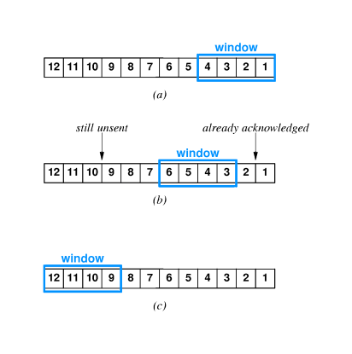
Comparison of stop-and-go and sliding window

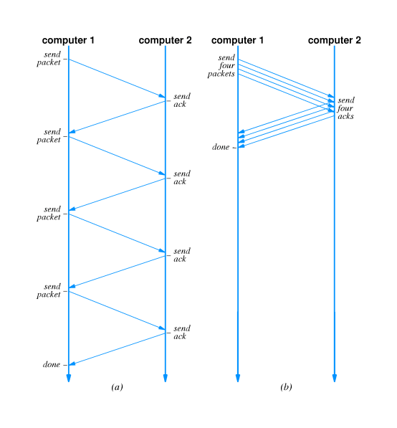
Transmission times

- For stop-and-go, each packet takes 2L time to deliver (where L is the latency, or network delivery time)
- Sliding window can improve by number of packets in window:
T_{w} = T_{g} * W
(T_{w} is sliding window throughput, T_{g} is stop-and-go throughput
- Transmission time also limited by network transmission rate:
T_{w} = min(B, T_{g} * W)
(B is maximum network bandwidth)

Network congestion

- Network congestion arises in network systems that include multiple links
- If input to some link exceeds maximum bandwidth, packets will queue up at connection to that link
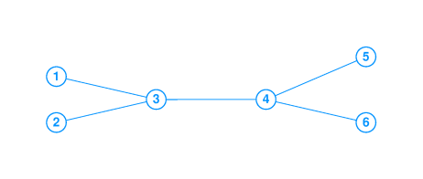
- Eventually, packets will be discarded and packets will be retransmitted
- Ultimately, network will experience congestion collapse
- Problem related to, but not identical to, data overrun
Avoiding and recovering from network congestion

- Protocols attempt to avoid congestion and recover from network collapse by monitoring the state of the network and taking appropriate action
- Can use two techniques:
  - Notification from packet switches
  - Infer congestion from packet loss
- Packet loss can be used to detect congestion because modern networks are reliable and rarely lose packets through hardware failure
- Sender can infer congestion from packet loss through missing acknowledgments
- Rate or percentage of lost packets can be used to gauge degree of congestion
Art, engineering and protocol design

- Protocol design mixes engineering and art
  - There are well-known techniques for solving specific problems
  - Those techniques interact in subtle ways
  - Resulting protocol suite must account for interaction
- Efficiency, effectiveness, economy must all be balanced
Summary

- Layering is a technique for guiding protocol design and implementation
- Protocols are grouped together into related protocol suites
- A collection of layered protocols is called a protocol stack
- Protocols use a variety of techniques for reliable delivery of data
Chapter 15 - Internetworking

Section | Title
1 | Motivation
2 | Universal service
3 | Internetworking
4 | Routers
5 | Internet architecture
6 | Routers in an organization
7 | A virtual network
8 | A protocol suite for internetworking
9 | Internetworking protocols
10 | TCP/IP layering
11 | Hosts, routers and protocol layers
12 | Summary

Motivation

- There are many different LAN and WAN technologies
- In real world, computers are connected by many different technologies
- Any system that spans a large organization must accommodate multiple technologies
Universal service

- Telephones are useful because any telephone can reach any other telephone
- Universal service among computers greatly increases the usefulness of each computer
- Providing universal service requires interconnecting networks employing different technologies
Internetworking

- Internetworking is a scheme for interconnecting multiple networks of dissimilar technologies
- Uses both hardware and software
  - Extra hardware positioned between networks
  - Software on each attached computer
- System of interconnected networks is called an internetwork or an internet
Routers

- A router is a hardware component used to interconnect networks
- A router has interfaces on multiple networks
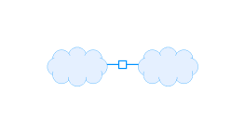

- Networks can use different technologies
- Router forwards packets between networks
- Transforms packets as necessary to meet standards for each network
Internet architecture

- An internetwork is composed of arbitrarily many networks interconnected by routers

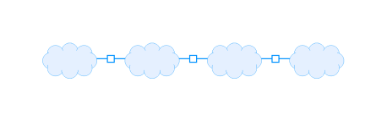
- Routers can have more than two interfaces

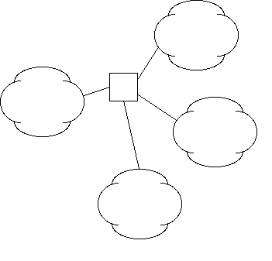
Routers in an organization

- Would be possible to interconnect all networks in an organization with a single router
- Most organizations use multiple routers
  - Each router has finite capacity; single router would have to handle all traffic across entire organization
  - Because internetworking technology can automatically route around failed components, using multiple routers increases reliability
A virtual network

- Internetworking software builds a single, seamless virtual network out of multiple physical networks
  - Universal addressing scheme
  - Universal service
- All details of physical networks hidden from users and application programs

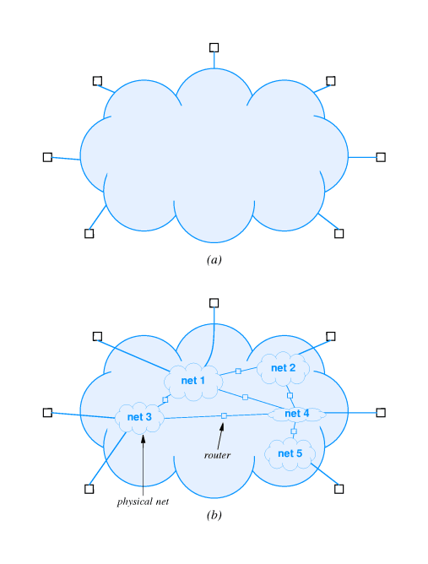
A protocol suite for internetworking

- The TCP/IP Internet Protocols or, simply, TCP/IP is the mostly widely used internetworking protocol suite
- First internetworking protocol suite
- Internet concept (originally called catenet developed in conjunction with TCP/IP
- Initially funded through ARPA
- Picked up by NSF
- Described in Where Wizards Stay Up Late
Internetworking protocols

- Others include IPX, VINES, AppleTalk
- TCP/IP is by far the most widely used
- Vendor and platform independent
- Used in the Internet - 20 million computers in 82 countries
TCP/IP layering

- OSI 7-layer model does not include internetworking
- TCP/IP layering model includes five layers
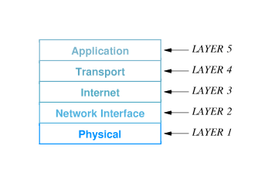
Layer 5: Application
Corresponds to ISO model layers 6 and 7; used for communication among applications
Layer 4: Transport
Corresponds to layer 4 in the ISO model; provides reliable delivery of data
Layer 3: Internet
Defines uniform format of packets forwarded across networks of different technologies and rules for forwarding packets in routers
Layer 2: Network
Corresponds to layer 2 in the ISO model; defines formats for carrying packets in hardware frames
Layer 1: Hardware
Corresponds to layer 1 in the ISO model; defines basic networking hardware

Hosts, routers and protocol layers

- A host computer or host is any system attached to an internet that runs applications
- Hosts may be supercomputers or toasters
- TCP/IP allows any pair of hosts on an internet communicate directly
- Both hosts and routers have TCP/IP stacks
  - Hosts typically have one interface and don't forward packets
  - Routers don't need layers 4 and 5 for packet forwarding
Summary

- An internet is a collection of physical networks interconnected into a single virtual network
- Routers provide the physical interconnection and forward packets between networks
- Hosts communicate across multiple network through packets forwarded by routers
- TCP/IP is the most widely used internetworking protocol suite
Chapter 16 - IP Protocol Addresses

Section | Title
1 | Motivation
2 | TCP/IP addresses
3 | IP address hierarchy
4 | Network and host numbers
5 | Porperties of IP addresses
6 | Designing the format of IP addresses
7 | Classes of addresses
8 | Using IP address classes
9 | Dotted decimal notation
10 | Bucknell's IP addresses
11 | Address classes at a glance
12 | Networks and hosts in each class
13 | Internet address allocation
14 | Example
15 | Special IP addresses
16 | Berkeley broadcast address
17 | Routers and IP addressing
18 | Multi-homed hosts
19 | Summary

Motivation

- One key aspect of virtual network is single, uniform address format
- Can't use hardware addresses because different technologies have different address formats
- Address format must be independent of any particular hardware address format
- Sending host puts destination internet address in packet
- Destination address can be interpreted by any intermediate router
- Routers examine address and forward packet on to the destination
TCP/IP addresses

- Addressing in TCP/IP is specified by the Internet Protocol (IP)
- Each host is assigned a 32-bit number
- Called the IP address or Internet address
- Unique across entire Internet
IP address hierarchy

- Each IP address is divided into a prefix and a suffix
  - Prefix identifies network to which computer is attached
  - Suffix identifies computer within that network
- Address format makes routing efficient
Network and host numbers

- Every network in a TCP/IP internet is assigned a unique network number
- Each host on a specific network is assigned a host number or host address that is unique within that network
- Host's IP address is the combination of the network number (prefix) and host address (suffix)
Porperties of IP addresses

- Network numbers are unique
- Host addresses may be reused on different networks; combination of network number prefix and host address suffix will be unique
- Assignment of network numbers must be coordinated globally; assignment of host addresses can be managed locally
Designing the format of IP addresses

- IP designers chose 32-bit addresses
- Allocate some bits for prefix, some for suffix
  - Large prefix, small suffix - many networks, few hosts per network
  - Small prefix, large suffix - few networks, many hosts per network
- Because of variety of technologies, need to allow for both large and small networks
Classes of addresses

- Designers chose a compromise - multiple address formats that allow both large and small prefixes
- Each format is called an address class
- Class of an address is identified by first four bits
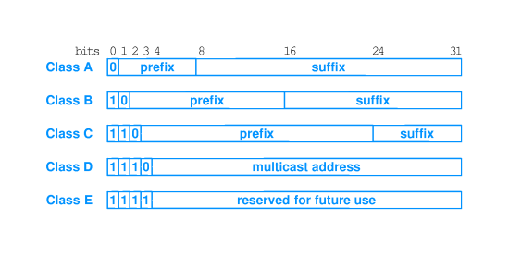
Using IP address classes

- Class A, B and C are primary classes
- Used for ordinary host addressing
- Class D is used for multicast, a limited form of broadcast
  - Internet hosts join a multicast group
  - Packets are delivered to all members of group
  - Routers manage delivery of single packet from source to all members of multicast group
  - Used for mbone (multicast backbone)
- Class E is reserved
Dotted decimal notation

- Class A, B and C all break between prefix and suffix on byte boundary
- Dotted decimal notation is a convention for representing 32-bit internet addresses in decimal
- Convert each byte of address into decimal; display separated by periods (``dots'')
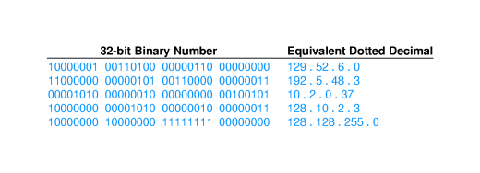
Bucknell's IP addresses

- Bucknell has a single Class B network: 134.82.0.0
- All hosts at Bucknell have 134.82 prefix:
  - 134.82.7.4 - coral
  - 134.82.56.108 - leo
  - 134.82.131.3 - charcoal
- Suffix bytes are used to determine local network and host through sub-netting

Address classes at a glance

- While dotted decimal makes separating network address from host address easier, determining class is not so obvious
- Look at first dotted decimal number, and use this table:
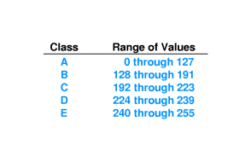
Networks and hosts in each class

- Classing scheme does not yield equal number of networks in each class
- Class A:
  - First bit must be 0
  - 7 remaining bits identify Class A net
  - 2⁷ (= 128) possible class A nets
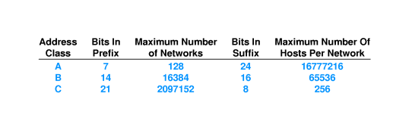
Internet address allocation

- Addresses in the Internet are not used efficiently
- Bucknell is typical, using 2,000-3,000 out of possible 2^16
- Large organizations may not be able to get as many addresses in the Internet as they need
- Example - UPS needs addresses for millions of computers
- Solution - set up private internet and allocate addresses from entire 32-bit address space
Example

- Select address class for each network depending on expected number of hosts
- Assign network numbers from appropriate classes
- Assign host suffixes to form internet addresses for all hosts
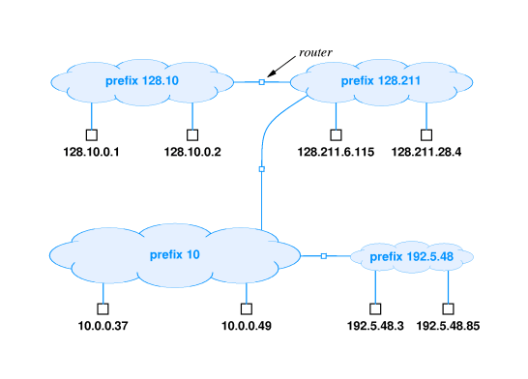

Special IP addresses

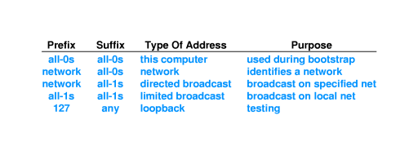
Berkeley broadcast address

- First BSD implementation (Berkeley Software Distribution) of UNIX used all 0s for broadcast instead of all 1s
- This non-standard implementation spread with BSD UNIX
- Still in common use today
``There are two major developments that have come out of Berkeley: BSD UNIX and LSD. This is not a coincidence.'' - Anon.

Routers and IP addressing

- IP address depends on network address
- What about routers - connected to two networks?
- IP address specifies an interface, or network attachment point, not a computer
- Router has multiple IP addresses - one for each interface
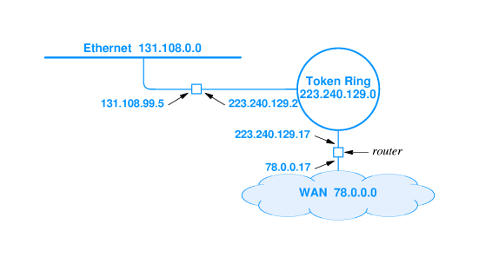

Multi-homed hosts

- Hosts (that do not forward packets) can also be connected to multiple networks
- Can increase reliability and performance
- Multi-homed hosts also have one address for each interface
Summary

- Virtual network needs uniform addressing scheme, independent of hardware
- IP address is a 32-bit address; each interface gets a unique IP address
- IP address is composed of a network address and a host address
- Network addresses are divided into three primary classes: A, B and C
- Dotted decimal notation is a standard format for Internet addresses: 134.82.11.70
- Routers have multiple addresses - one for each interface
Chapter 17 - Binding Protocol Addresses

Section | Title
1 | Introduction
2 | Address translation
3 | Address resolution
4 | Address resolution (continued)
5 | Address resolution techniques
6 | Table lookup
7 | Table lookup (continued)
8 | Closed-form computation
9 | Dynamic resolution
10 | Dynamic resolution techniques
11 | ARP
12 | ARP message exchange
13 | ARP example
14 | ARP message contents
15 | ARP message format
16 | Sending an ARP message
17 | Caching ARP responses
18 | Identifying ARP frames
19 | Processing ARP messages
20 | Layering and address resolution
21 | Summary

Introduction

- Upper levels of protocol stack use protocol addresses
- Network hardware must use hardware address for eventual delivery
- Protocol address must be translated into hardware address for delivery; will discuss three methods
Address translation

- Upper levels use only protocol addresses
  - "Virtual network" addressing scheme
  - Hides hardware details
- Translation occurs at data link layer
  - Upper layer hands down protocol address of destination
  - Data link layer translates into hardware address for use by hardware layer
Address resolution

- Finding hardware address for protocol address:
  - address resolution
  - Data link layer resolves protocol address to hardware address
- Resolution is local to a network
- Network component only resolves address for other components on same network
Address resolution (continued)

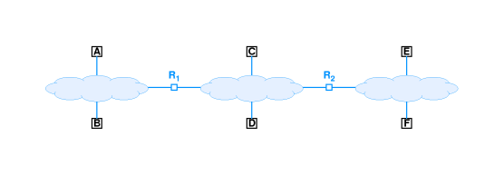

- A resolves protocol address for B for protocol messages from an application on A sent to an application on B
- A does not resolve a protocol address for F
  - Through the internet layer, A delivers to F by routing through R₁ and R₂
  - A resolves R₁ hardware address
- Network layer on A passes packet containing destination protocol address F for delivery to R₁
Address resolution techniques

- Association between a protocol address and a hardware address is called a binding
- Three techniques:
  - Table lookup
    - Bindings stored in memory with protocol address as key
    - Data link layer looks up protocol address to find hardware address
  - Closed-form computation
    - Protocol address based on hardware address
    - Data link layer derives hardware address from protocol address
  - Dynamic
    - Network messages used for "just-in-time" resolution
    - Data link layer sends message requesting hardware address; destination responds with its hardware address
Table lookup

- Use a simple list containing IP address and hardware address for each host on net
- Search on IP address and extract corresponding hardware address
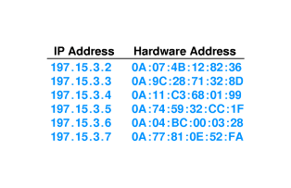

- Note that all IP addresses have same prefix; can save space by dropping prefix
Table lookup (continued)

- Sequential search may be prohibitively expensive (O(n²))
- Can use indexing or hashing for O(n) lookup
  - Indexing - use hostid part of IP address as list (array) index
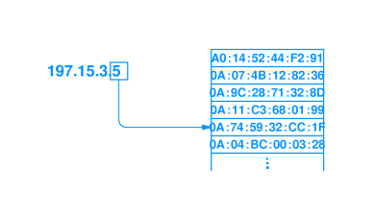
  - Hashing - use hashing function on hostid to generate list index
Closed-form computation

- If hardware technology uses small, configurable hardware address, network administrator can choose hardware address based on IP address
- Example - hardware uses one octet address that can be configured
- Simply choose hardware address to be hostid
- Now, any host can determine hardware address as:
hardware_address = ip_address & 0xff

Dynamic resolution

- Use network to resolve IP addresses
- Message exchange with other computer(s) returns hardware address to source
- Two designs:
  - Server-based - computer sends message to server to resolve address
    - List of servers
    - Broadcast to locate servers
  - Distributed - all computers participate; destination provides hardware address to host
Dynamic resolution techniques

- Server-based - centralized, easier to manage, used on non-broadcast media (e.g., ATM)
- Distributed - requires no dedicated computers, no administration
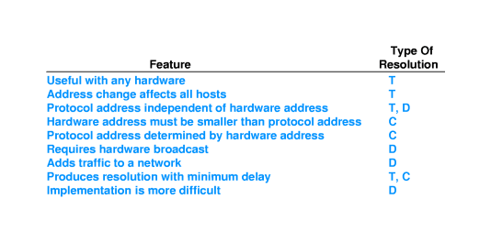
ARP

- IP uses distributed resolution technique
- Address Resolution Protocol (ARP) - part of TCP/IP protocol suite
- Two-part protocol
  - Request from source asking for hardware address
  - Reply from destination carrying hardware address
ARP message exchange

- ARP request message dropped into hardware frame and broadcast
- Uses separate protocol type in hardware frame (ethernet = 806)
- Sender inserts IP address into message and broadcast
- Every other computer examines request
- Computer whose IP address is in request responds
  - Puts hardware address in response
  - Unicasts to sender
- Original requester can then extract hardware address and send IP packet to destination
ARP example

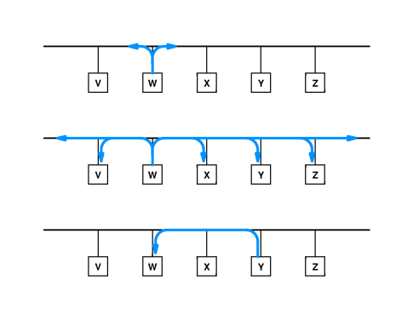
ARP message contents

- Maps protocol address to hardware address
- Both protocol address and hardware address sizes are variable
  - Ethernet = 6 octets
  - IP = 4 octets
- Can be used for other protocols and hardware types
ARP message format

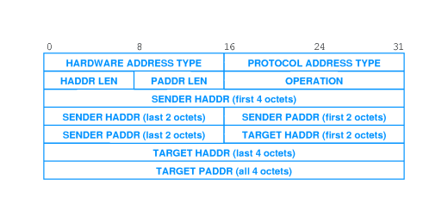
- HARDWARE ADDRESS TYPE = 1 for Ethernet
- PROTOCOL ADDRESS TYPE = 0x0800 for IP
- OPERATION = 1 for request, 2 for response
- Contains both target and sender mappings from protocol address to hardware address
  - Request sets hardware address of target to 0
  - Target can extract hardware address of sender (saving an ARP request)
  - Target exchanges sender/target in response
Sending an ARP message

- Sender constructs ARP message
- ARP message carried as data in hardware frame - encapsulation
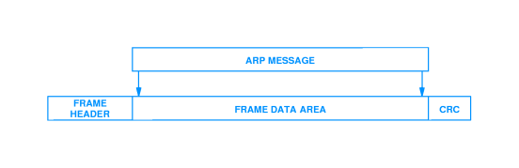
Caching ARP responses

- Using ARP for each IP packet adds two packets of overhead for each IP packet
- Computer caches ARP responses
  - Flushes cache at system startup
  - Entries discarded periodically
- Cache searched prior to sending ARP request
Identifying ARP frames

- Uses separate frame type
- Ethernet uses type 0x0806
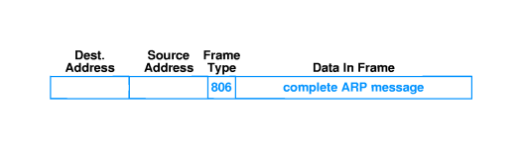
Processing ARP messages

- Receiver extracts sender's hardware address and updates local ARP table
- Receiver checks operation - request of response
- Response:
  - Adds sender's address to local cache
  - Sends pending IP packet(s)
- Request:
  - If receiver is target, forms response
  - Unicasts to sender
  - Adds sender's address to local cache
- Note:
  - Target likely to respond "soon"
  - Computers have finite storage for ARP cache
  - Only target adds sender to cache; others only update if target already in cache
Layering and address resolution

- Address resolution (ARP) is a network interface layer function
- Protocol addresses used in all higher layers
- Hides ugly details and allows generality in upper layers
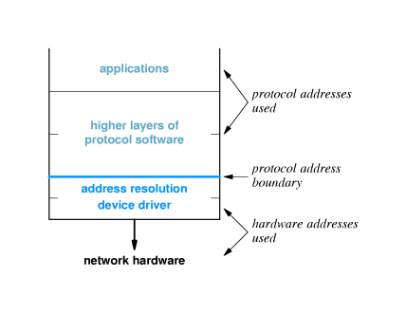
Summary

- Address resolution - translates protocol address to hardware address
  - Static - table lookup
  - Computation - extract hardware address from protocol address
  - Dynamic - use network messages to resolve protocol address
- ARP - TCP/IP protocol for address resolution
Chapter 18 - IP Datagrams and Datagram Forwarding

Section | Title
1 | Introduction
2 | Connectionless service
3 | Virtual packets
4 | IP datagram format
5 | Forwarding datagrams
6 | Routing example
7 | Routing table
8 | Default routes
9 | Routing tables and address masks
10 | Address masks
11 | Forwarding, destination address and next-hop
12 | Best-effort delivery
13 | IP datagram header format
14 | IP datagram header fields
15 | IP datagram options
16 | Summary

Introduction

- Fundamental Internet communication service
- Format of packets
- Processing of packets by routers
  - Forwarding
  - Delivery
Connectionless service

- End-to-end delivery service is connectionless
- Extension of LAN abstraction
  - Universal addressing
  - Data delivered in packets (frames), each with a header
- Combines collection of physical networks into single, virtual network
- Transport protocols use this connectionless service to provide connectionless data delivery (UDP) and connection-oriented data delivery (TCP)
Virtual packets

- Packets server same purpose in internet as frames on LAN
- Each has a header
- Routers (formerly gateways) forward between physical networks
- Packets have a uniform, hardware-independent format
  - Includes header and data
  - Can't use format from any particular hardware
- Encapsulated in hardware frames for delivery across each physical network
IP datagram format

- Formally, the unit of IP data delivery is called a datagram
- Includes header area and data area
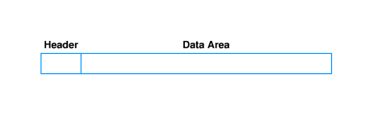
- Datagrams can have different sizes
  - Header area usually fixed (20 octets) but can have options
  - Data area can contain between 1 octet and 65,535 octets (2¹⁶ - 1)
  - Usually, data area much larger than header
Forwarding datagrams

- Header contains all information needed to deliver datagram to destination computer
  - Destination address
  - Source address
  - Identifier
  - Other delivery information
- Router examines header of each datagram and forwards datagram along path to destination
Routing example

http://www.eg.bucknell.edu/~cs363/lecture_notes/chap18/chap18_6.html
Shockwave
Routing table

- For efficiency, information about forwarding is stored in a routing table
  - Initialized at system initialization
  - Must be updated as network topology changes
- Contains list of destination networks and next hop for each destination
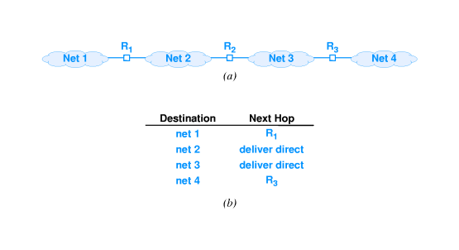
Default routes

- Routing table kept small by listing destination networks rather than hosts
- Can be further reduced through default route
  - Entry used if destination network not explicitly listed in routing table
  - E.g., Bucknell uses default routes for all off-campus networks
Routing tables and address masks

- In practice, additional information is kept in routing table
- Destination stored as network address
- Next hop stored as IP address of router
- Address mask defines how many bits of address are in prefix
  - Prefix defines how much of address used to identify network
  - E.g., class A mask is 255.0.0.0
  - Used for subnetting
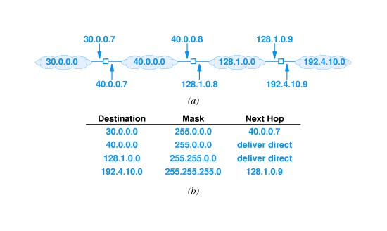
Address masks

- To identify destination network, apply address mask to destination address and compare to network address in routing table
- Can use Boolean and
if ((Mask[i] & D) == Dest[i]) forward to NextHop[i]
- Consider 128.1.15.26:

Forwarding, destination address and next-hop

- Destination address in IP datagram is always ultimate destination
- Router looks up next-hop address and forwards datagram
- Network interface layer takes two parameters:
  - IP datagram
  - Next-hop address
- Next-hop address never appears in IP datagram
Best-effort delivery

- IP provides service equivalent to LAN
- Does not guarantee to prevent
  - Duplicate datagrams
  - Delayed or out-of-order delivery
  - Corruption of data
  - Datagram loss
- Reliable delivery provided by transport layer
- Network layer - IP - can detect and report errors without actually fixing them
  - Network layer focuses on datagram delivery
  - Application layer not interested in differentiating among delivery problems at intermediate routers
IP datagram header format

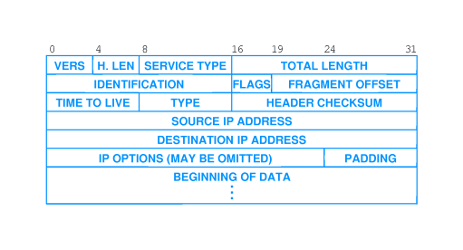
IP datagram header fields

- VERS - version of IP (currently 4)
- H. LEN - header length (in units of 32 bits)
- SERVICE TYPE - sender's preference for low latency, high reliability (rarely used)
- TOTAL LENGTH - total octets in datagram
- IDENT, FLAGS, FRAGMENT OFFSET - used with fragmentation
- TTL - time to live; decremented in each router; datagram discarded when TTL = 0
- TYPE - type of protocol carried in datagram; e.g., TCP, UDP
- HEADER CHECKSUM - 1s complement of 1s complement sum
- SOURCE, DEST IP ADDRESS - IP addresses of original source and ultimate destination
IP datagram options

- Several options can be added to IP header:
  - Record route
  - Source route
  - Timestamp
- Header with no options has H. LEN field value 5; data begins immediately after DESTINATION IP ADDRESS
- Options added between DESTINATION IP ADDRESS and data in multiples of 32 bits
- Header with 96 bits of options has H. LEN field value 8
Summary

- Basic unit of delivery in TCP/IP is IP datagram
- Routers use destination address in IP datagram header to determine next-hop
- Forwarding information stored in routing table
- IP datagram header has 40 octets of fixed field information and (possibly) options
Chapter 19 - IP Encapsulation, Fragmentation and Reassembly

Section | Title
1 | Datagram transmission and frames
2 | Encapsulation
3 | Encapsulation across multiple hops
4 | Internet encapsulation (example)
5 | MTU
6 | MTU and datagram transmission
7 | MTU and heterogeneous networks
8 | Fragmentation
9 | Fragmentation (details)
10 | Datagram reassembly
11 | Fragment identification
12 | Fragment loss
13 | Fragmenting a fragment
14 | Summary

Datagram transmission and frames

- IP internet layer
  - Constructs datagram
  - Determines next hop
  - Hands to network interface layer
- Network interface layer
  - Binds next hop address to hardware address
  - Prepares datagram for transmission
- But ... hardware frame doesn't understand IP; how is datagram transmitted?
Encapsulation

- Network interface layer encapsulates IP datagram as data area in hardware frame
  - Hardware ignores IP datagram format
  - Standards for encapsulation describe details
- Standard defines data type for IP datagram, as well as others (e.g., ARP)
- Receiving protocol stack interprets data area based on frame type
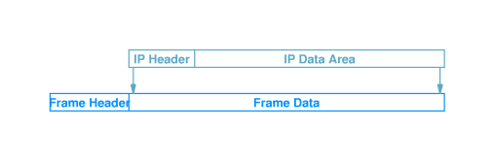
Encapsulation across multiple hops

- Each router in the path from the source to the destination:
  - Unencapsulates incoming datagram from frame
  - Processes datagram - determines next hop
  - Encapsulates datagram in outgoing frame

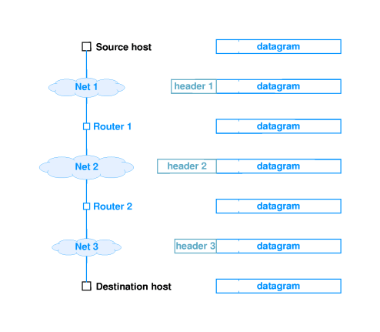
- Datagram may be encapsulated in different hardware format at each hop
- Datagram itself is (almost!) unchanged
Internet encapsulation (example)

http://www.eg.bucknell.edu/~cs363/lecture_notes/chap19/chap19_4.html
Shockwave
MTU

- Every hardware technology specification includes the definition of the maximum size of the frame data area
- Called the maximum transmission unit (MTU)
- Any datagram encapsulated in a hardware frame must be smaller than the MTU for that hardware
MTU and datagram transmission

- IP datagrams can be larger than most hardware MTUs
  - IP: 2¹⁶ ⁻ ¹
  - Ethernet: 1500
  - Token ring: 2048 or 4096
- Source can simply limit IP datagram size to be smaller than local MTU
  - Must pass local MTU up to TCP for TCP segments
  - What about UDP?
MTU and heterogeneous networks

- An internet may have networks with different MTUs
- Suppose downstream network has smaller MTU than local network?
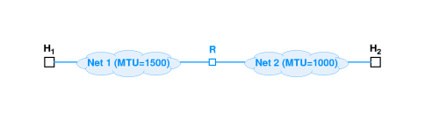
Fragmentation

- One technique - limit datagram size to smallest MTU of any network
- IP uses fragmentation - datagrams can be split into pieces to fit in network with small MTU
- Router detects datagram larger than network MTU
  - Splits into pieces
  - Each piece smaller than outbound network MTU
Fragmentation (details)

- Each fragment is an independent datagram
  - Includes all header fields
  - Bit in header indicates datagram is a fragment
  - Other fields have information for reconstructing original datagram
  - FRAGMENT OFFSET gives original location of fragment
- Router uses local MTU to compute size of each fragment
- Puts part of data from original datagram in each fragment
- Puts other information into header
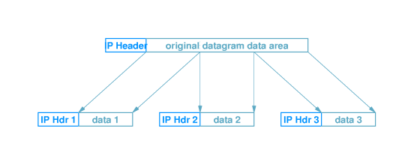
Datagram reassembly

- Reconstruction of original datagram is call reassembly
- Ultimate destination performs reassembly
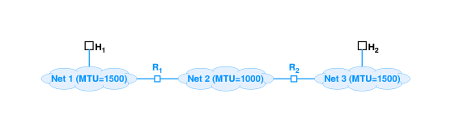
- Fragments may arrive out of order; header bit identifies fragment containing end of data from original datagram
- Fragment 3 identified as last fragment
Fragment identification

- How are fragments associated with original datagram?
- IDENT field in each fragment matches IDENT field in original datagram
- Fragments from different datagrams can arrive out of order and still be sorted out
Fragment loss

- IP may drop fragment
- What happens to original datagram?
  - Destination drops entire original datagram
- How does destination identify lost fragment?
  - Sets timer with each fragment
  - If timer expires before all fragments arrive, fragment assumed lost
  - Datagram dropped
- Source (application layer protocol) assumed to retransmit
Fragmenting a fragment

- Fragment may encounter subsequent network with even smaller MTU
- Router fragments the fragment to fit
- Resulting (sub)fragments look just like original fragments (except for size)
- No need to reassemble hierarchically; (sub)fragments include position in original datagram
Summary

- IP uses encapsulation to transmit datagrams in hardware frames
- Network technologies have an MTU
- IP uses fragmentation to carry datagrams larger than network MTU
Chapter 20 - IPv6

Section | Title
1 | Introduction - the future of IP
2 | Success of IP
3 | Motivation for change
4 | Name and versions number
5 | New features
6 | IPv6 datagram format
7 | IPv6 base header format
8 | IPv6 NEXT HEADER
9 | Parsing IPv6 headers
10 | Fragmentation
11 | Fragmentation and path MTU
12 | Use of multiple headers
13 | IPv6 addressing
14 | IPv6 address notation
15 | Summary

Introduction - the future of IP

- Current version of IP - version 4 - is 20 years old
- IPv4 has shown remarkable ability to move to new technologies
- IETF has proposed entirely new version to address some specific problems
Success of IP

- IP has accommodated dramatic changes since original design
  - Basic principles still appropriate today
  - Many new types of hardware
  - Scale
- Scaling
  - Size - from a few tens to a few tens of millions of computers
  - Speed - from 56Kbps to 1Gbps
  - Increased frame size in hardware
Motivation for change

- Address space
  - 32 bit address space allows for over a million networks
  - But...most are Class C and too small for many organizations
  - 2¹⁴ Class B network addresses already almost exhausted (and exhaustion was first predicted to occur a couple of years ago)
- Type of service
  - Different applications have different requirements for delivery reliability and speed
  - Current IP has type of service that's not often implemented
- Multicast
Name and versions number

- Preliminary versions called IP - Next Generation (IPng)
- Several proposals all called IPng
- One was selected and uses next available version number (6)
- Result is IP version 6 (IPv6)
New features

- Address size - IPv6 addresses are 128bits
- Header format - entirely different
- Extension headers - Additional information stored in optional extension headers, followed by data
- Support for audio and video - flow labels and quality of service allow audio and video applications to establish appropriate connections
- Extensible - new features can be added more easily
IPv6 datagram format

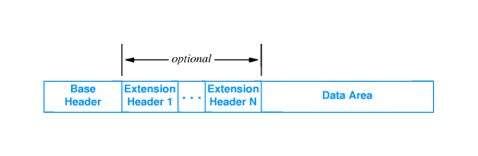
IPv6 base header format

- Contains less information than IPv4 header
- NEXT HEADER points to first extension header
- FLOW LABEL used to associate datagrams belonging to a flow or communication between two applications
  - Traffic class
  - Specific path
  - Routers use FLOW LABEL to forward datagrams along prearranged path
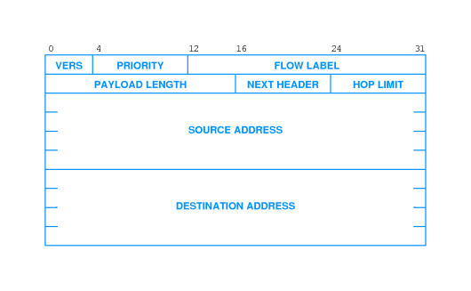
IPv6 NEXT HEADER

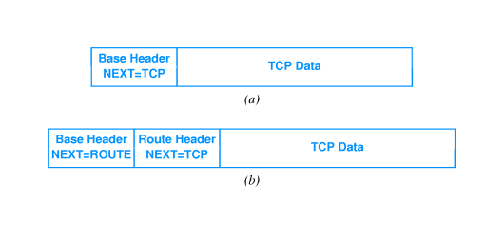
Parsing IPv6 headers

- Base header is fixed size - 40 octets
  - NEXT HEADER field in base header defines type of header
  - Appears at end of fixed-size base header
- Some extensions headers are variable sized
  - NEXT HEADER field in extension header defines type
  - HEADER LEN field gives size of extension header
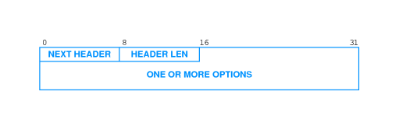
Fragmentation

- Fragmentation information kept in separate extension header
- Each fragment has base header and (inserted) fragmentation header
- Entire datagram, including original header may be fragmented
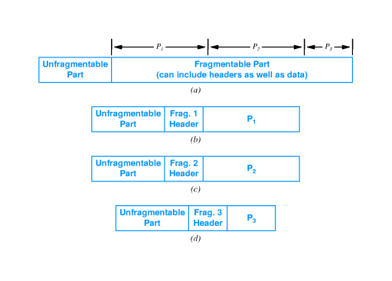
Fragmentation and path MTU

- IPv6 source (not intermediate routers) responsible for fragmentation
  - Routers simply drop datagrams larger than network MTU
  - Source must fragment datagram to reach destination
- Source determines path MTU
  - Smallest MTU on any network between source and destination
  - Fragments datagram to fit within that MTU
- Uses path MTU discovery
  - Source sends probe message of various sizes until destination reached
  - Must be dynamic - path may change durin
Use of multiple headers

- Efficiency - header only as large as necessary
- Flexibility - can add new headers for new features
- Incremental development - can add processing for new features to testbed; other routers will skip those headers
IPv6 addressing

- 128-bit addresses
- Includes network prefix and host suffix
- No address classes - prefix/suffix boundary can fall anywhere
- Special types of addresses:
  - unicast - single destination computer
  - multicast - multiple destinations; possibly not at same site
  - cluster - collection of computers with same prefix; datagram is delivered to one out of cluster
- IPv4 broadcast flavors are subsets of multicast
- Cluster addressing allows for duplication of services
IPv6 address notation

- 128-bit addresses unwieldy in dotted decimal; requires 16 numbers
105.220.136.100.255.255.255.255.0.0.18.128.140.10.255.255
- Groups of 16-bit numbers in hex separated by colons - colon hexadecimal (or colon hex)
69DC:8864:FFFF:FFFF:0:1280:8C0A:FFFF
- Zero-compression - series of zeroes indicated by two colons
FF0C:0:0:0:0:0:0:B1

FF0C::B1
- IPv6 address with 96 leading zeros is interpreted to hold an IPv4 address
Summary

- IPv4 basic abstractions have been very successful
- IPv6 carries forward many of those abstraction... but, all the details are changed
  - 128-bit addresses
  - Base and extension headers
  - Source does fragmentation
  - New types of addresses
  - Address notation
Chapter 21 - ICMP

Section | Title
1 | Introduction
2 | Error detection
3 | Error reporting
4 | Types of messages
5 | ICMP message transport
6 | ICMP and reachability
7 | ICMP and internet routes
8 | ICMP and path MTU discovery
9 | ICMP and router discovery
10 | ICMP redirect
11 | Summary

Introduction

- IP provides best-effort delivery
- Delivery problems can be ignored; datagrams can be "dropped on the floor"
- Internet Control Message Protocol (ICMP) provides error-reporting mechanism
Error detection

- Internet layer can detect a variety of errors:
  - Checksum (header only!)
  - TTL expires
  - No route to destination network
  - Can't deliver to destination host (e.g., no ARP reply)
- Internet layer discards datagrams with problems
- Some - e.g., checksum error - can't trigger error messages
Error reporting

- Some errors can be reported
  - Router sends message back to source in datagram
  - Message contains information about problem
- Encapsulated in IP datagram
Types of messages

- Internet Control Message Protocol (ICMP) defines error and informational messages
- Error messages:
  - Source quench
  - Time exceeded
  - Destination unreachable
  - Redirect
  - Fragmentation required
- Informational messages:
  - Echo request/reply
  - Address mask request/reply
  - Router discovery
ICMP message transport

- ICMP encapsulated in IP
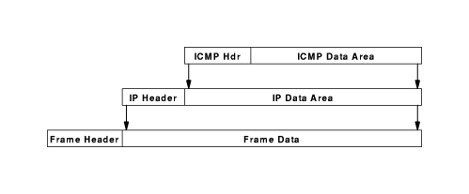
- But ... how can that work?
- ICMP messages sent in response to incoming datagrams with problems
- ICMP message not sent for ICMP message
ICMP and reachability

- An internet host, A, is reachable from another host, B, if datagrams can be delivered from A to B
- ping program tests reachability - sends datagram from B to A that A echoes back to B
- Uses ICMP echo request and echo reply messages
- Internet layer includes code to reply to incoming ICMP echo request messages
ICMP and internet routes

- List of all routers on path from A to B is called the route from A to B
- traceroute uses UDP to non-existent port and TTL field to find route via expanding ring search
- Sends ICMP echo messages with increasing TTL
  - Router that decrements TTL to 0 sends ICMP time exceeded message, with router's address as source address
  - First, with TTL 1, gets to first router, which discards and sends time exceeded message
  - Next, with TTL 1, gets through first router to second router
  - Continue until message from destination received
- traceroute must accommodate varying network delays
- Must also accommodate dynamically changing routes
ICMP and path MTU discovery

- Fragmentation should be avoided
- How can source configure outgoing datagrams to avoid fragmentation?
- Source determines path MTU - smallest network MTU on path from source to destination
- Source probes path using IP datagrams with don't fragment flag
- Router responds with ICMP fragmentation required message
- Source sends smaller probes until destination reached
ICMP and router discovery

- Router can fail, causing "black-hole" or isolating host from internet
- ICMP router discovery used to find new router
- Host can broadcast request for router announcements to auto-configure default route
- Host can broadcast request if router fails
- Router can broadcast advertisement of existence when first connected
ICMP redirect

- Default route may cause extra hop
- Router that forwards datagram on same interface sends ICMP redirect
- Host installs new route with correct router as next hop
Summary

- Internet layer provides best-effort delivery service
- May choose to report errors for some problems
- ICMP provides error message service
Chapter 22 - Transport Protocols

Section | Title
1 | Introduction
2 | User Datagram Protocol
3 | UDP and TCP/IP layering
4 | UDP headers
5 | Selecting UDP port numbers
6 | Well-known port numbers
7 | TCP
8 | Features of TCP
9 | Using IP for data delivery
10 | Delvering TCP
11 | TCP and reliable delivery
12 | Lost packets
13 | TCP segments and sequence numbers
14 | Acknowledgments
15 | Setting the timeout
16 | RTOs for different network delays
17 | Picking a timeout value
18 | Computing RTT and RTO
19 | Measuring RTT
20 | Karn's algorithm
21 | TCP sliding window
22 | Sliding window with acknowledgments
23 | Sliding window example
24 | Sliding window with lost segment
25 | Flow control with sliding window
26 | Silly window syndrome
27 | TCP segment format
28 | Three-way handshake
29 | Closing a connection
30 | Opening a connection
31 | Closing a connection
32 | Congestion control
33 | Summary

Introduction

- Internet Protocol (IP) provides ``unreliable datagram service'' between hosts
- Transport protocols provide end-to-end delivery between endpoints of a connection; e.g., processes or programs
- User Datagram Protocol (UDP) provides datagram service
- Transmission Control Protocol (TCP) provides reliable data delivery
User Datagram Protocol

- UDP delivers independent messages, called datagrams between applications or processes on host computers
  - ``Best effort'' delivery - datagrams may be lost, delivered out of order, etc.
  - Checksum (optionally) guarantees integrity of data
- For generality, endpoints of UDP are called protocol ports or ports
- Each UDP data transmission identifies the internet address and port number of the destination and the source of the message
- Destination port and source port may be different
UDP and TCP/IP layering

- Transport protocols use IP to provide data delivery for application protocols
Application
Transport
UDP, TCP
Internet
Network interface
Hardware

UDP headers

- UDP datagrams have a header that follows the hardware and IP headers:
Hardware | IP | UDP | Application | Data
- UDP header is very simple:
  - Port numbers
  - Message length
  - Checksum
UDP source port | UDP destination port
UDP message length | UDP checksum
Data

Selecting UDP port numbers

- Communicating computers must agree on a port number
  - ``Server'' opens selected port and waits for incoming messages
  - ``Client'' selects local port and sends message to selected port
- Services provided by many computers use reserved, well-known port numbers:
  - ECHO
  - DISCARD
  - NTP
- Other services use dynamically assigned port numbers
Well-known port numbers

Port | Name | Description
7 | echo | Echo input back to sender
9 | discard | Discard input
11 | systat | System statistics
13 | daytime | Time of day (ASCII)
17 | quote | Quote of the day
19 | chargen | Character generator
37 | time | System time (seconds since 1970)
53 | domain | DNS
69 | tftp | Trivial File Transfer Protocol (TFTP)
123 | ntp | Network Time Protocol (NTP)
161 | snmp | Simple Network Management Protocol (SNMP)

TCP

- Transmission Control Protocol (TCP) is most widely used transport protocol
- Provides reliable data delivery by using IP unreliable datagram delivery
- Compensates for loss, delay, duplication and similar problems in Internet components
- Reliable delivery is high-level, familiar model for construction of applications
Features of TCP

- Connection oriented: Application requests connection to destination and then uses connection to deliver data to transfer data
- Point-to-point: A TCP connection has two endpoints
- Reliability: TCP guarantees data will be delivered without loss, duplication or transmission errors
- Full duplex: The endpoints of a TCP connection can exchange data in both directions simultaneously
- Stream interface: Application delivers data to TCP as a continuous stream, with no record boundaries; TCP makes no guarantees that data will be received in same blocks as transmitted
- Reliable connection startup: Three-way handshake guarantees reliable, synchronized startup between endpoints
- Graceful connection shutdown: TCP guarantees delivery of all data after endpoint shutdown by application
Using IP for data delivery

- TCP uses IP for data delivery (like UDP)
- Endpoints are identified by ports (like UDP)
  - Allows multiple connections on each host
  - Ports may be associated with an application or a process
- IP treats TCP like data and does not interpret any contents of the TCP message
Delvering TCP

- TCP travels in IP datagrams
- Internet routers only look at IP header to forward datagrams
- TCP at destination interprets TCP messages
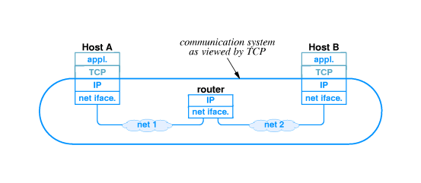
TCP and reliable delivery

- TCP uses many techniques described earlier to provide reliable delivery
- Recovers from
  - Lost packets
  - Duplicate packets
  - Delayed packets
  - Corrupted data
  - Transmission speed mismatches
  - Congestion
  - System reboots
Lost packets

- TCP uses positive acknowledgment with retransmission to achieve reliable data delivery
- Recipient sends acknowledgment control messages (ACK) to sender to verify successful receipt of data
- Sender sets timer when data transmitted; if timer expires before acknowledgment arrives, sender retransmits (with new timer)
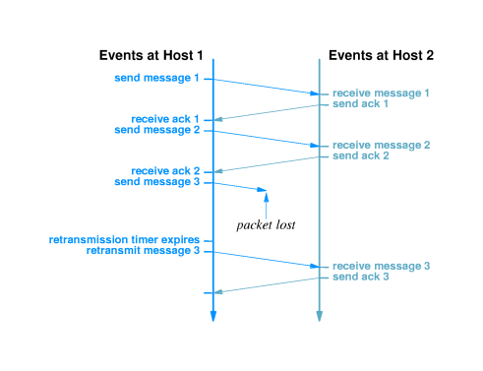
TCP segments and sequence numbers

- Application delivers arbitrarily large chunks of data to TCP as a``stream''
- TCP breaks this data into segments, each of which fits into an IP datagram
- Original stream is numbered by bytes
- Segment contains sequence number of data bytes
Acknowledgments

- Receiver sends segment with sequence number of acknowledged data (not segments)
- One ACK can acknowledge many segments
Setting the timeout

- Inappropriate timeout can cause poor performance:
  - Too long - sender waits longer than necessary before retransmitting
  - Too short - sender generates unnecessary traffic
- Timeout must be different for each connection and set dynamically
  - Host on same LAN should have shorter timeout than host 20 hops away
  - Delivery time across internet may change over time; timeout must accommodate changes
RTOs for different network delays

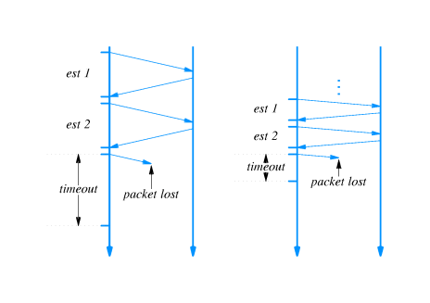
Picking a timeout value

- Timeout should be based on round trip time (RTT)
- Sender can't know RTT of any packet before transmission
- Sender picks retransmission timeout (RTO) based on previous RTTs
- Specific method is call adaptive retransmission algorithm
Computing RTT and RTO

- Weighted average for RTT:
RTT_{new} = (alpha*RTT_{old}) + ((1 - alpha)*RTT_{sample}))
- Computation of RTO:
RTO = beta*RTT_{new}
Measuring RTT

- RTT measured by observing difference between time of transmission and arrival of acknowledgment
- However - acknowledgments carry no information about which packet is acknowledged
- Sender cannot determine whether acknowledgment is from original transmission or retransmission
  - Choosing original transmission overestimates RTT
  - Choosing retransmission underestimates RTT
Karn's algorithm

- How to choose between original and retransmission? Answer: choose neither!
- Karn's algorithm specifies that sender ignores RTTs for retransmitted segments
- How will RTT get updated if internet round trip time increases?
- Karn's algorithm specifies that RTO is separated from RTT when retransmission occurs
- RTO doubles for each new message until ACK arrives with no retransmission
TCP sliding window

- TCP uses sliding window for flow control
- Receiver specifies window
  - Called window advertisement
  - Specifies which bytes in the data stream can be sent
  - Carried in segment along with ACK
- Sender can transmit any bytes, in any size segment, between last acknowledged byte and within window size

Sliding window with acknowledgments

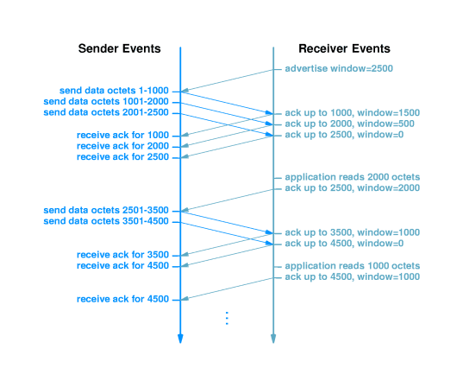
Sliding window example

http://www.eg.bucknell.edu/~cs363/lecture_notes/chap22/chap22_23.html
Shockwave
Sliding window with lost segment

http://www.eg.bucknell.edu/~cs363/lecture_notes/chap22/chap22_24.html
Shockwave
Flow control with sliding window

http://www.eg.bucknell.edu/~cs363/lecture_notes/chap22/chap22_25.html
Shockwave
Silly window syndrome

- Under some circumstances, sliding window can result in transmission of many small segments
- If receiver window full, and receiving application consumes a few data bytes, receiver will advertise small window
- Sender will immediately send small segment to fill window
- Inefficient in processing time and network bandwidth
- Solutions:
  - Receiver delays advertising new window
  - Sender delays sending data when window is small
TCP segment format

- TCP segment has header containing:
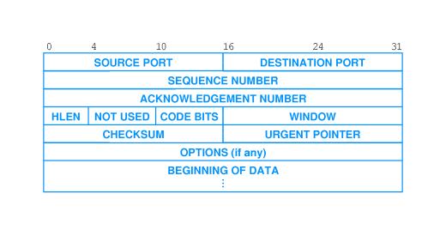
- Same header format used in both directions
- Segment can carry both data and acknowledgment
Three-way handshake

- TCP uses three-way handshake for reliable connection establishment and termination
  - Host 1 sends segment with SYN bit set and random sequence number
  - Host 2 responds with segment with SYN bit set, acknowledgment to Host 1 and random sequence number
  - Host 1 responds with acknowledgment
- TCP will retransmit lost segments
- Random sequence numbers ensure synchronization between endpoints
Closing a connection

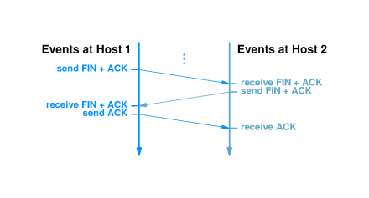
Opening a connection

http://www.eg.bucknell.edu/~cs363/lecture_notes/chap22/chap22_30.html
Shockwave
Closing a connection

http://www.eg.bucknell.edu/~cs363/lecture_notes/chap22/chap22_31.html
Shockwave
Congestion control

- Excessive traffic can cause packet loss
  - Transport protocols respond with retransmission
  - Excessive retransmission can cause congestion collapse
- TCP interprets packet loss as an indicator of congestion
- Sender uses TCP congestion control and slows transmission of packets
  - Sends single packet
  - If acknowledgment returns without loss, sends two packets
  - When TCP sends one-half window size, rate of increase slows
Summary

- UDP provides end-to-end best-effort message delivery
  - IP used for delivery to destination host
  - Protocol ports demultiplex to destination application
- TCP provides end-to-end reliable bytestream delivery
  - IP used for delivery to destination host
  - Protocol ports demultiplex to destination application
  - Additional techniques develop reliable delivery from IP messages
- Positive acknowledgment with retransmission
- Sequence numbers detect missing, duplicate and out-of-order data
- Sliding window flow control
- Three-way handshake
- Congestion control
Chapter 23 - Client-Server Interaction

Section | Title
1 | Introduction
2 | Internet protocols and network applications
3 | Establising contact through internet protocols
4 | Client-server paradigm
5 | Characteristics of client
6 | Characteristics of server
7 | ``Server-class'' computers
8 | Message exchanges
9 | Transport protocols and client-server paradigm
10 | Multiple services on one computer
11 | Identifying a service
12 | Multiple servers for one service
13 | Master-slave servers
14 | Selecting from multiple servers
15 | Connection-oriented and connectionless transport
16 | Client-server interactions
17 | Summary

Introduction

- Application-level protocols provide high-level services
  - DNS
  - Electronic mail
  - Remote login
  - FTP
  - World Wide Web
- All of these applications use client-server architecture
Internet protocols and network applications

- Internet protocols provide
  - General-purpose facility for reliable data transfer
  - Mechanism for contacting hosts
- Application programs
  - Use internet protocols to contact other applications
  - Provide user-level services
Establising contact through internet protocols

- Application must interact with protocol software before contact is made
- Listening application informs local protocol software that it is ready to accept incoming messages
- Connecting application uses internet protocol to contact listener
- Applications exchange messages through resulting connection
Client-server paradigm

- Server application is ``listener''
  - Waits for incoming message
  - Performs service
  - Returns results
- Client application establishes connection
  - Sends message to server
  - Waits for return message
Characteristics of client

- Arbitrary application program
  - Becomes client when network service is needed
  - Also performs other computations
- Invoked directly by user
- Runs locally on user's computer
- Initiates contact with server
- Can access multiple services (one at a time)
- Does not require special hardware or sophisticated operating system
Characteristics of server

- Special purpose application dedicated to providing network service
- Starts at system initialization time
- Runs on a remote computer (usually centralized, shared computer)
- Waits for service requests from clients; loops to wait for next request
- Will accept requests from arbitrary clients; provides one service to each client
- Requires powerful hardware and sophisticated operating system
``Server-class'' computers

- Shared, centralized computers that run many server applications are sometimes called ``servers''
- More precisely, the applications are the ``servers'' and the computer is a ``server-class computer''
- Servers can run on very simple computers...
Message exchanges

- Typically, client and server exchange messages:
  - Client sends request, perhaps with data
  - Server send response, perhaps with data
- Client may send multiple requests; server sends multiple responses
- Server may send multiple response - imagine video feed
Transport protocols and client-server paradigm

- Clients and servers exchange messages through transport protocols; e.g., TCP or UDP
- Both client and server must have same protocol stack and both interact with transport layer

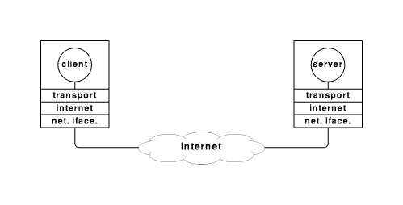
Multiple services on one computer

- Sufficiently powerful computer - fast enough processor, multi-tasking OS - may run multiple servers
- Servers run as independent processes and can manage clients simultaneously

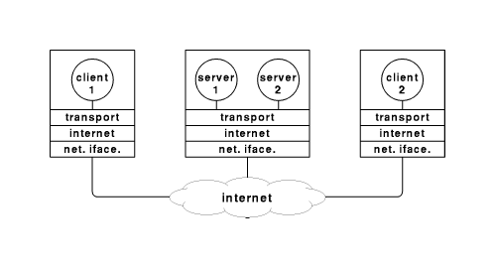
Identifying a service

- Each service gets a unique identifier; both client and
- Server use that identifier
  - Server registers with local protocol software under the identifier
  - Client contacts protocol software for session under that identifier
- Example - TCP uses protocol port numbers as identifiers
  - Server registers under port number for service
  - Client requests session with port number for service
Multiple servers for one service

- Responding to a client request may require significant time
- Other clients must wait while earlier requests are satisfied
- Multiple servers can handle requests concurrently, completing shorter requests without waiting for longer requests
Master-slave servers

- One way to run concurrent servers is to dynamically create server processes for each client
- Master server accepts incoming requests and starts slave server for each client
- Slave handles subsequent requests from its client
- Master server then waits for next request
Selecting from multiple servers

- How do incoming messages get delivered to the correct server?
- Each transport session has two unique identifiers
  - (IP address, port number) on server
  - (IP address, port number) on client
- No two clients on one computer can use same source port
- Thus, client endpoints are unique, and server computer protocol software can deliver messages to correct server process
Connection-oriented and connectionless transport

- Which to choose?
- TCP - connection-oriented
  - Client establishes connection to server
  - Client and server exchange multiple messages of arbitrary size
  - Client terminates connection
- UDP - connectionless
  - Client constructs message
  - Client sends message to server
  - Server responds
  - Message must fit in one UDP datagram
- Some services use both
  - DNS, chargen, motd
  - Can be provided by single server
Client-server interactions

- Clients can access multiple services sequentially
- Clients may access different servers for one service
- Servers may become clients of other servers
- Circular dependencies may arise...
Summary

- Client-server paradigm used in almost every distributed computation
  - Client requests service when needed
  - Server waits for client requests
- Servers usually run on server-class computer
- Clients and servers use transport protocols to communicate
- Often, but not always, there is an application protocol
Chapter 24 - Socket Interface

Section | Title
1 | Introduction
2 | API
3 | The Socket API
4 | Sockets and socket libraries
5 | Sockets and UNIX I/O
6 | The socket API
7 | Summary of socket system calls
8 | socket
9 | close
10 | bind
11 | Socket address formats
12 | listen
13 | accept
14 | connect
15 | send
16 | sendto, sendmsg
17 | recv
18 | recvfrom, recvmsg
19 | Other procedures
20 | Sockets and processes
21 | Summary

Introduction

- The socket is one form of interface between application programs and protocol software
- Widely available - program portability
- Used by both clients and servers
- Extension to UNIX file I/O paradigm
API

- Application interactions with protocol software:
  - Passive listen or active open
  - Protocol to use
  - IP address and port number
- Interface to protocol is call Application Program Interface (API)
  - Defined by programming/operating system
  - Includes collection of procedures for application program
The Socket API

- Protocols do not typically specify API
- API defined by programming system
- Allows greatest flexibility - compatibility with different programming systems
- Socket API is a specific protocol API
  - Originated with Berkeley BSD UNIX
  - Now available on Windows 95 and Windows NT, Solaris, etc.
- Not defined as TCP/IP standard; de factostandard
Sockets and socket libraries

- BSD UNIX includes sockets as system calls
- Other vendors (mostly UNIX) have followed suit
- Some systems have different API
  - Adding sockets would require changing OS
  - Added library procedures - socket library - instead
- Adds layer of software between application and operating system
  - Enhances portability
  - May hide native API altogether
Sockets and UNIX I/O

- Developed as extension to UNIX I/O system
- Uses same file descriptor address space (small integers)
- Based on open-read-write-close paradigm
  - open - prepare a file for access
  - read/write - access contents of file
  - close - gracefully terminate use of file
- Open returns a file descriptor, which is used to identify the file to read/write/close
The socket API

- Socket programming more complex than file I/O
- Requires more parameters
  - Addresses
  - Protocol port numbers
  - Type of protocol
  - New semantics
- Two techniques
  - Add parameters to existing I/O system calls
  - Create new system calls
- Sockets use a collection of new system calls
Summary of socket system calls

- socket - create a new socket
- close - terminate use of a socket
- bind - attach a network address to a socket
- listen - wait for incoming messages
- accept - begin using incoming connection
- connect - make connection to remote host
- send - transmit data through active connection
- recv - receive data through active connection
socket

descriptor = socket(protofamily, type, protocol)
- Returns socket descriptor used in subsequent calls
- protofamily selects protocol family; e.g.:
  - PF_INET - Internet protocols
  - PF_APPLETALK - AppleTalk protocols
- type selects type of communication
  - SOCK_DGRAM - connectionless
  - SOCK_STREAM - connection-oriented
- protocol specifies protocol within protocol family
  - IPPROTO_TCP - selects TCP
  - IPPROTO_UDP - selects UDP
close

close(descriptor)
- Terminates use of socket descriptor
- descriptor contains descriptor of socket to be closed
bind

bind(socket, localaddr, address)
- Initially, socket has no addresses attached
- bind selects either local, remote or both addresses
  - server binds local port number for incoming messages
  - client binds remote address and port number to contact server
Socket address formats

- Because sockets can be used for any protocols, address format is generic:
struct sockaddr {
u_char sa_len; /* total length of address */
u_char sa_family; /* family of the address */
char sa_data[14]; /* address */
}
- For IP protocols, sa_data hold IP address and port number:
struct sockaddr_in {
u_char sin_len; /* total length of address */
u_char sin_family; /* family of the address */
u_short sin_port; /* protocol port number */
struct in_addr sin_addr; /* IP address */
char sin_zero[8] /* unused */
}
- First two fields match generic sockaddr structure
- Remainder are specific to IP protocols
- INADDR_ANY interpreted to mean "any" IP address
listen

listen(socket, queuesize)
- Server uses listen to wait for incoming connections
- socket identifies socket through which connections will arrive (address)
- New connection requests may arrive while server processes previous request
- Operating system can hold requests on queue
- queuesize sets upper limit on outstanding requests
accept

accept(socket, caddress, caddresslen)
- Server uses accept to accept the next connection request
- accept call blocks until connection request arrives
- Returns new socket with server's end of new connection
- Old socket remains unchanged and continues to field incoming requests
- caddress returns struct sockaddr client address; format depends on address family of socket
- caddresslen returns length of address
connect

connect(socket, saddress, saddresslen)
- Client uses connect to establish connection to server
- Blocks until connection completed (accepted)
- socket holds descriptor of socket to use
- saddress is a struct sockaddr that identifies server
- saddresslen gives length of saddress
- Usually used with connection-oriented transport protocol
- Can be used with connectionless protocol
  - Marks local socket with server address
  - Implicitly identifies server for subsequent messages
send

send(socket, data, length, flags)
- Used to send data through a connected socket
- socket identifies socket
- data points to data to be sent
- length gives length of data (in bytes)
- flags indicate special options
sendto, sendmsg

sendto(socket, data, length, flags, destaddress, addresslen)
sendmsg(socket, msgstruct, flags)
- Used for unconnected sockets by explicitly specifying destination
- sendto adds additional parameters:
  - destaddress - struct sockaddr destination address
  - addresslen - length of destaddress
- sendmsg combines list of parameters into single structure:
struct msgstruct {
struct sockaddr *m_addr; /* ptr to destination address */
struct datavec *m_vec; /* pointer to message vector */
int m_dvlength; /* num. of items in vector */
struct access *m_rights; /* ptr to access rights list */
int m_alength; /* num. of items in list */
}
recv

recv(socket, buffer, length, flags)
- Used to receive incoming data through connected socket
- socket identifies the socket
- Data copied into buffer
- At most length bytes will be recved
- flags give special options
- Returns number of bytes actually recved
  - 0 implies connection closed
  - -1 implies error
recvfrom, recvmsg

recvfrom(socket, buffer, length, flags, sndraddress, addresslen)
recvmsg(socket, msgstruct, flags)
- Like sendto and sendmsg (in reverse!)
- Address of source copied into sndraddress
- Length of address in addresslen
- recvmsg uses msgstruct for parameters
Other procedures

- getpeername - address of other end of connection
- getsockname - current address bound to socket
- setsockopt - set socket options
Sockets and processes

- Like file descriptors, sockets are inherited by child processes
- Socket disappears when all processes have closed it
- Servers use socket inheritance to pass incoming connections to slave server processes
Summary

- Socket API is de facto standard
  - Originally developed for BSD UNIX
  - Copied to many other systems
- Sockets are an extension of the UNIX file I/O system
  - Use same descriptor addresses
  - Can (but typically don't) use same system calls
- Many specific system calls for sockets
Chapter 25 - Client/Server Example

Section | Title
1 | Introduction
2 | Connection-oriented communication
3 | An example service
4 | Example programs
5 | Program architecture
6 | Server
7 | Client
8 | Client calls to recv
9 | Sockets and blocking
10 | Using client with another server
11 | Using another client with server
12 | Summary

Introduction

- Will examine details of client and server programs
- Examples use socket API
- Will illustrate details of socket use
- Will also illustrate program architecture
Connection-oriented communication

- Client/server developer must choose between connectionless and connection-oriented service
  - Connectionless can be used at any time; does not provide reliability
  - Connection-oriented requires explicit connection; provides reliable data delivery
- This example will use connection-oriented transport
  - Server contacts local protocol software to accept incoming connections
  - Client establishes connection to server through client's local protocol software
- Client and server exchange data once connection is established
An example service

- Server
  - Keeps track of how many times it has been contacted
  - Returns that count in an ASCII string
- Client
  - Establishes connection
  - Waits for message from server (ASCII string)
  - Prints data from message
- Application-level protocol:
  - Syntax:
    - No headers
    - Client sends null message body
    - Server message contains ASCII string
  - Semantics - Client establishes connection; server returns ASCII string
Example programs

- Example server in server.c
  - Runs as background program
  - Takes single (optional) command line argument: port number to listen on (default is 5193)
- Example client in client.c
  - Runs as user program
  - Takes two (optional) command line arguments: name of host to contact (default is localhost) and port number to contact (default is 5193)
Program architecture

- Sequence of socket calls in server and client

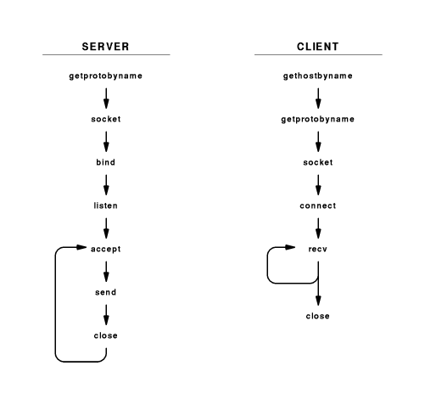
Server

- Initialization:
  - getprotobyname - looks up protocol number for TCP
  - socket - creates socket
  - listen - associates socket with incoming requests
- Loop:
  - accept - accepts incoming connection
  - send - send message to client
  - close - closes connection socket
Client

- Initialization:
  - gethostbyname - looks up server
  - getprotobyname - looks up protocol port number for TCP
  - socket - creates socket
  - connect - connects to server port
- Loop:
  - recv - receives message from server
- Termination:
  - close - closes socket
Client calls to recv

- The call to recv is in a loop in the client
- But, the server send only a single message - why would multiple calls be required?
- Protocol software does not guarantee to deliver data to receiver in the same blocks as generated by the server
  - May travel in different segments
  - recv need not return as much data as was requested
- Client must make repeated calls to recv until 0 returned
Sockets and blocking

- Most socket calls are blocking
- Calling process is blocked (taken off ready queue) until socket operation completes
- Server blocks:
  - accept until new connection arrives
  - send until data delivered to protocol software
- Client blocks:
  - gethostbyname until DNS resolves server name
  - recv until message delivered from server
Using client with another server

- Other services use similar application protocol:
  - DAYTIME
  - CHARGEN
  - MOTD
- Specifying port connects to alternate services
- Example:
$ client www.netbook.cs.purdue.edu 13
Thu Feb 27 15:19:06 1997
$ client leo.eg.bucknell.edu 13
Thu Feb 27 15:19:18 1997
$ client merlin.cs.purdue.edu 13
Thu Feb 27 15:19:26 1997
$ client cs.ucla.edu 13
Thu Feb 27 12:20:28 1997
$ client uran.informatik.uni-bonn.de 13
Thu Feb 27 21:22:37 1997
$ client yotaga.psu.ac.th 13
Fri Feb 28 03:24:20 1997

Using another client with server

- Other client that uses same application protocol can test server
- Example: telnet
$ telnet www.netbook.cs.purdue.edu 5193
Trying 134.82.11.70 ...
Connected to regulus.eg.bucknell.edu.
Escape character is '^]'.
This server has been contacted 5 times.
Connection closed by foreign host.
Summary

- Example client and server
  - Connection-oriented transport
  - Very simple application protocol
- Demonstrates use of socket calls
- Can be used with other clients and servers
Chapter 26 - the Domain Name System

Section | Title
1 | Introduction
2 | Structure of DNS names
3 | DNS naming structure
4 | Geographic structure
5 | Domain names within an organization
6 | Example DNS hierarchy
7 | DNS names and physical location
8 | Client-server computing
9 | DNS and client-server computing
10 | DNS server hierarchy
11 | Choosing DNS server architecture
12 | Name resolution
13 | DNS messages
14 | DNS servers
15 | Using DNS servers
16 | DNS caching
17 | Types of DNS entries
18 | Abbreviations
19 | Summary

Introduction

- IP assigns 32-bit addresses to hosts (interfaces)
  - Binary addresses easy for computers to manage
  - All applications use IP addresses through the TCP/IP protocol software
  - Difficult for humans to remember:
% telnet 134.82.11.70
- The Domain Name System (DNS) provides translation between symbolic names and IP addresses
Structure of DNS names

- Each name consists of a sequence of alphanumeric components separated by periods
- Examples:
www.eg.bucknell.edu
www.netbook.cs.purdue.edu
charcoal.eg.bucknell.edu
- Names are hierarchical, with most-significant component on the right
- Left-most component is computer name
DNS naming structure

- Top level domains (right-most components; also known as TLDs) defined by global authority
com | Commercial organization
edu | Educational institution
gov | Government organization
mil | Military organization
- Organizations apply for names in a top-level domain:
bucknell.edu
macdonalds.com
- Organizations determine own internal structure
eg.bucknell.edu
cs.purdue.edu
Geographic structure

- Top-level domains are US-centric
- Geographic TLDs used for organizations in other countries:
TLD | Country
.uk | United Kingdom
.fr | France
.ch | Switzerland
.in | India
- Countries define their own internal hierarchy: ac.uk and .edu.au are used for academic organizations in the United Kingdom and Australia
Domain names within an organization

- Organizations can create any internal DNS hierarchy
- Uniqueness of TLD and organization name guarantee uniqueness of any internal name (much like file names in your directories)
- All but the left-most component of a domain name is called the domain for that name:
Name | Domain
www.netbook.cs.purdue.edu | netbook.cs.purdue.edu
regulus.eg.bucknell.edu | eg.bucknell.edu
coral.bucknell.edu | bucknell.edu
- Authority for creating new subdomains is delegated to each domain
- Administrator of bucknell.edu has authority to create eg.bucknell.edu and need not contact any central naming authority
Example DNS hierarchy

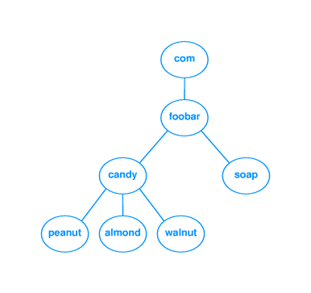
DNS names and physical location

- DNS domains are logical concepts and need not correspond to physical location of organizations
- DNS domain for an organization can span multiple networks
  - bucknell.edu covers all networks at Bucknell
  - www.netbook.cs.purdue.edu is in 318 Dana
  - laptop.eg.bucknell.edu could be connected to a network in California
Client-server computing

- Clients and servers communicate in distributed computing
  - Client initiates contact to request some remote computation
  - Server waits for clients and answers requests as received
- Clients are usually invoked by users as part of an end-user application
- Servers are usually run on central, shared computers

DNS and client-server computing

- DNS names are managed by a hierarchy of DNS servers
- Hierarchy is related to DNS domain hierarchy
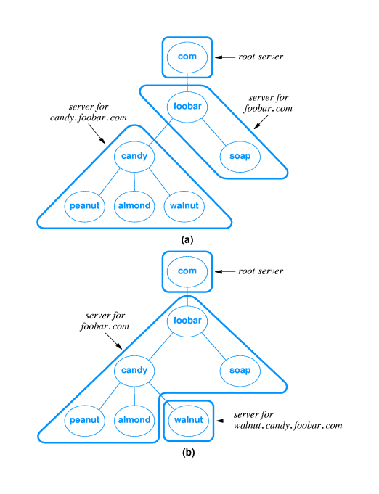

- Root server at top of tree knows about next level servers
- Next level servers, in turn, know about lower level servers
DNS server hierarchy

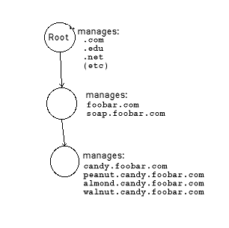
Choosing DNS server architecture

- Small organizations can use a single server
  - Easy to administer
  - Inexpensive
- Large organizations often use multiple servers
  - Reliability through redundancy
  - Improved response time through load-sharing
  - Delegation of naming authority
- Locality of reference applies - users will most often look up names of computers within same organization
Name resolution

- Resolver software typically available as library procedures
  - Implement DNS application protocol
  - Configured for local servers
  - Example - UNIX gethostbyname
- Calling program is client
  - Constructs DNS protocol message - a DNS request
  - Sends message to local DNS server
- DNS server resolves name
  - Constructs DNS protocol message - a DNS reply
  - Sends message to client program and waits for next request
DNS messages

- DNS request contains name to be resolved
- DNS reply contains IP address for the name in the request
DNS servers

- Each DNS server is the authoritative server for the names it manages
- If request contains name managed by receiving server, that server replies directly
- Otherwise, request must be forwarded to the appropriate authoritative server

Using DNS servers

- DNS request is forwarded to root server, which points at next server to use
- Eventually, authoritative server is located and IP address is returned
- DNS server hierarchy traversal is called iterative resolution
- Applications use recursive iteration and ask DNS server to handle traversal
DNS caching

- DNS resolution can be very inefficient
  - Every host referenced by name triggers a DNS request
  - Every DNS request for the address of a host in a different organization goes through the root server
- Servers and hosts use caching to reduce the number of DNS requests
  - Cache is a list of recently resolved names and IP addresses
  - Authoritative server include time-to-live with each reply
Types of DNS entries

- DNS can hold several types of records
- Each record includes
  - Domain name
  - Record type
  - Data value
- A records map from domain name to IP address
  - Domain name - regulus
  - Record type - A
  - Data value - 134.82.56.118
- Other types:
  - MX (Mail eXchanger) - maps domain name used as e-mail destination to IP address
  - CNAME - alias from one domain name to another
- Result - name that works with one application may not work with another!
Abbreviations

- May be convenient to use abbreviations for local computers; e.g. coral for coral.bucknell.edu
- Abbreviations are handled in the resolver; DNS servers only know full-qualified domain names (FQDNs)
- Local resolver is configured with list of suffixes to append
- Suffixes are tried sequentially until match found
Summary

- Domain Name System maps from computer names and IP addresses
- Important to hide 32-bit IP addresses from humans
- DNS names are hierarchical and allocated locally
- Replication and caching are important performance enhancements
- DNS provides several types of records
Chapter 27 - Electronic Mail

Section | Title
1 | Introduction
2 | Electronic mail paradigm
3 | Electronic mailboxes
4 | E-mail addresses
5 | Networked e-mail addresses
6 | Internet mail addressing
7 | E-mail message format
8 | E-mail headers
9 | E-mail example
10 | E-mail headers
11 | Data in e-mail
12 | MIME
13 | MIME (continued)
14 | Programs as mail recipients
15 | Mail transfer
16 | SMTP
17 | SMTP protocol exchange
18 | Multiple recipients on one computer
19 | Mailing lists and forwarders
20 | Mail gateways
21 | Mail gateways and forwarding
22 | Mail gateways and e-mail addresses
23 | Mailbox access
24 | Mail access protocols
25 | POP and dialup access
26 | Summary

Introduction

- Many user applications use client-server architecture
- Electronic mail client accepts mail from user and delivers to server on destination computer
- Many variations and styles of delivery
Electronic mail paradigm

- Electronic version of paper-based office memo
  - Quick, low-overhead written communication
  - Dates back to time-sharing systems in 1960s
- Because e-mail is encoded in an electronic medium, new forms of interaction are possible
  - Fast
  - Automatic processing - sorting, reply
  - Can carry other content
Electronic mailboxes

- E-mail users have an electronic mailbox into which incoming mail is deposited
- User then accesses mail with a mail reader program
- Usually associated with computer account; one user may have a different electronic mailboxes
E-mail addresses

- Electronic mailbox is identified by an e-mail address
- Typically user's account ID, although not always
- On non-networked multi-user computer, e-mail address is just account ID (no need to identify computer)
Networked e-mail addresses

- Mail delivery among networked computers is more complicated
- Must identify computer as well as mailbox
- Syntactically, e-mail address is composed of computer name and mailbox name
- Common example - user@host
- Other:
  - host1!host2!host!user
  - host%user
Internet mail addressing

- User portion is site-specific
  - droms
  - Ralph_E._Droms
  - 578.4309
- Host portion is domain name
- Source mail client
  - Resolves destination name using DNS (MX, if available)
  - Contacts mail delivery server at destination
  - Copies mail to server
- Destination mail server
  - Interprets user name according to local mailbox addresses
  - Places mail in appropriate mailbox
E-mail message format

- Simple two-part format:
  - Header includes delivery information
  - Body carries text of message
- Header and body separated by blank line
E-mail headers

- Lines of text in format keyword: information
- keyword identifies information; information can appear in any order
- Essential information:
  - To: list of recipients
  - From: sender
  - Cc: list of copy recipients
- Useful information:
  - Reply-to: different address than From:
  - Received-by: for debugging
- Frivolous information:
  - Favorite-drink: lemonade
  - Phase-of-the-moon: gibbous
E-mail example



E-mail headers

- Mail software passes unknown headers unchanged
- Some software may interpret vendor-specific information
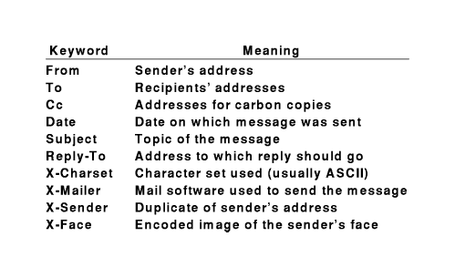
Data in e-mail

- Original Internet mail carried only 7-bit ASCII data
- Couldn't contain arbitrary binary values; e.g., executable program
- Techniques for encoding binary data allowed transport of binary data
- uuencode: 3 8-bit binary values as 4 ASCII characters (6 bits each)
  - Also carries file name and protection information
  - Incurs 33% overhead
  - Requires manual intervention
MIME

- Extends and automates encoding mechanisms - Multipart Internet Mail Extensions
- Allows inclusion of separate components - programs, pictures, audio clips - in a single mail message
- Sending program identifies the components so receiving program can automatically extract and inform mail recipient
  - Header includes:
MIME-Version: 1.0
Content-Type: Multipart/Mixed; Boundary=Mime_separator
  - Separator line gives information about specific encoding
  - Plain text includes:
Content-type: text/plain

MIME (continued)

- MIME is extensible - sender and receiver agree on encoding scheme
- MIME is compatible with existing mail systems
  - Everything encoded as ASCII
  - Headers and separators ignored by non-MIME mail systems
- MIME encapsulates binary data in ASCII mail envelope

Programs as mail recipients

- Can arrange for e-mailbox to be associated with a program rather than a user's mail reader
- Incoming mail automagically processed as input to program
- Example - mailing list subscription administration
- Can be used to implement client-server processing
  - Client request in incoming mail message
  - Server response in returned mail reply
Mail transfer

- E-mail communication is really a two-part process:
  - User composes mail with an e-mail interface program
  - Mail transfer program delivers mail to destination
    - Waits for mail to be placed in outgoing message queues
    - Picks up message and determines recipient(s)
    - Becomes client and contacts server on recipient's computer
    - Passes message to server for delivery

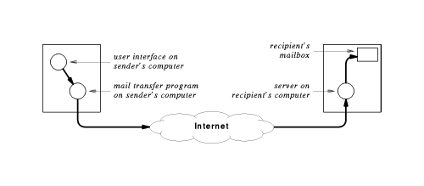
SMTP

- Simple Mail Transfer Protocol (SMTP) is standard application protocol for delivery of mail from source to destination
- Provides reliable delivery of messages
- Uses TCP and message exchange between client and server
- Other functions:
  - E-mail address lookup
  - E-mail address verification
SMTP protocol exchange

220 coral.bucknell.edu Sendmail 5.65v3.0 (1.1.8.2/29Aug94-0956AM) Sat, 5 Apr 1997 06:47:12 -0500
HELO regulus.eg.bucknell.edu
250 coral.bucknell.edu Hello regulus.eg.bucknell.edu, pleased to meet you
MAIL FROM: droms
250 droms... Sender ok
RCPT TO: droms
250 droms... Recipient ok
DATA
354 Enter mail, end with "." on a line by itself
This is a test mail message.
.
250 Ok
QUIT
221 coral.bucknell.edu closing connection

Multiple recipients on one computer

- Suppose droms@bucknell.edu, zaccone@bucknell.edu and hyde@bucknell.edu are all recipients of a mail message
- SMTP allows client to specify all three and delvier single copy of message
- Server makes three copies for delivery
Mailing lists and forwarders

- E-mail addresses can be attached to programs as well as electronic mailboxes
- Mail exploder or mail forwarder resends copies of message to e-mail addresses in mailing list
  - UNIX mail program sendmail provides simple mail aliases
  - Mailing list processor, e.g., listserv, can also interpret subscription management commands

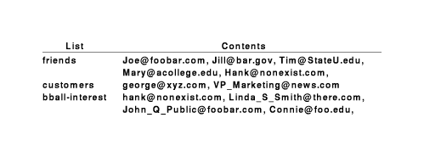

Mail gateways

- Mailing list processing may take significant resources in large organization
- May be segregated to a dedicated server computer: mail gateway
  - Provides single mail destination point for all incoming mail
  - e.g., bucknell.edu
  - Can use MX records in DNS to cause all mail to be delivered to gateway

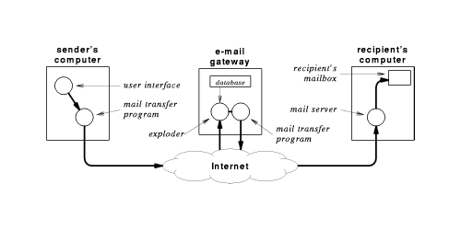
Mail gateways and forwarding

- Users within an organization may want to read mail on local or departmental computer
- Can arrange to have mail forwarded from mail gateway
- Message now makes multiple hops for delivery
- Hops may be recorded in header
- Forwarded mail may use proprietary (non-SMTP) mail system
Mail gateways and e-mail addresses

- Organization may want to use uniform naming for external mail
- Internally, may be delivered to many different systems with different naming conventions
- Mail gateways can translate e-mail addresses
Ralph_Droms | droms@bucknell.edu
Dan_Little | dlittle@mail.bucknell.edu
Ruth_Miller | miller@charcoal.eg.bucknell.edu

Mailbox access

- Where should mailbox be located?
- Users want to access mail from most commonly used computer
- Can't always use desktop computer as mail server
  - Not always running
  - Requires multitasking operating system
  - Requires local disk storage
- Can TELNET to remote comptuer with mail server
Mail access protocols

- Instead of TELNET, use prtocl that accesses mail on remote computer directly
- TCP/IP protocol suite includes Post Office Protocol (POP) for remote mailbox access
  - Computer with mailboxes runs POP server
  - User runs POP client on local computer
  - POP client can access and retrieve messages from mailbox
  - Requires authentication (password)
  - Local computer uses SMTP for outgoing mail

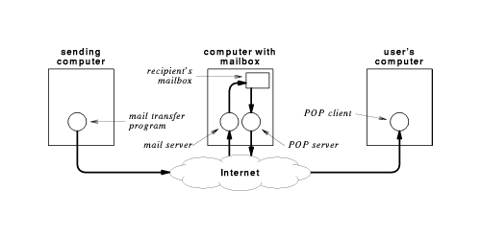
POP and dialup access

- POP useful for dialup connection
  - Users computer not always connected
  - Can download all mail at once and read off-line
  - Can compose mail off-line and mail in one connection
Summary

- Electronic mail based on office memo paradigm
- Allows quick, asynchronous communication across entire Internet
- Can attach e-mail addresses to programs for processing
  - Mailing lists
  - Other client-server applications
- Simple Mail Transfer Protocol (SMTP) is Internet standard for mail delivery
- Mail gateways
  - Provide uniform user addressing outside organizations
  - Translate from Internet mail (e.g., SMTP) to proprietary systems
- Post Office Protocol (POP) allows remote access to electronic mailboxes
Chapter 28 - File Transfer and Remote File Access

Section | Title
1 | Introduction
2 | Two problems
3 | Generalized file transfer
4 | Interactive and batch transfer
5 | File transfer Protocol
6 | Model and interface
7 | ftp client commands
8 | Two-way file transfer
9 | File name translation
10 | File types and transfer modes
11 | FTP messages
12 | FTP client-server model
13 | Using separate data connections
14 | TFTP
15 | NFS
16 | NFS function
17 | NFS implementation
18 | Summary

Introduction

- Many programs written to use disk file paradigm for I/O
- Moving a file from one computer to another required removable medium and sneakernet
- Network allows direct communication
  - File transfer - equivalent of tape, floppy transfer
  - Remote file system - access to files on networked computer through same interface as local files
Two problems

- Coordinating scheduling of distributed computations
- Saving intermediate results
- File transfer paradigm - programs write intermediate results to disk file
  - Components of distributed application need not be run concurrently
  - Intermediate results can be used to restart failed computation
Generalized file transfer

- Allow transfer of arbitrary files
- Accommodate different file types
- Convert between heterogeneous systems
  - Data types
  - Word lengths
  - Rules for file names
- User login
Interactive and batch transfer

- Batch transfer
  - User creates list of files to be transferred through interface program
  - Request dropped in queue
  - Transfer program reads requests and performs transfers
  - Transfer program retries until successful
  - Good for slow or unreliable transfers
- Interactive transfer
  - User starts transfer program
  - Actions include listing contents of directories, transferring files
  - User can find and transfer files immediately
  - Quick feedback in case of, e.g., spelling errors
File transfer Protocol

- TCP/IP standard is File Transfer Protocol (FTP)
- General purpose protocol
  - Operating system and hardware independent
  - Transfers arbitrary files
  - Accommodates file ownership and access restrictions
- Predates TCP/IP; adapted to TCP/IP later
Model and interface

- Underlying protocol can run either interactive or batch mode
  - ftp client gives interactive interface
  - MIME, HTTP can use directly
- Protocol actions include:
  - List contents of directory
  - Change to a different working directory
  - Retrieve a file
  - Put a file
ftp client commands

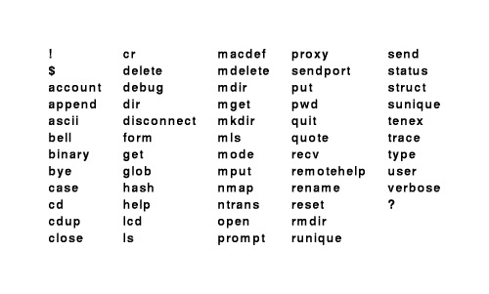

- ftp client interface from BSD UNIX is de facto standard
  - Many commands archaic and no longer used: tenex, carriage control
  - Most often used: cd, dir, ls, get, put
  - Other useful: cr, pwd, lcd
- Two-step process:
  - Launch ftp
  - Connect to remote host
    - Connect involves using user account on remote host
    - Some FTP servers provide anonymous FTP
Two-way file transfer

- get: from FTP server to local host
- put: to FTP server from local host
- Default uses same name on both hosts; ftp client allows specification of different names
- mget, mput transfer multiple files
  - UNIX-like wildcard expansion
  - prompt disables prompt for batch transfer
File name translation

- File name syntaxes may be incompatible
- UNIX - 128 character, mixed case; DOS - 8+3 character, upper case
- Some names may not be legal in all systems
- BSD ftp allows rules for filename translation
File types and transfer modes

- Many different styles of file typing
  - UNIX - untyped; may hold anything
  - MacOS - strongly typed
- ftp does two types of transfer:
  - Text - with appropriate translations to maintain integrity
  - Binary - no translation whatsoever
FTP messages

- Each message from server includes a three-digit decimal number
  - 226 Transfer complete
  - 221 Goodbye
- Convenient for computer and human recognition
- Verbose mode shows messages; quiet mode suppresses messages
FTP client-server model

- Remote server accepts control connection from local client
  - Client sends commands to server
  - Persists through entire session
- Server creates data connection for data transfer
  - One data connection for each transferred file
  - Data transferred (either way)

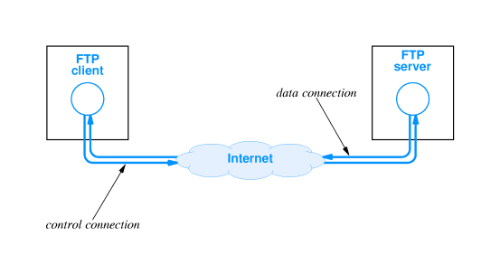

Using separate data connections

- Separates commands from data
- Client can send commands during data transfer
- Closed connection indicates end of file
TFTP

- Trivial File Transfer Protocol (TFTP) - much simpler than FTP
  - Based on UDP
  - File transfer only; no directory listing
  - No authorization
- Can be used in UDP-only system
- Requires less code than FTP
- Often used for bootstrap; e.g., ROM-based diskless system
NFS

- Network File System gives random access to files across a network
- Many distributed file systems exist; NFS is TCP/IP standard
  - AppleShare
  - Microsoft/NETBIOS
- Based on client-server model
- Originally developed by Sun; implementations now available on most UNIX and many PC systems
NFS function

- Provides functions equivalent to OS access to local files
  - Open
  - Read
  - Write
  - Close
- Local file access operations mapped to network messages
  - Each message contains file system operation
  - Read/write carry one disk block in each message
- File naming integrated into local directory system
  - Remote file systems mounted onto local directory
  - Access through mount point mapped to server
NFS implementation

- NFS operations are UNIX-like, but not exactly equivalent
  - Local OS performs some operations - open, close
  - NFS provides block read/write; local OS does buffering
- Other OS file functions can also be mapped into NFS operations
- File naming, authorization/account identification, access rights all problematic
Summary

- FTP - whole file transfer using TCP between Internet hosts
  - Directory listing
  - Data translation
- TFTP - whole file transfer using UDP between Internet hosts
  - File transfer only
  - No authorization
- NFS - file-level access using UDP
Chapter 29 - WWW

Section | Title
1 | Introduction
2 | Hypertext/hypermedia
3 | Hypermedia pointers
4 | Browser interface
5 | Document representation
6 | HTML
7 | Example
8 | CS363 - Example Page
9 | Other HTML Tags
10 | Embedded graphics
11 | Identifying a page
12 | Links between HTML documents
13 | Client-server model
14 | Server architecture
15 | Browser architecture
16 | Caching in browsers
17 | Summary

Introduction

- Hypertext model
- Use of hypertext in World Wide Web (WWW)
- WWW client-server model
- Use of TCP/IP protocols in WWW
Hypertext/hypermedia

- Hypermedia system allows interactive access to collections of documents
- Document can hold:
  - Text (hypertext)
  - Graphics
  - Sound
  - Animations
  - Video
- Documents linked together
  - Nondistributed - all documents stored locally (like CD-ROM)
  - Distributed - documents stored on remote servers
Hypermedia pointers

- Each document contains links (pointers) to other documents
  - Link represented by "active area" on screen
    - Graphic - button
    - Text - highlighted
  - Selecting link fetches referenced document for display
- Links may become invalid
  - Link is simply a text name for a remote document
  - Remote document may be removed while name in link remains in place
Browser interface

- Interactive, "point-and-click" interface to hypermedia documents
- Each document is displayed in screen
- User can select and follow links - "point-and-click"
- Application is called a browser (infinite time sink)
Document representation

- Each WWW document is called a page
- Initial page for individual or organization is called a home page
- Page can contain many different types of information; page must specify
  - Content
  - Type of content
  - Location
  - Links
- Rather than fixed WYSIWYG representation (e.g., Word), pages are formatted with a mark up language (like TeX)
  - Allows browser to reformat to fit display
  - Allows text-only browser to discard graphics
- Standard is HyperText Markup Language (HTML)
HTML

- HTML specifies
  - Major structure of document
  - Formatting instructions
  - Hypermedia links
  - Additional information about document contents
- Two parts to document:
  - Head contains details about the document
  - Body contains information/content
- Page is represented in ASCII text with embedded HTML tags formatting instructions
  - Tags have format <TAGNAME>
  - End of formatted section is </TAGNAME>
Example

<HTML>
<HEAD>
<TITLE>
CS363 - Example Page
</TITLE>
</HEAD>
<BODY>
<HR>
Lecture notes for today go here!
<HR>
<CENTER>
<TABLE BORDER=3>
<TR>
<TD><A HREF="./chap27_6.html">Previous</A>
<TD><A HREF="./chap27_8.html">Next</A>
<TD><A HREF="./chap27_0.html">Top of chapter</A>
<TD><A HREF="../lecture_notes.html">Lecture notes</A>
<TD><A HREF="../../index.html">Top of CS363</A>
</TABLE>
</CENTER>
</BODY>
</HTML>
Other HTML Tags

- Headings - <H1>, <H2>
- Lists
  - <OL> - Ordered (numbered) list
  - <UL> - Unordered (bulleted) list
  - <LI> - List item
- Tables
  - <TABLE>, </TABLE> - Define table
  - <TR> - Begin row
  - <TD> - Begin item in row
- Parameters
  - Keyword-value pairs in HTML tags
  - <TABLE BORDER=3>
Embedded graphics

- IMG tag specifies insertion of graphic
- Parameters:
  - SRC="filename"
  - ALIGN= - alignment relative to text
- Image must be in format known to browser, e.g., Graphics Interchange Format (GIF)

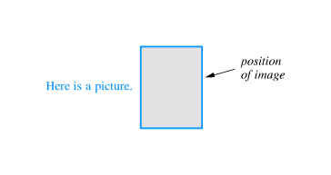

Identifying a page

- Page identified by:
  - Protocol used to access page
  - Computer on which page is stored
  - TCP port to access page
  - Pathname of file on server
- Specific syntax for Uniform Resource Locator (URL): protocol://computer_name:port/document_name
  - Protocol can be http, ftp, file, mailto
  - Computer name is DNS name
  - (Optional) port is TCP port
  - document_name is path on computer to page
Links between HTML documents

- Each link is specified in HTML
- Item on page is associated with another HTML document
- Link is passive; no action taken until selected
- HTML tags are <A> and </A>
  - Linked document specified by parameter: HREF="document URL"
  - Whatever is between HTML tags is highlighted item
- <A HREF="http://www.bucknell.edu/~droms">Your obdt. svt.</A>
- Your obdt. svt.
Client-server model

- Browser is client, WWW server is server
- Browser:
  - Makes TCP connection
  - Sends request for page
  - Reads page
- Each different item - e.g., IMG - requires separate TCP connection
- HyperText Transport Protocol (HTTP) specifies commands and client-server interaction
Server architecture

- Much like robowar or ftp server
  - Waits for incoming connection
  - Accepts command from connection
  - Writes page to connection
- Performance is hard issue
Browser architecture

- Browser has more components:
  - Display driver for painting screen
  - HTML interpreter for HTML-formatted documents
  - Other interpreters (e.g., Shockwave) for other items
  - HTTP client to fetch HTML documents from WWW server
  - Other clients for other protocols (e.g., ftp)
  - Controller to accept input from user
- Must be multi-threaded

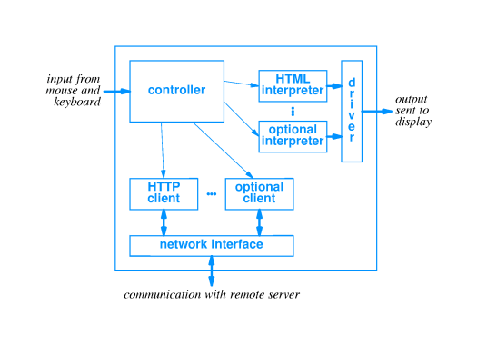
Caching in browsers

- Downloading HTML documents from servers may be slow
  - Internet congested
  - Dialup connection
  - Server busy
- Returning to previous HTML document requires reload from server
- Local cache can be used to hold copies of visited pages
- Also can implement organizational HTTP proxy that caches documents for multiple users
Summary

- WWW is based on hypermedia
- HTML is markup language for WWW documents
- HTML can specify links to other documents
- WWW based on client-server model
  - Browser - client
  - WWW server - server

Chapter 30 - CGI and Dynamic Web Documents

Section | Title
1 | Introduction
2 | Document types
3 | Dynamic documents and servers
4 | CGI standard
5 | Output from CGI program
6 | CGI example
7 | Inputs to CGI programs
8 | State information
9 | CGI program with long-term state
10 | CGI program with short-term state
11 | Forms and interactions
12 | Summary

Introduction

- Documents in previous section are static
  - Defined in text file by page author
  - Remains unchanged until edited by author
- Dynamic documents are generated on demand by HTTP server
- Active execute code on the WWW browser host computer
Document types

Document type | Description | Advantages/disadvantages
Static | - Text file on server  - Edited by author  - Contents unchanged (until edited) | - Easy to generate  - Fast to display  - Inflexible
Dynamic | - Program on server  - Output returned to client  - Client displays as HTML page | - Can generate contents at time of access  - Harder to author  - Must be refreshed to update display
Active | - Consists of a program that is downloaded to browser  - Browser executes program  - Interacts with user through keyboard  - Updates display  - Can read files and contact other Internet services | - Browser must be able to run program  - Program must be platform independent  - Requires more complexity in browser  - Standards not fixed (Java is de facto standard  - Requires programming skill (typically more than dynamic)

Dynamic documents and servers

- Support for dynamic documents requires some changes on HTTP server
- Typically implemented as extensions to existing server
- Server must be able to execute program that generates dynamic document
  - Can be implemented in
    - Shell/csh script
    - C program (executable)
    - Others?
  - Output returned to browser (looks like contents of static page)
- Each dynamic document needs separate program
- Server must differentiate between static and active document references
CGI standard

- Common Gateway Interface (CGI) standard defines server-application interaction
- Program sometimes called CGI program
- Guidelines for interaction
  - Language
  - Parameter passing
Output from CGI program

- Output from CGI program routed to WWW browser
- Can be in several formats, e.g., plain text or HTML
- Program must identify content to server for relay to browser
- Header - consists of lines of text followed by blank line
Content-type: text/html
Content-type: text/plain
Location: http://other.server.com/new.txt
CGI example

- Here's an example
A simple CGI program
- Try it again...
- Uses shell script language
  - echo prints its command line arguments
  - date returns date
  - `foo` returns output from command foo as command line argument
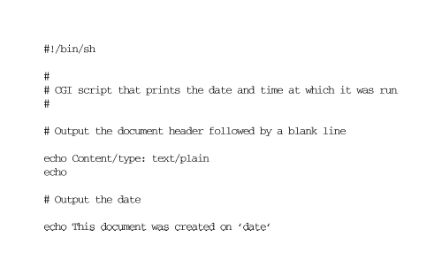
- Linked to with:
<a href="http://www.netbook.cs.purdue.edu/cgi-bin/netbook-28-1">
A simple CGI program</a>

Inputs to CGI programs

- Server passes inputs to CGI programs through parameters
- Browser may supply parameters (through server)
  - Browser extends URL with additional parameters
  - Separated by "?"
- Parameters passed as environment variables
  - Essentially keyword-value pairs
  - Based on original UNIX servers
- Very easy to access in shell script

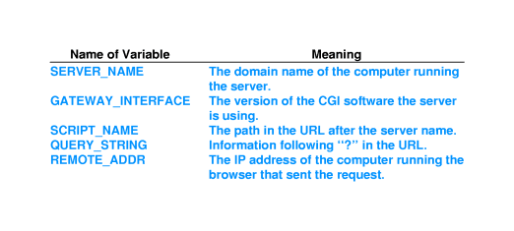
State information

- CGI program invoked identically at each reference
- Server maintains no history of previous invocations or any other state
- Long-term - store in file on server
- Short-term - return to browser in URL
CGI program with long-term state

- Keeps record of IP addresses
- Responds with initial message at first reference; subsequent message otherwise
- Try me!
- Try it again...
- Implementation details
  - List of known addresses kept in file ipaddrs
  - grep -s returns TRUE if argument string not found in file
  - Environment variables $REMOTE_ADDR contains string with IP address of browser host
CGI program with short-term state

- Trick is to encode state in URL, return URL in link
- When user selects link, state returned as parameter suffix in new URL
- Script can parse $QUERY_STRING to retrieve state
- Try me!
- Try it again...
- Implementation details
  - N is internal variable
  - case statement allows for null string
  - ;; is end of case

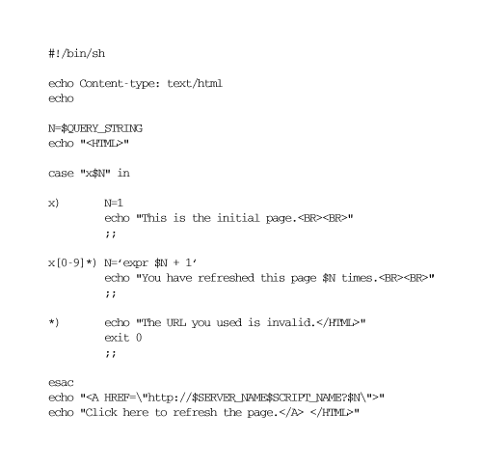

Forms and interactions

- CGI includes support for forms
- Server sends document to browser identified as a form
- Form includes items for information entry
  - Each form item has a name
  - Contents of that item encoded in query string:
?ITEM1=4,ITEM2=Bucknell,ITEM3=CS363
Summary

- Three types of WWW documents
  - Static
  - Dynamic
  - Active
- Dynamic document
  - Generated by program on server at each reference
  - May display different contents over time
  - Must be refreshed to update display
- May include long-term and short-term state
Chapter 31 Java Technology For Active Web Documents
Section | Title
1 | Introduction
2 | Continuous update through server push
3 | Active documents
4 | Representing and executing active documents
5 | Java
6 | Java language
7 | Java run-time environment
8 | Portability
9 | Java library
10 | AWT graphics
11 | Java and browsers
12 | Compiling a Java program
13 | An example applet
14 | A Java example
15 | Running the example
16 | Interacting with the browser
17 | Running the example
18 | Alternatives
19 | JavaScript example
20 | Summary

Introduction

- Active documents consist of code executed on computer running browser
- Java language allows development of active document programs
  - Programs called applets
  - Platform independent
  - Secure

Continuous update through server push

- Some servers will send new versions of document
- Technique called server push
- Each server push document requires dedicated server resources
- May scale with number of clients
- Also requires network bandwidth for each update
Active documents

- Delegates responsibility for updates to browser client
- Work scales with number of active documents on client
- Active document can, in fact, incur less server overhead than dynamic document
Representing and executing active documents

- Requires programming language; what should that language look like?
- How should the language be represented for execution?
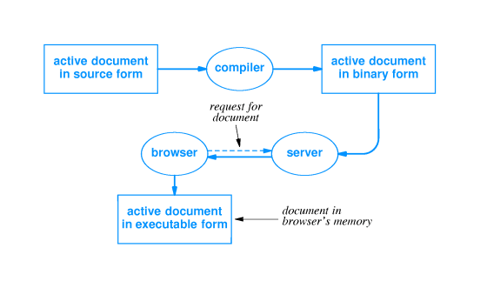

- Multiple implementations possible; standards necessary for coordination
Java

- Technique for writing, compiling, downloading and executing active documents
- Includes:
  - Programming language
  - Runtime environment
  - Class library
Java language

- Resembles C++
  - Object-oriented
  - Some C++ cruft excised or restricted
- Characteristics:
  - High level, general purpose, object oriented
  - Dynamic
  - Strongly typed, static type checking
  - Concurrent
Java run-time environment

- Interpretive execution - Java language compiled into bytecodes
- Automatic garbage collection
- Multithreaded execution
- Internet access
- Graphics
Portability

- Java must be platform-independent
- Run-time environment clearly defined and has no implementation dependencies
- Bytecode representation is platform independent
Java library

- Library provides collection of common functions for Java applets
- Class definitions and methods
- Classes:
  - Graphics
  - Low-level network I/O (socket-level)
  - Web server interaction
  - Run-time system calls
  - File I/O
  - Data structures
  - Event capture - user interaction
  - Exception handling
AWT graphics

- Java graphics library called Abstract Window Toolkit (AWT)
- Includes high-level and low-level facilities
  - Windows with components - scrollbars, buttons
  - Blank rectangular area with object drawing
- Implements abstract functions; run-time environment implementation maps to window system-specific functions
Java and browsers

- Browser must include Java interpreter
- Java interpreter works through browser
  - Graphics
  - HTML
- Interpreter also works through native operating system
  - File I/O
  - Network operations
Compiling a Java program

- javac translates Java source code into bytecodes
  - Checks for correct syntax
  - Imports classes from library
  - Writes bytecode program to filename.class
- Other development environments exist
  - May include source code management
  - "Visual" systems provide "pluggable" modules
An example applet

NerdClock

http://www.eg.bucknell.edu/~cs363/lecture_notes/chap31/chap31_13.html
Shockwave
A Java example

- Example code...
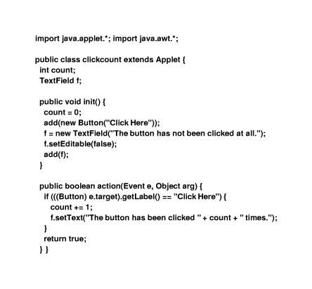
Running the example

<applet code="clickcount.class" height=50 width=400> </applet>
Shockwave
http://www.eg.bucknell.edu/~cs363/lecture_notes/chap31/chap31_15.html
Interacting with the browser

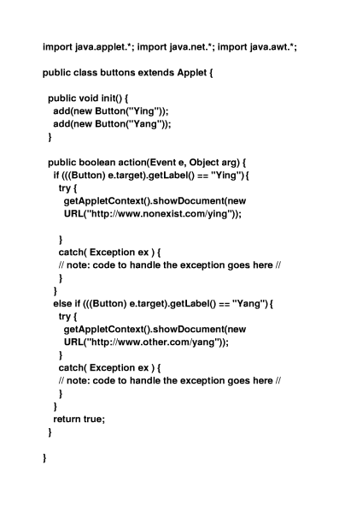
Running the example

http://www.eg.bucknell.edu/~cs363/lecture_notes/chap31/chap31_17.html

Alternatives

- JavaScript
  - Interpreted scripting language
  - Like csh for browser
- Other languages compiled into Java bytecodes
- Other programming technologies - Inferno
JavaScript example

<SCRIPT LANGUAGE="JavaScript">
<!--
var loc = location.href.toString()
var ep = loc.lastIndexOf("/")
var dirloc = ""
if (ep > 0) {
dirloc = loc.substring(0, ep)
}
function doform(form)
{
// Find next file
var URL
URL = dirloc + "/page20b.htm"
// Some problems getting background to look nice...
parent.frames[2].document.open()
parent.frames[2].document.clear()
parent.frames[2].document.writeln('<HTML><HEAD></HEAD><BODY BGCOLOR="#FFFFFF">')
parent.frames[2].document.writeln("<DL>")
//search stuff goes here
URL = URL + "?" + form.keyword.value
parent.frames[0].location.href = URL
}
// some hackery to force the bottom frame to be empty every
// time the page is reloaded
var URL
var loc = location.href.toString()
var ep = loc.lastIndexOf("/")
URL = dirloc + "/page20y.htm"
// force frame 0 to empty frame so re-execution is a no-op
parent.frames[0].location.href = URL
// -->
</SCRIPT>
Summary

- Active documents execute code in browser on user's computer
- Java is most widely used active document technology
- Java consists of:
  - Programming language
  - Run-time environment
  - Class library
  - Tags in browser for Java program invocation

Chapter 32 - RPC and Middleware

Section | Title
1 | Introduction
2 | Tools for networked applications
3 | Programming with procedures
4 | Procedure call graph
5 | Remote Procedure Call
6 | RPC paradigm
7 | RPC call graph
8 | What does RPC mechanism have to do?
9 | Where is this work done?
10 | External data representation
11 | Middleware and Object-oriented Middleware
12 | ONC RPC
13 | DCE RPC
14 | CORBA
15 | Summary

Introduction

- Client-server model most often used for networked applications
  - Fits well with program execution model
  - Modular
- May not be easy to program
  - Model not intuitive to coding experience
  - Lots of details to manage
Tools for networked applications

- Lots of details to manage
  - Connections between components of networked application
  - Synchronization
  - Robust data exchange
  - Data conversions
  - Error conditions
- Many details similar or identical in different networked applications
- Idea: use tools to handle routine parts of interface
Programming with procedures

- Modularizes code
  - Reusable components
  - Procedures operate on parameters
- Procedures may call other procedures
Procedure call graph

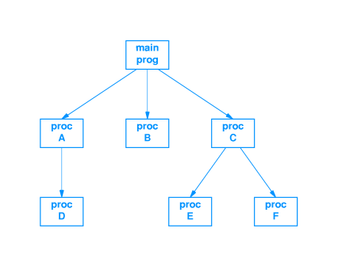
Remote Procedure Call

- Remote Procedure Call (RPC) model provides structure for development of networked applications
  - Based on procedure call model in familiar languages
  - Related to client-server model
- Hides details of communication and synchronization beneath procedure call interface
RPC paradigm

- Network communication hidden by procedure calls
  - Procedure may be executed on different computer
  - RPC mechanism hides details
- Programmer decides which procedures are executed where
RPC call graph

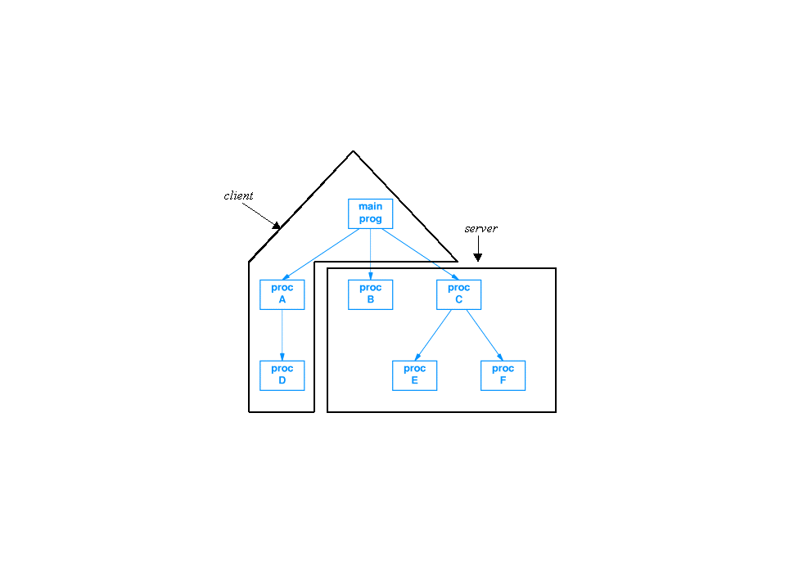
What does RPC mechanism have to do?

- Caller:
  - Marshal arguments
  - Transmit procedure identifier and arguments to remote procedure
  - Wait for response
- Called procedure:
  - Unpack arguments
  - Execute procedure
  - Reply with any returned value
Where is this work done?

- Client stub with name of remote procedure on client
- Server stub "spoofs" caller on server

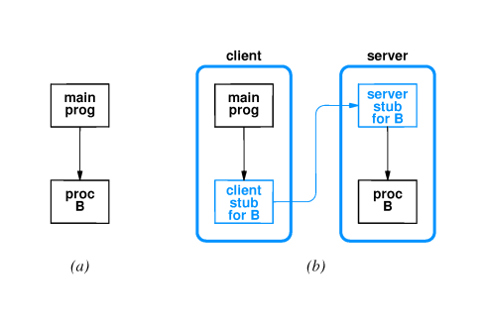
External data representation

- Machine-dependent data representations
  - Integer byte ordering
  - Floating point
  - Character strings (ASCII - EBCDIC; null-terminated - length encoded)
- External data representation: common format for data exchange
Middleware and Object-oriented Middleware

- Middleware: tools for generating RPC-based applications
- Interface Definition Language (IDL)
  - Defines specifications for procedure interfaces
  - Used by client and server programmers
- Object-oriented middleware: remote invocation of object methods
ONC RPC

- Open Network Computing Remote Procedure Call (ONC RPC)
  - Designed by Sun Microsystems
  - Early example of middleware
- Used in many Sun applications; e.g. NFS
- Includes eXternal Data Representation (XDR) standard
DCE RPC

- Open Software Foundation (OSF) defined Distributed Computing Environment (DCE)
- Includes DCE RPC as middleware component
- Defines its own IDL
- Microsoft derived Microsoft Remote Procedure Call (MSRPC) from DCE RPC
CORBA

- Common Object Request Broker Architecture (CORBA)
  - Developed by Object Management Group (OMG)
  - Vendor-independent, interoperable spec for middleware
- Remote invocation instantiated by local object proxies
  - Proxies instantiated at runtime
  - Methods passed to "real" remote object
Summary

- Client-server programming may be difficult due to details and synchronization
- Procedure call model is "natural" paradigm for programmers
- Remote Procedure Call (RPC) uses procedure call paradigm for client-server communication
  - Client sends parameters for procedure call to server
  - Server executes procedure and replies with returned value
- Middleware is category of development tools for RPC

Chapter 33 - Network Management: SNMP

Section | Title
1 | Introduction
2 | Internet Management
3 | Types of problems
4 | Problem with hidden failures
5 | Network management software
6 | Network management model
7 | SNMP
8 | SNMP data representation
9 | Fetch-store paradigm
10 | SNMP operations
11 | Identifying objects with SNMP
12 | Storing ASN.1 numeric values
13 | Storing ASN.1 lengths
14 | Types of MIBs
15 | Arrays in MIBs
16 | Array example
17 | Summary

Introduction

- Network management is a hard problem
- Will discuss network management paradigm base on network communication and client-server model
- SNMP is TCP/IP standard
Internet Management

- Network manager or network administrator is responsible for monitoring and controlling network hardware and software
  - Designs and implements efficient and robust network infrastructure
  - Identifies and corrects problems as they arise
  - Must know both hardware and software
- Why is network management hard?
  - Most internets heterogeneous
  - Most internets large
Types of problems

- Catastrophic
  - Fiber broken by backhoe
  - LAN switch loses power
  - Invalid route in router
  - Easiest to diagnose
- Intermittent or partial
  - NIC sends frames too close together
  - Router has one invalid entry
  - Hardest to diagnose
Problem with hidden failures

- Some intermittent of partial failures may not be evident to user
  - Hardware may drop frames with data errors
  - Network protocols may recover from lost packet
- However, network performance decreases
Network management software

- Monitor operation and performance of network devices:
  - Hosts
  - Routers
  - Bridges, switches
- Control operations through rebooting, changing routing table entries
Network management model

- Network management does not have an internet or transport layer protocol
- Defines application layer protocol using TCP/IP transport layer protocol
- Based on client-server model; names changes
  - Manager == client; run by network manager
  - Agent == server; runs on managed device
- Manager composes requests for agent; agent composes response and returns to manager
SNMP

- TCP/IP standard is Simple Network Management Protocol (SNMP)
- Defines all communication between manager and agent
  - Message formats
  - Interpretation of messages
  - Data representation
SNMP data representation

- SNMP uses Abstract Syntax Notation.1 (ASN.1)
  - Platform-independent data representation standard
  - Strongly-typed
  - Can accommodate arbitrary data types
- Example - integer representation
  - Length octet - number of octets containing data
  - Data octets - value in big-endian binary

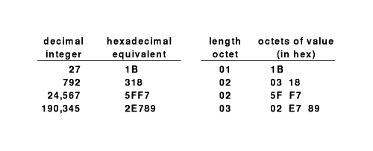
Fetch-store paradigm

- Manager-agent interaction based on fetch-store paradigm
  - Fetch retrieves a value from the agent
  - Store changes a value on the agent
  - Any other information is extracted from the fetched data and displayed by the manager
- Fetch used to monitor internal data values and data structures
- Store used to modify and control data values and data structures; also used to control behavior by setting "reboot" object
SNMP operations

- Get (fetch) retrieves value of object
- Set (store) stores new values into object
- Get-next retrieves next object (for scanning)
Identifying objects with SNMP

- SNMP is not tied to any particular set of data structures
- Operates on a collection of related objects identified in a Management Information Base (MIB)
- Objects in a MIB are identified by ASN.1 naming scheme
  - Hierarchical naming structure
  - Authority for new names delegated as in DNS
- Example - count of incoming IP datagrams:
iso.org.dod.internet.mgmt.mib.ip.ipInReceives
- For efficiency, each name has a numeric equivalent; e.g.:
1.3.6.1.2.1.4.3
Storing ASN.1 numeric values

- Value stored in sequence of octets
- Leftmost bit is 0 in last octet
- Example:

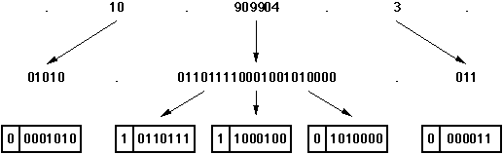

Storing ASN.1 lengths

- Leftmost bit 0 means length in same octet
- Leftmost bit 1 means length in k octets

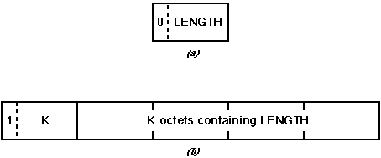

Types of MIBs

- Very flexible structure
- MIBs defined for protocols, devices, network interfaces
- MIB I is original TCP/IP standard for protocol suite; MIB II extends that original version

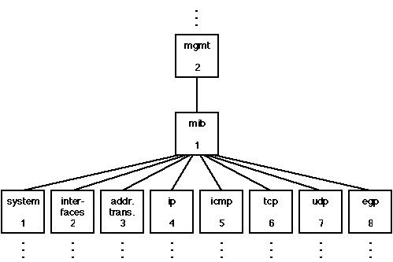

Arrays in MIBs

- Some types of data - such as a routing table - is most naturally stored as an array
- ASN.1 supports variable length, associative arrays
  - Number of elements can increase and decrease over time
  - Each element can be a structured object
- Indexing is implicit
  - Manager must know object is an array
  - Manager must include indexing information as suffix
Array example

- Routing table is an array:
ip.ipRoutingTable
- List of routing table entries is indexed by IP address
- To identify one value:
ip.ipRoutingTable.ipRouteEntry.ipRouteNextHop.IPdestaddr
  - ipRouteEntry indicates indexing
  - ipRouteNextHop is a field in a routing table entry
  - IPdestaddr is 32-bit IP address
Summary

- TCP/IP includes SNMP as network management protocol
- SNMP is an application protocol that uses UDP for transport
- Based on fetch-store paradigm
  - Controls operation as side-effect of store operations
  - Get-next used top scan objects
- Management Information Base (MIB) defines structure of objects
- Abstract Syntax Notation.1 (ASN.1) used for data representation and object identification

Chapter 34 - Network security

Section | Title
1 | Introduction
2 | Secure networks and security policies
3 | Components of security policy
4 | Aspects of security
5 | Responsibility and control
6 | Integrity mechanisms
7 | Encryption and privacy
8 | Public key encryption
9 | Digital signatures
10 | Digital signatures and privacy
11 | Packet filtering
12 | Internet firewall
13 | Summary

Introduction

- Routers forward packets - from any source
- Bad guys can send in packets from outside
- How to avoid security breaches?
Secure networks and security policies

- Can't describe a network as secure in the abstract
- University may have different notion of security than military installation
- Must define a security policy
- Many possibilities to consider:
  - Data stored on servers
  - Messages traversing LANs
  - Internal or external access
  - Read/write versus read-only access
Components of security policy

- Describes items to be protected and rules for protection
- Must cover computer systems, LANs, interconnection devices, ...
- Development must include assessment of cost of protected information versus cost of protection
Aspects of security

- Data accessibility - contents accessible
- Data integrity - contents remain unchanged
- Data confidentiality - contents not revealed
Responsibility and control

- Must be able to delegate and control responsibility
- Accountability - who is responsible for tracking access to data
- Authorization - who is responsible for who access data
Integrity mechanisms

- Checksum, CRC - protects integrity
- Message digest - more robust integrity check
Encryption and privacy

- Encryption - rewrite contents so that they cannot be read without key
  - Encrypting function - produces encrypted message
  - Decrypting function - extracts original message
  - Encryption key - parameter that controls encryption/decryption; sender and receiver share secret key
- Sender produces: E = encrypt(K, M)
- Sender transmits E on network
- Receiver extracts: M = decrypt(K, E)
Digital signatures

- Goal - guarantee that message must have originated with certain entity
- Idea - encrypt with private key, decrypt with public key
- Only owner of private key could have generated original message
Digital signatures and privacy

- Can combine techniques - signed by A, private 10 B
- A forms: X = encrypt(PUBB, encrypt(PRVA, M))
- B extracts: M = decrypt(PUBA, decrypt(PRVB))
Packet filtering

- Can configure packet forwarding devices - esp. routers - to drop certain packets
- Consider example:

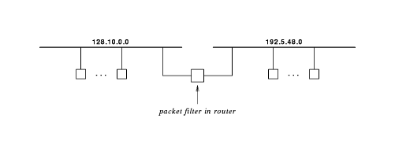

- Suppose 192.5.48.0 is test network and 128.10.0.0 has controlling workstations
  - Install filter to allow packets only from 192.5.48.0 to 128.10.0.0
  - Keeps potentially bad packets away from remainder of Internet
Internet firewall

- Packet filter at edge of intranet can disallow unauthorized packets
- Restricts external packets to just a few internal hosts

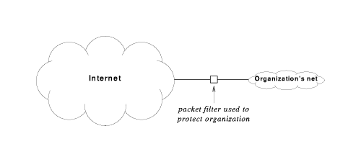

- Proxies forward packets through firewall after authorization
- DMZ net adds extra layer of access
- Net 10 and network address translation (NAT) boxes also add security
Summary

- Security is a problem because Internet is not owned by one entity
- Organizations can use firewalls to prevent unauthorized access
- Encryption and digital signatures can provide confidentiality and secure identification
Chapter 35 - Initialization

Section | Title
1 | Introduction
2 | Bootstrapping
3 | Protocol parameters
4 | Examples
5 | Modes of protocol configuration
6 | Why automate?
7 | Methods of automated protocol configuration
8 | The chicken-and-egg problem
9 | RARP
10 | ICMP
11 | BOOTP
12 | BOOTP forwarding
13 | Automatic address assignment
14 | DHCP
15 | Address leases
16 | DHCP message format
17 | DHCP and DNS
18 | Summary
Introduction

- How does protocol software begin operation
- From where is the software loaded
- How are configuration parameters determined
Bootstrapping

- Generally. initialization process is called bootstrapping
- Key idea is to perform initialization in stages, each of which enables more functions
- Protocol software may be:
  - Run out of on-board PROM
  - Loaded with bootstrap program from disk
  - Loaded with operating system from disk
Protocol parameters

- Protocol software needs specific information for operation
- Software employs parameters for operation on a specific hardware and network
- Process of supplying parameters to protocol software is called configuration
Examples

- IP address - depends on network, must be unique on network
- Default router address - where to send packets aimed at remote network
- Subnet mask - to specify if subnet addressing is used and what the subnet is
- DNS server address - for DNS queries
- Server addresses
Modes of protocol configuration

- Manual
- Local disk file
- Automated through network
Why automate?

- Centralized configuration for groups of computers
- Automatic address assignment
Methods of automated protocol configuration

- Decentralized - host discovers parameters independently
- Server-based - host contacts server
The chicken-and-egg problem

- How can host use network to get network address?
- Use broadcast-based link-layer protocol
  - RARP
  - AppleTalk
RARP

- Reverse Address Resolution Protocol (RARP)
- Maps MAC address to IP address
- Host broadcasts RARP request with its MAC address
- Server replies:
  - Must be on same subnet
  - Looks up MAC address in table
  - Replies with IP address
ICMP

- ICMP address mask request - find subnet mask
- ICMP gateway discovery - find default router
- Sequence:
- Broadcast RARP request
- Extract IP address from RARP response
- Broadcast ICMP address mask request
- Extract subnet mask from ICMP address mask reply
- Broadcast ICMP gateway discovery request
- Extract default router from ICMP gateway discovery reply
BOOTP

- Bootstrap Protocol (BOOTP) provides multiple parameters
- BOOTP request broadcast on subnet
- Server returns reply with IP address, subnet mask, servers, etc.
- Format:

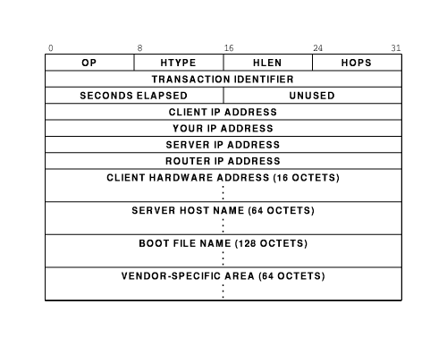
BOOTP forwarding

- Maintaining BOOTP server on each subnet can be expensive
- BOOTP relay agent listens for BOOTP requests
  - Forwards to BOOTP server
  - Returns responses from server back to BOOTP client
Automatic address assignment

- BOOTP requires that client be present in server database before BOOTP arrives
- Can addresses be allocated automatically?
  - AppleTalk
  - IPX
DHCP

- Dynamic Host Configuration Protocol (DHCP) can be used to allocate addresses to hosts without pre-configuration
- Plug-and-play networking
  - Host sends DHCP request message
  - Server finds unused address
  - Adds to local list of addresses
  - Returns address to host
Address leases

- Suppose host leaves subnet?
- Address no longer in use; server should reassign
- How does server know when to reassign?
- Address is assigned with a lease
  - Client cannot use address after lease expires
  - Client can ask for extension prior to expiration
DHCP message format

- Extension of BOOTP; includes new options

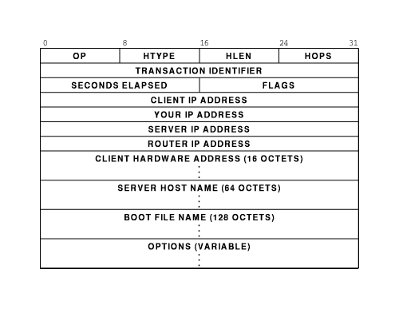

DHCP and DNS

- New addresses should be entered in DNS
- DNS just recently added capability to automate entry updates
- "Soon", DHCP client or server will be able to add new entries to DNS
Summary

- Protocol software requires configuration parameters
- Small, heterogeneous networks can use decentralized configuration
- IP uses server-based configuration
  - BOOTP
  - DHCP

